**SOFTWARE ENGINEERING DEPARTMENT**

**SPRING 2015**

**CMPE 273 – Enterprise Distributed Systems – Team Project**

**Amazon Farmers Market – Report**

**Team Number 8**

|  |  |
| --- | --- |
| **Team Member** | **SJSU ID** |
| Ankil Shah | 010817703 |
| Bhargav Jain | 010806510 |
| Bhavin Agrawal | 010827206 |
| Nischith Bedachuvaly Nataraja | 010700430 |
| Saurabh Jain | 010809344 |

**Member Contribution towards the Group Project**

* **Ankil Shah :**

Design and development of Admin module and Farmer module – Front End

Mocha testing

Dynamic pricing implementation

* **Bhargav Jain :**

Design and development of Customer module and Farmer module – Back End.

Project report generation.

Jmeter testing

* **Bhavin Agrawal :**

Design and development of Customer module – Front End

Testing of Farmer module

RabbitMQ implementation

* **Nischith Bedachuvaly Nataraja :**

Design and development of Admin module – Back End

Google map API integration

REDIS implementation

* **Saurabh Jain :**

Design and development of Billing module – Front and Back End.

Project report generation.

Testing of Admin

Jmeter testing

* Introduction
* Goal

The application is the replica of the Amazon Fresh Farmers Market. In this project we build Amazon Farmers Market Plus in which the local farmers are allowed to sell their fresh products directly to the customers. The farmers display their products and the customers can browse and select the required products. They can also check the progress of their delivery using Google maps.

* Purpose of System

We learn and implement the MEAN stack for web development and also the use of RabbitMQ using the AMQP protocol for scalability. We have used the Redis for cache management.

* System Design
* Technologies used
* Angular.js – Frontend
* Node.js – Backend
* CSS/Bootstrap – UI/UX
* Html – Markup Language
* JavaScript – Scripting language
* MongoDB and MySQL– Database
* Bcrypt – Password Encryption
* Passportjs – Authentication Module
* AMQP – Messaging Protocol
* RabbitMQ – Middleware
* Express – Framework
* Express session – Sessions
* Redis – Caching
* Object Management Policy

1. Planning and Requirement Analysis:

At this stage, we planned and performed requirement analysis, as per the requirements of the project the three tiers are:

a) The Client tier: The user will interact with our system and send responses using the UI.

b) The Middle tier/middleware/messaging system: The majority of the processing takes place in this tier; it supports sending and receiving messages between distributed systems. It is at this most critical point that it needs to integrate new components or to scale existing ones as efficiently as possible. Few of the modules have been implemented using RabbitMQ which implements the [Advanced Message Queuing Protocol](https://en.wikipedia.org/wiki/Advanced_Message_Queuing_Protocol).

c) The Third tier: This tier comprises of a database to store the state of the entity objects of the system. At this tier, we also have constraints and relations that define the data. Few modules use MySQL as the relational database and MongoDB as the NoSQL database to store data.

1. Consideration of the Functional Requirements:

Form the project requirement; we implemented different modules namely Farmer, Customers, Admin, Products, Billing and Trips. Each of the modules has an associated schema which is responsible for showing how object should be stored in database. Each objects exhibit their respective functionalities as per the project requirements.

1. Development:

On the basis of project requirement, we have created UI and implemented different functionalities. We implemented key features like maps using Google maps API to help customers to select the driver, track the truck using Rabbit MQ to increase the sustainability while the load in high. Redis has been used for cache management.

1. Testing the System :

The mocha and jmeter test cases are shown below which display the performance behavior for different number of users. After the development of the application, on the basis of requirement along with the test cases, we have drafted test cases which were checked if all the requirement functionality is working fine or not.

* How we handled “Heavy Weight” resources.

The heavy weight resources in the project are images and videos of farmer introduction, photos of products and photos and videos uploaded by customer during product review. All these heavy weight resources have been stored inside mongodb as loading the same from the MySQL might take much time. As we have stored the image and video from the mongodb, retrieving will be much faster compared to MySQL.

* The policy you used to decide when to write data into the database

We have decided to insert data into database optimally. Likewise in the scenario like signup, we use mongo session to store the data provided by customer in multiple screen and store it into database once the signup gets completed. Eg: Signup module has 3 screens. If data is saved to DB in every screen then if the transaction fails in 2nd or 3rd screen or if the user terminates it in any of these steps, then the previous transactions needs to be rolled back. Hence we are storing the data in session in each screen and saving the data at once in the third step. This will also reduce 2 inserts that needs to be done in previous steps and any updated in the following screens. Similarly for the Customer cart, the data has been stored in the local storage and will be stored in the database after successful checkout only.

* Modules
* Admin

1. Main Page: The index page where different options are available for Sign up and Sign in for different modules.

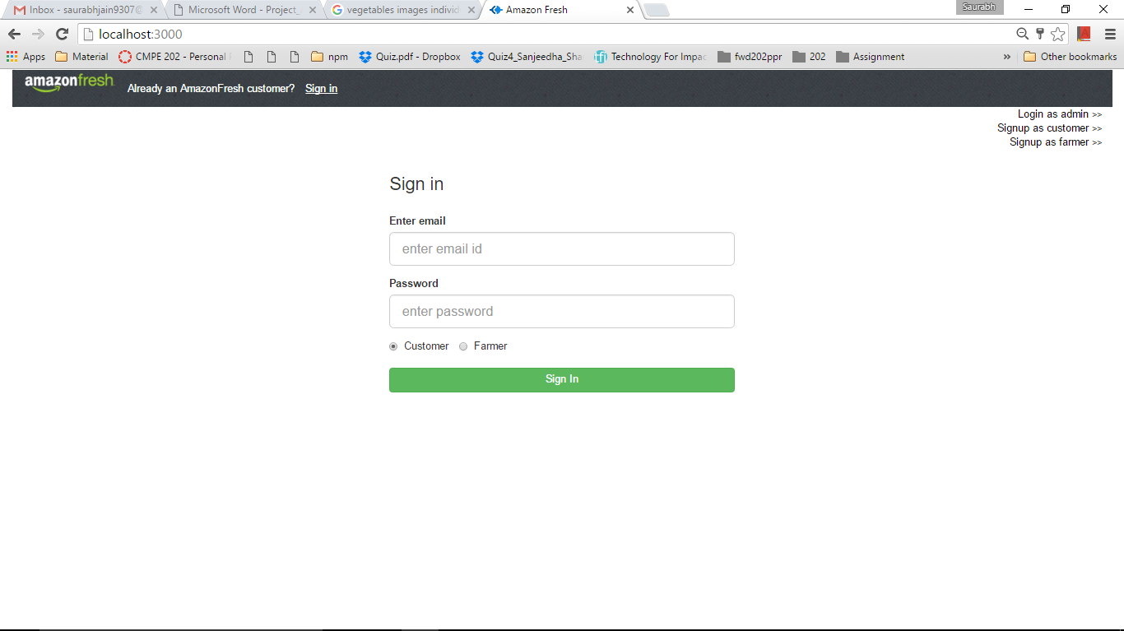

1. Login Page: In the above image an existing admin will be redirected to the admins sign up page by clicking on the Login as admin.

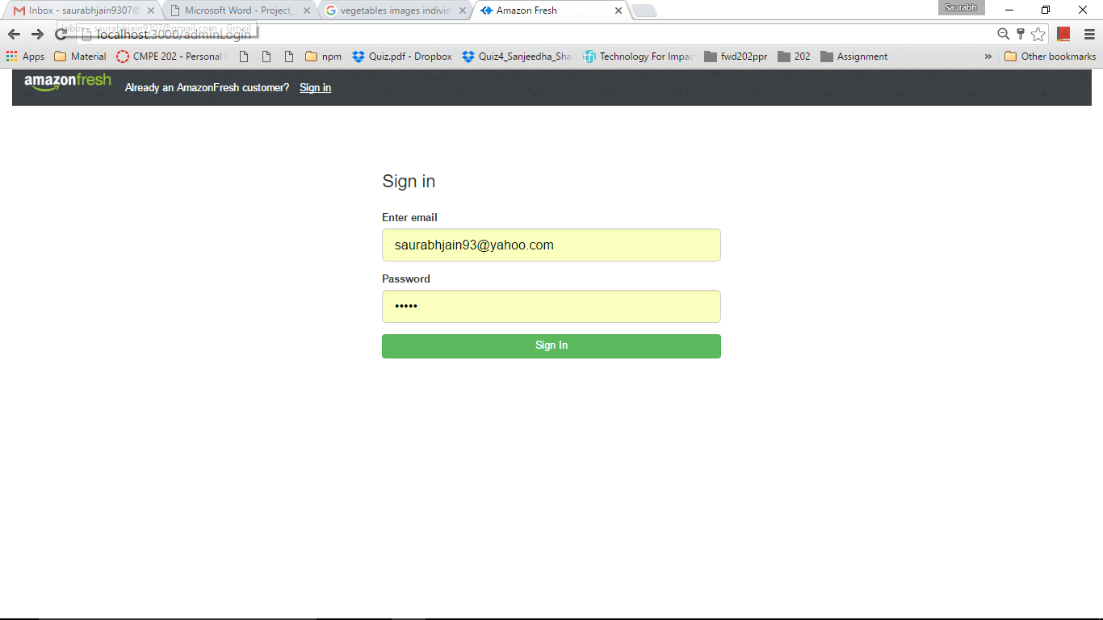

1. Validations: Invalid users will be given proper errors.

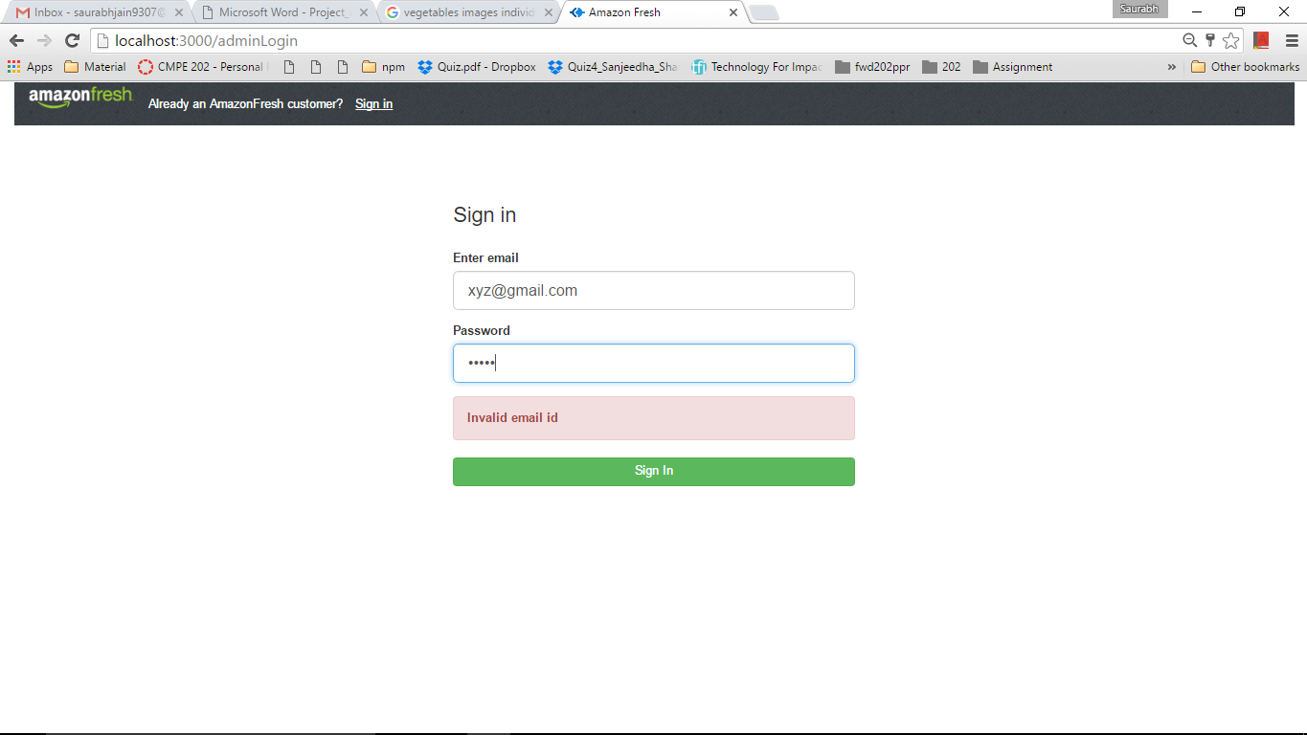

1. Valid Admin : Can login in and will be redirected to the admins home page.



1. Database of admin table

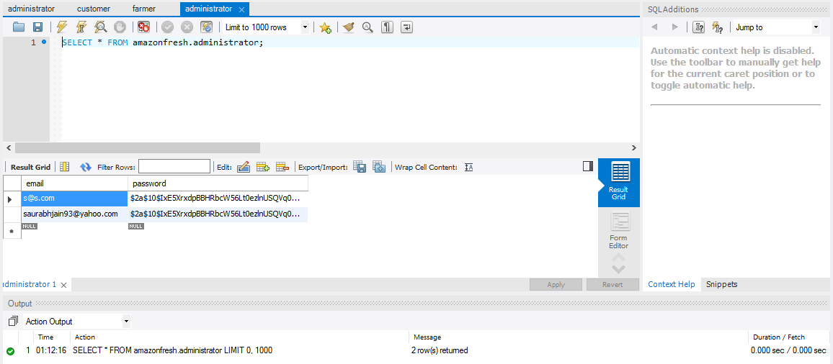

1. Admins Home Page: Initially no request is available and proper messages are shown. The list of all the pages is shown for the menu with proper messages.

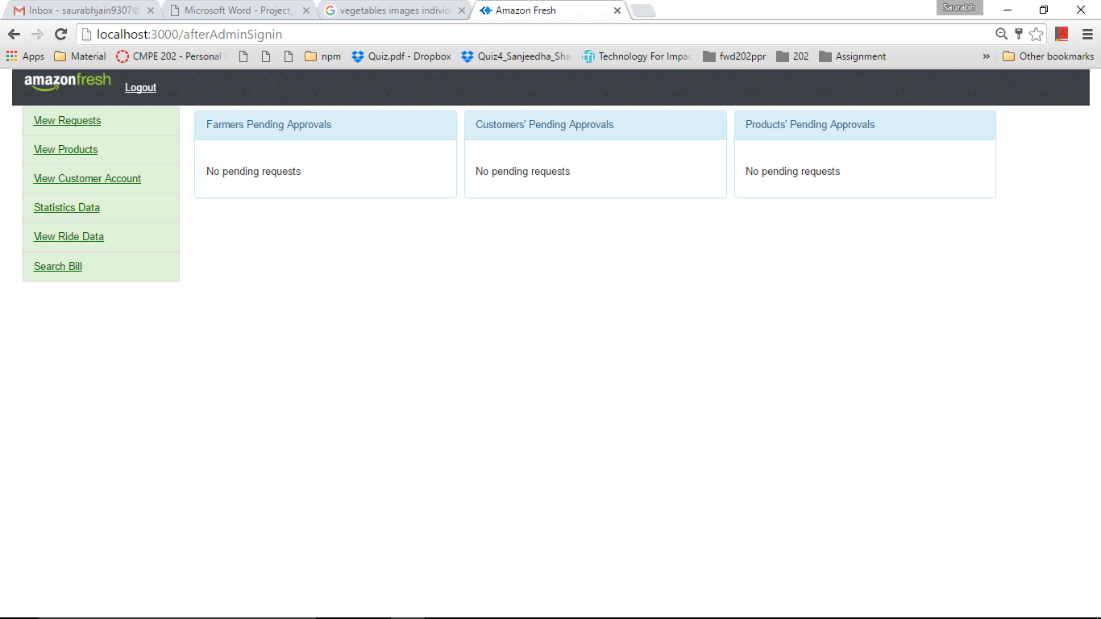

1. The list of all the pages is shown for the menu with proper messages. Initially it will have no products.

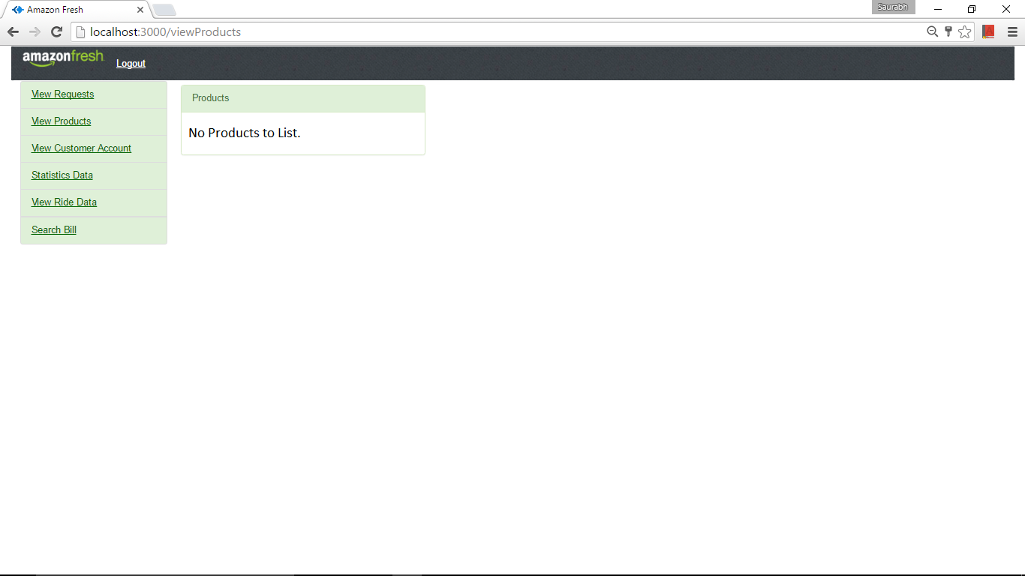

1. Customer Account List

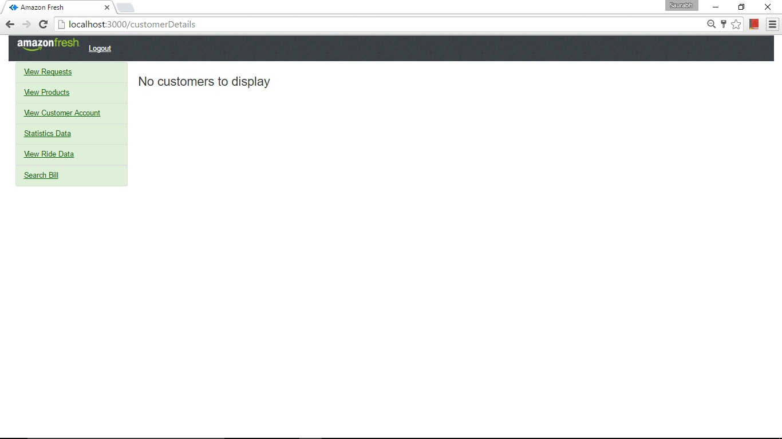

1. Statistics

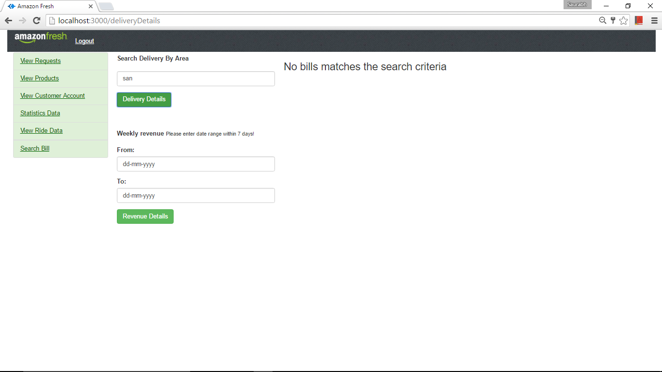

1. For weekly revenue

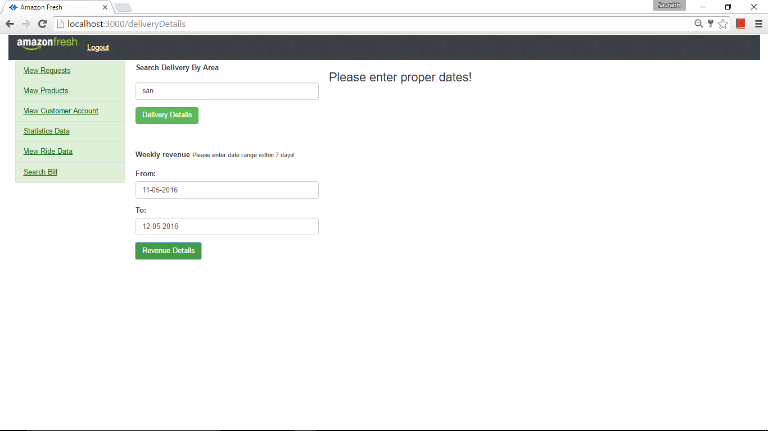

1. View Rides Data which will be grouped by Area, Driver Id, Customer Id.

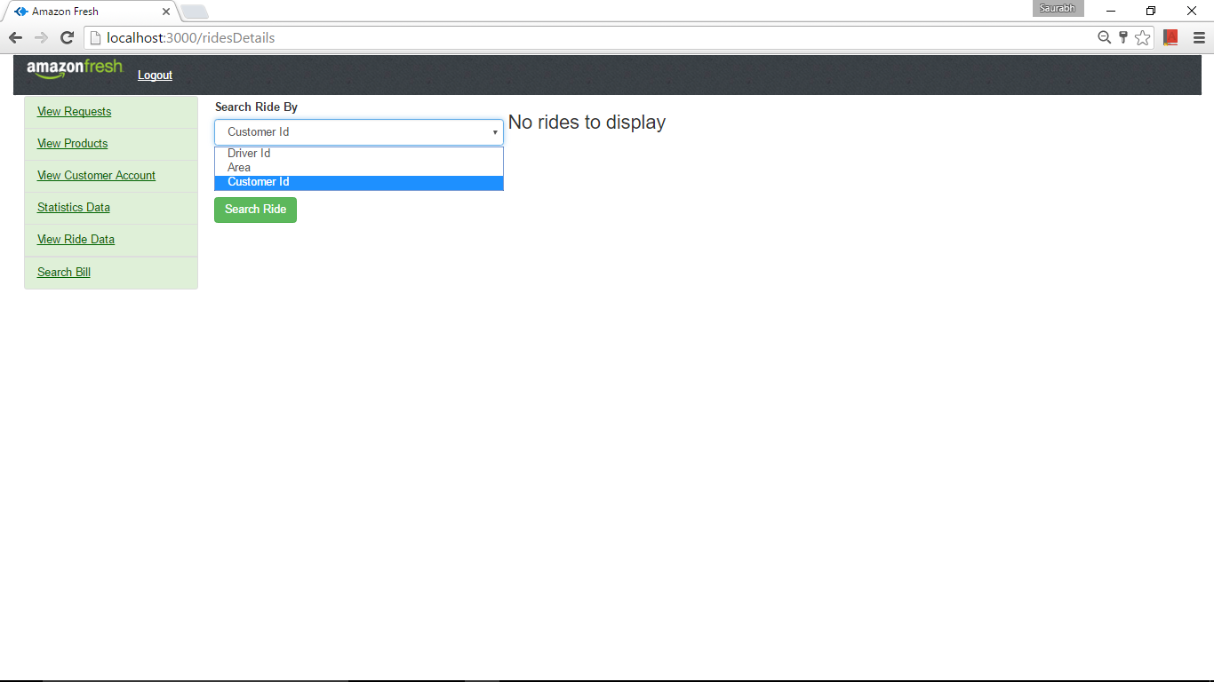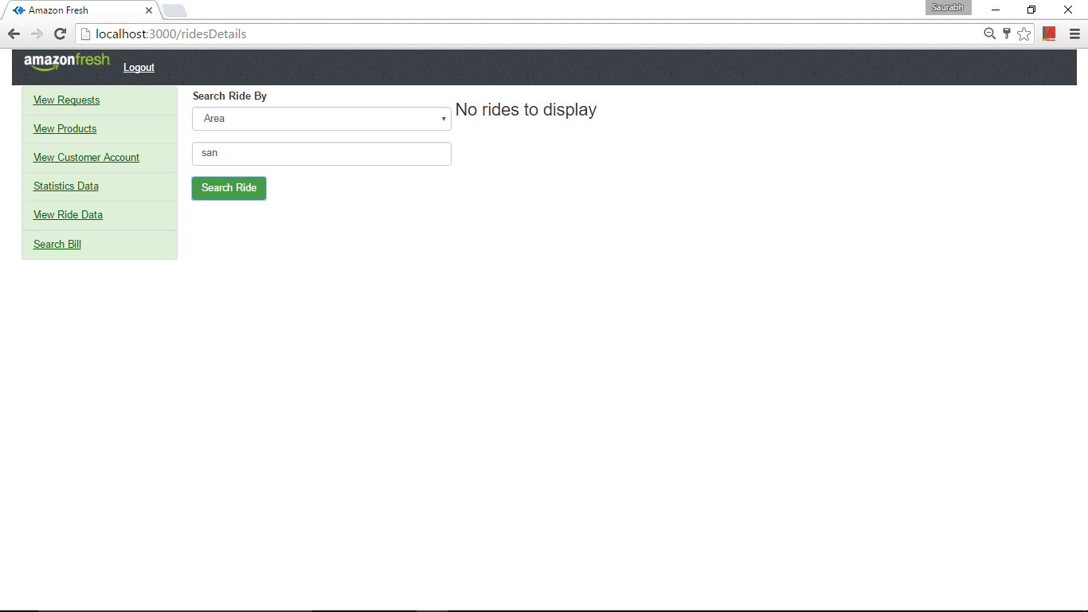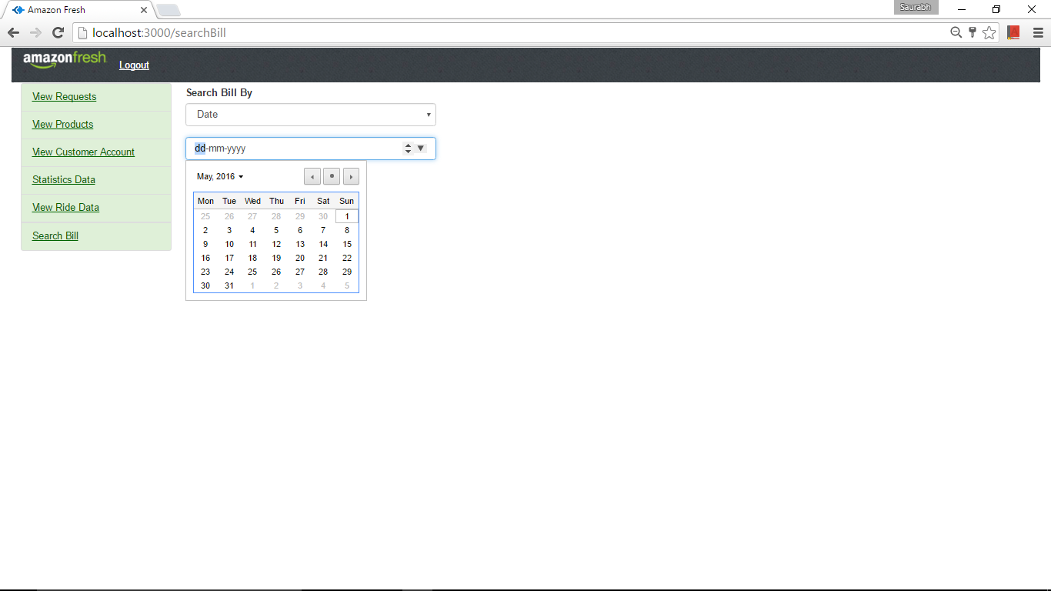

1. Search Bills by Billing ID and Customer ID

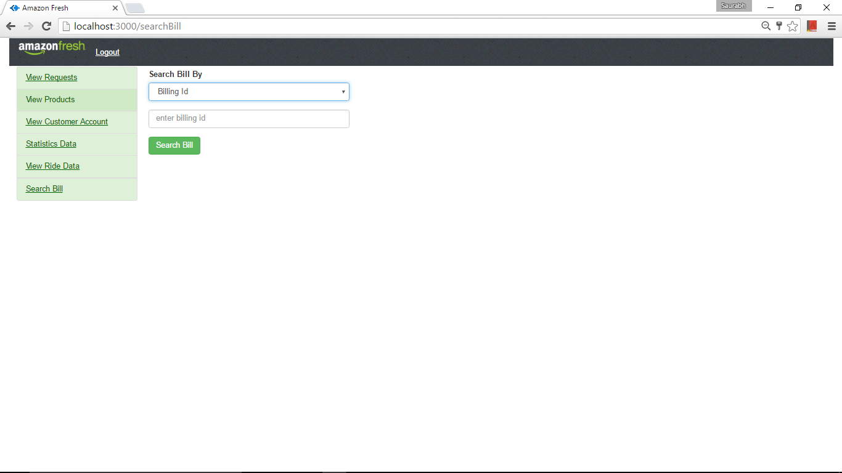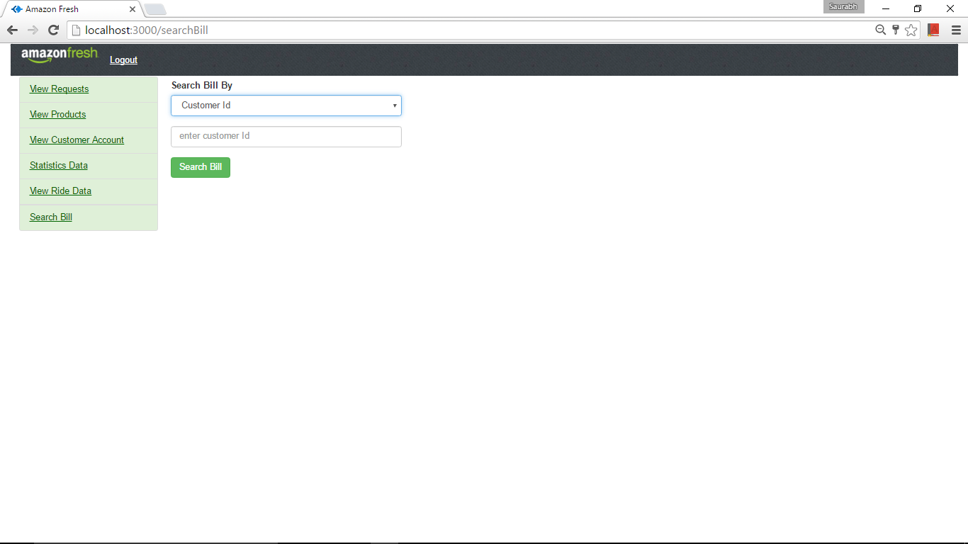

1. Logout: Once the admin logout the sessions will be destroyed and he will not be able to go to the homepage using the back button.

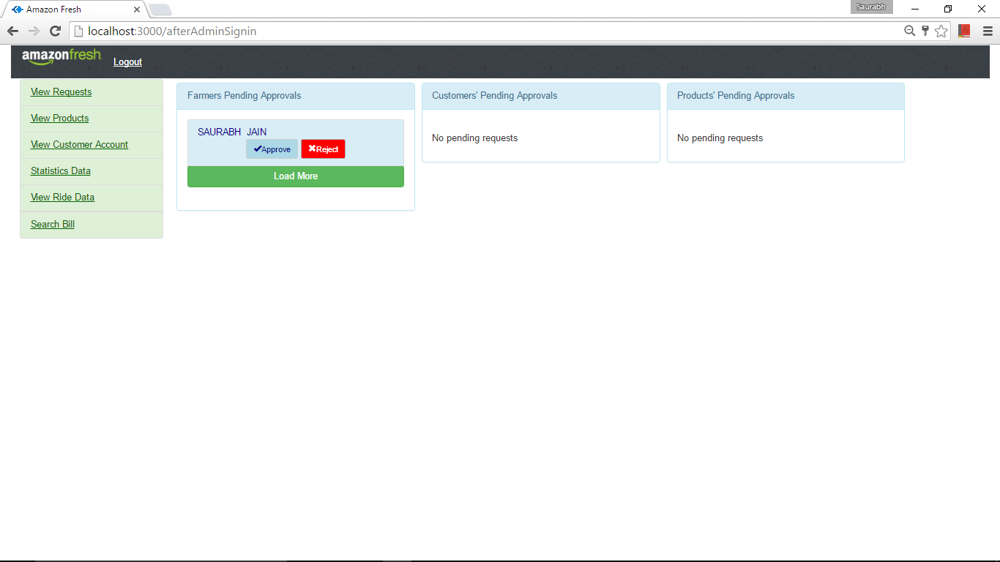

1. When I add different Customers, Farmers and Products the list is shown on the admins home page. We have the functionality of load more to show more pending request. Once the request is approved only then a customer and a farmer can log in and the products can be displayed in the customers page.

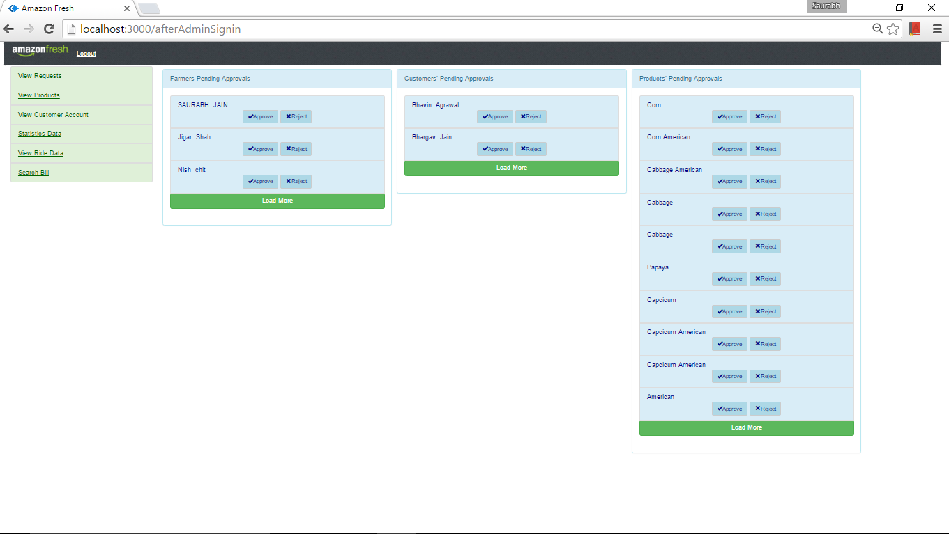

1. Reject functionality: Nich request has been rejected and now when he tries to access it shows Rejected message.

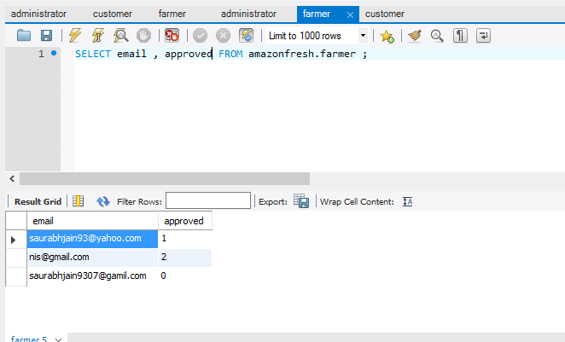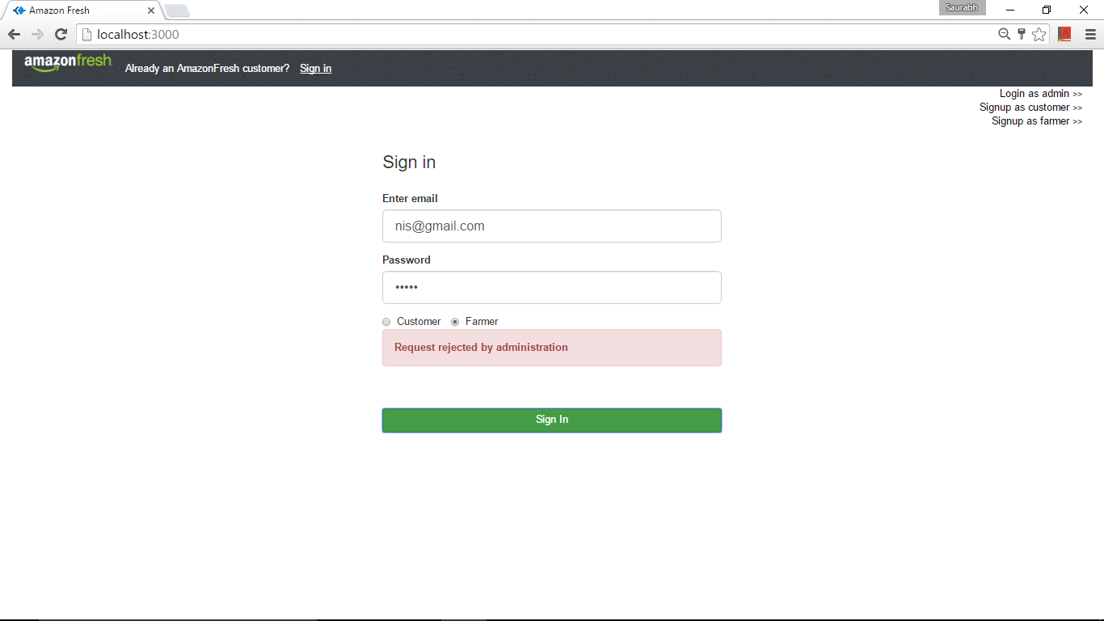

1. Admins module approves or rejects option.

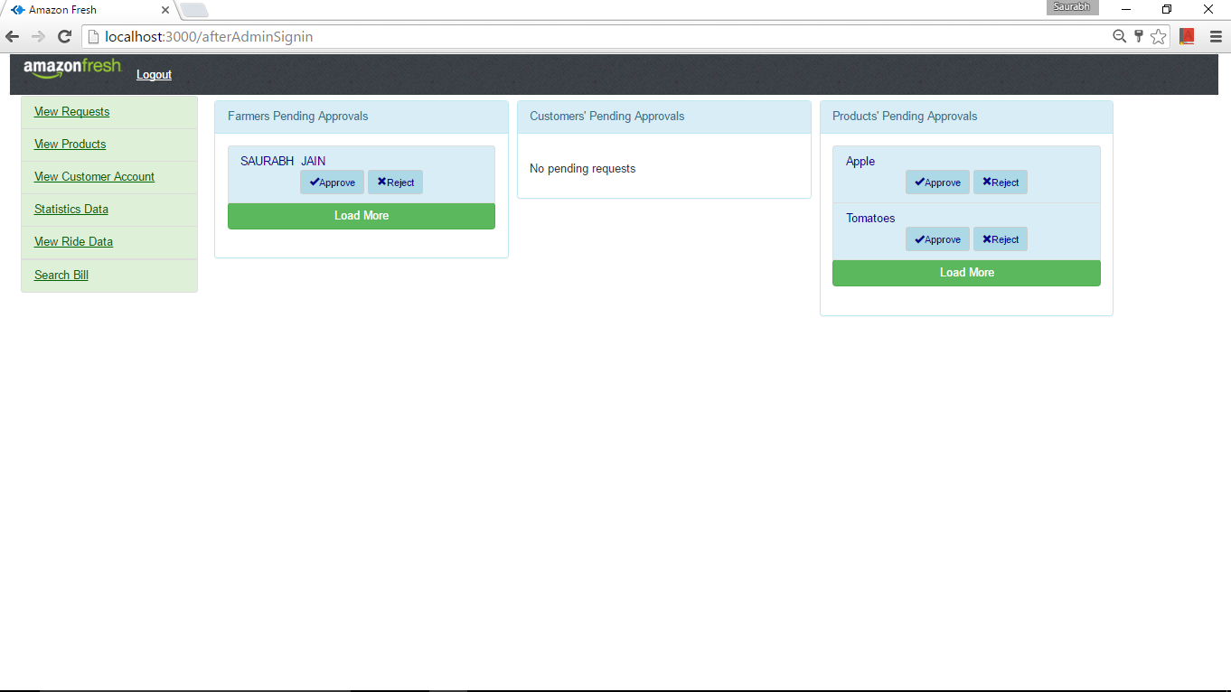

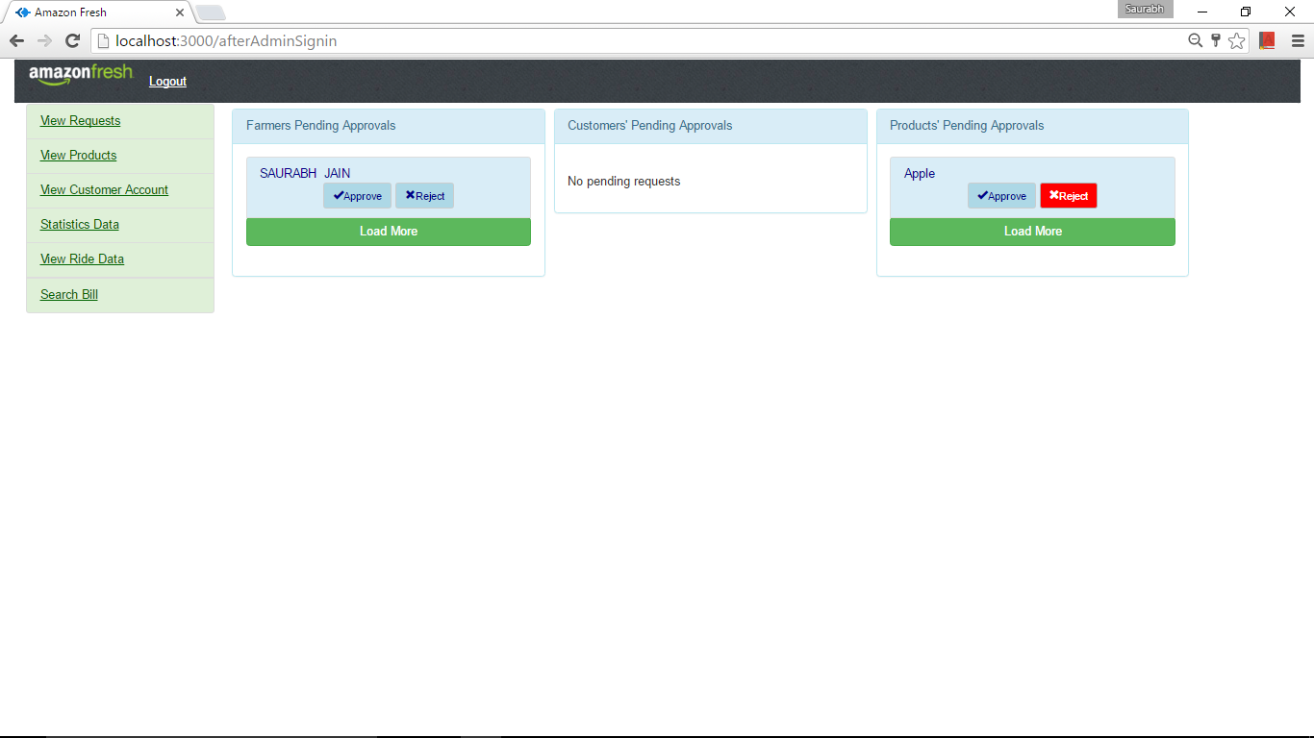

1. List all farmers

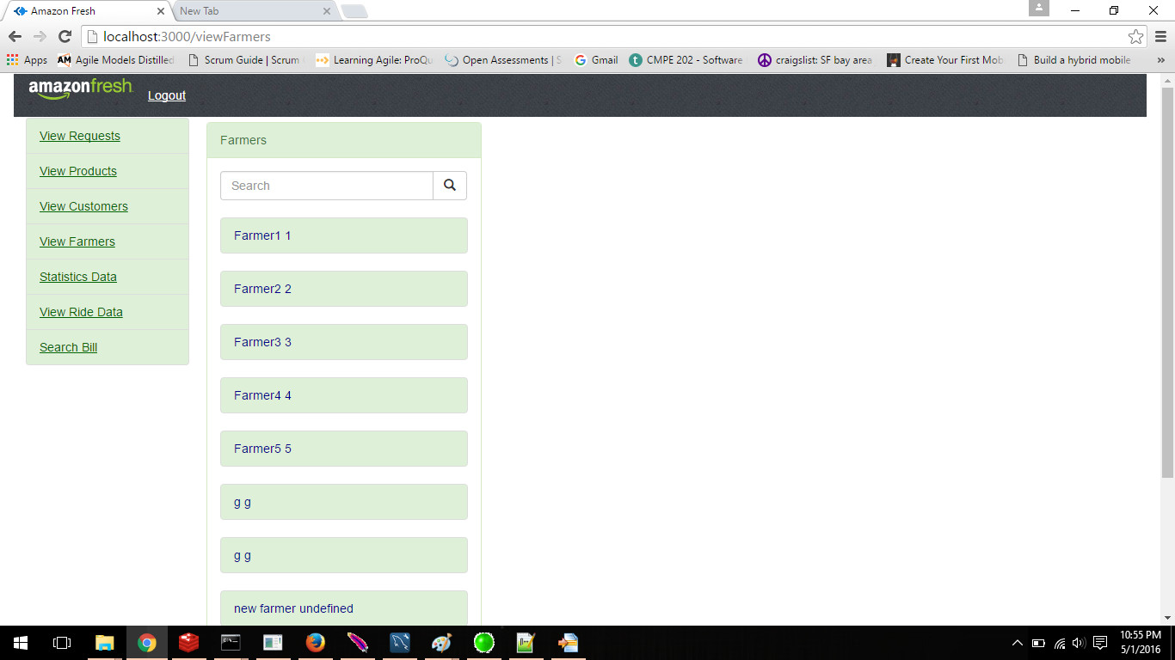

1. Display the farmers details

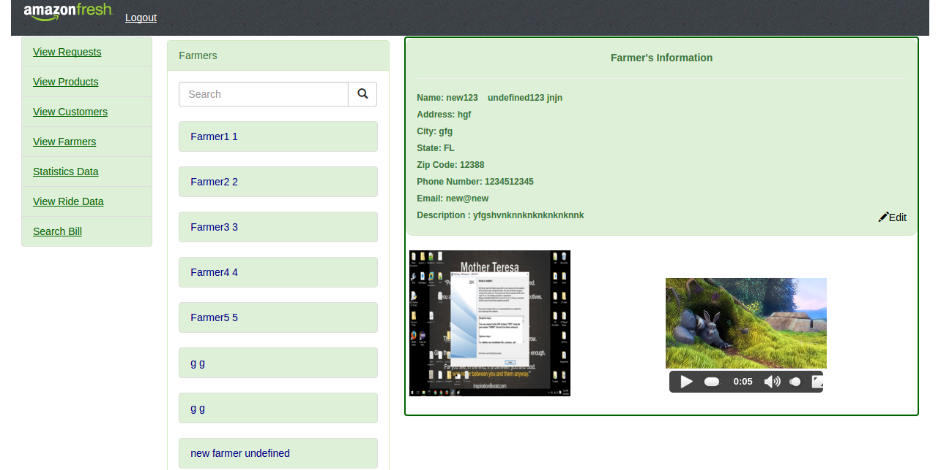

1. Search a particular Farmer

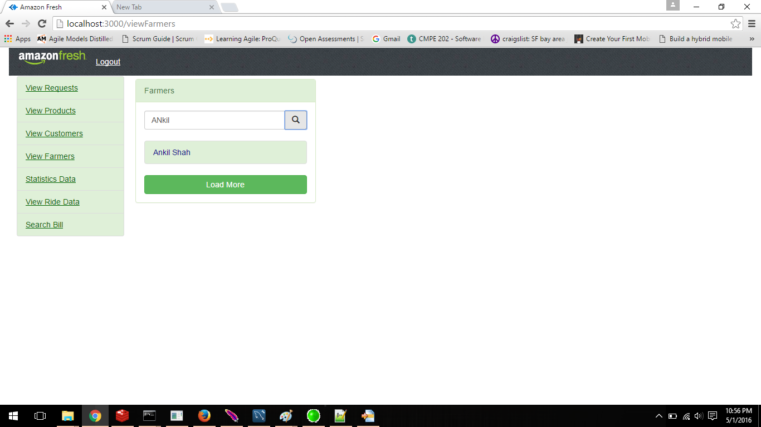

1. he same is shown in the admins module in list all products:



1. Load More: Here the admin can load more request. For example in the products request shown below. The number of items have increased.

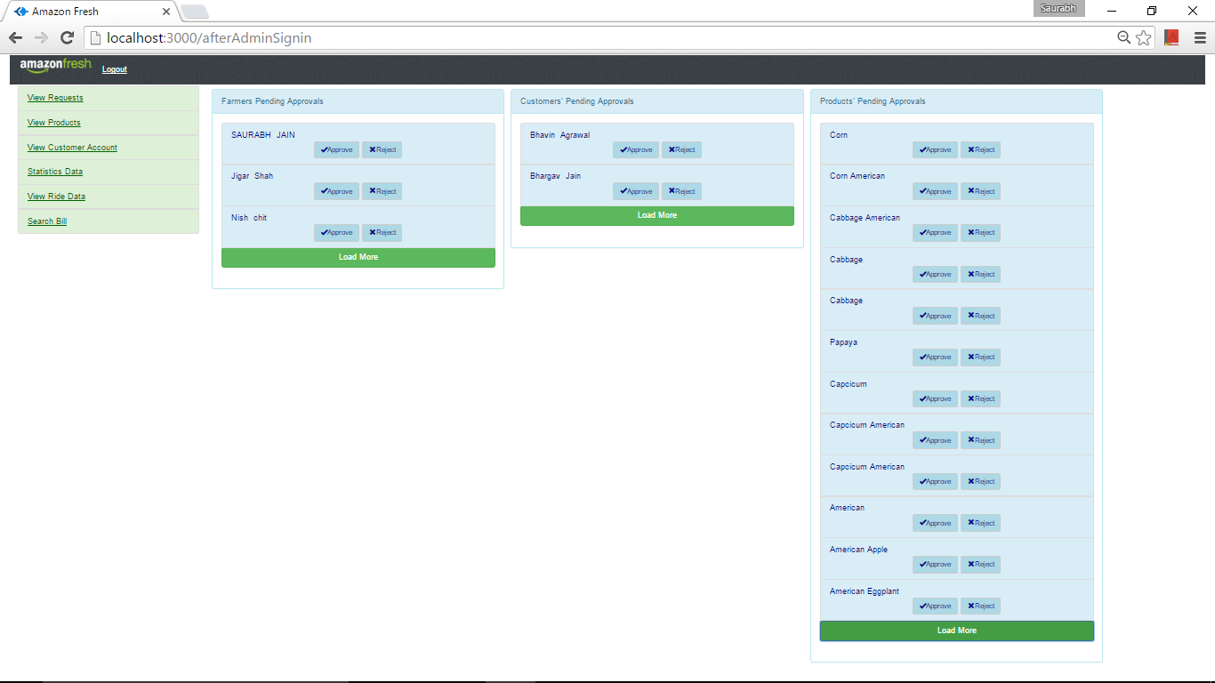

1. Search Statistics by Driver ID

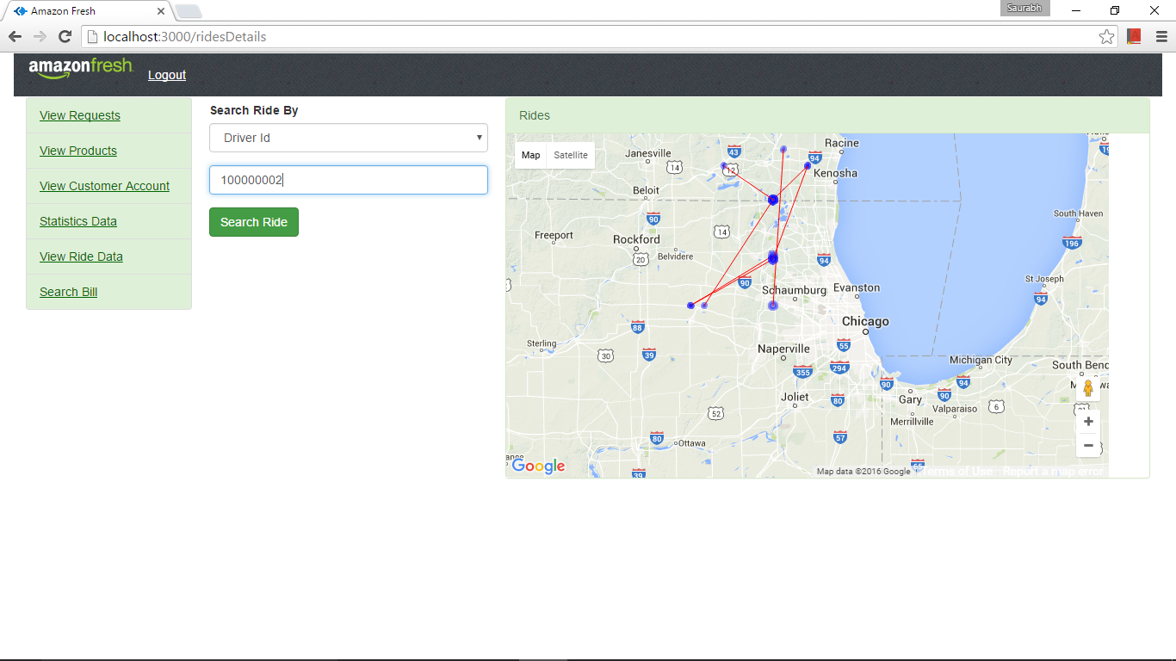

1. Search Statistics by Area

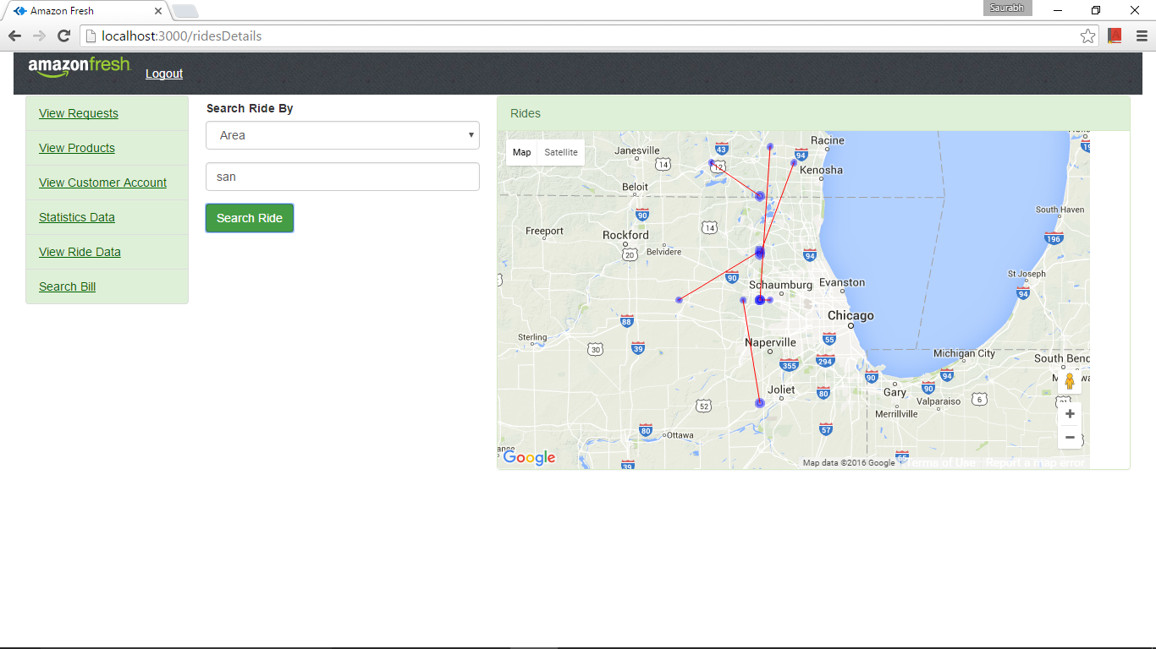

1. Search Statistics by Customer ID

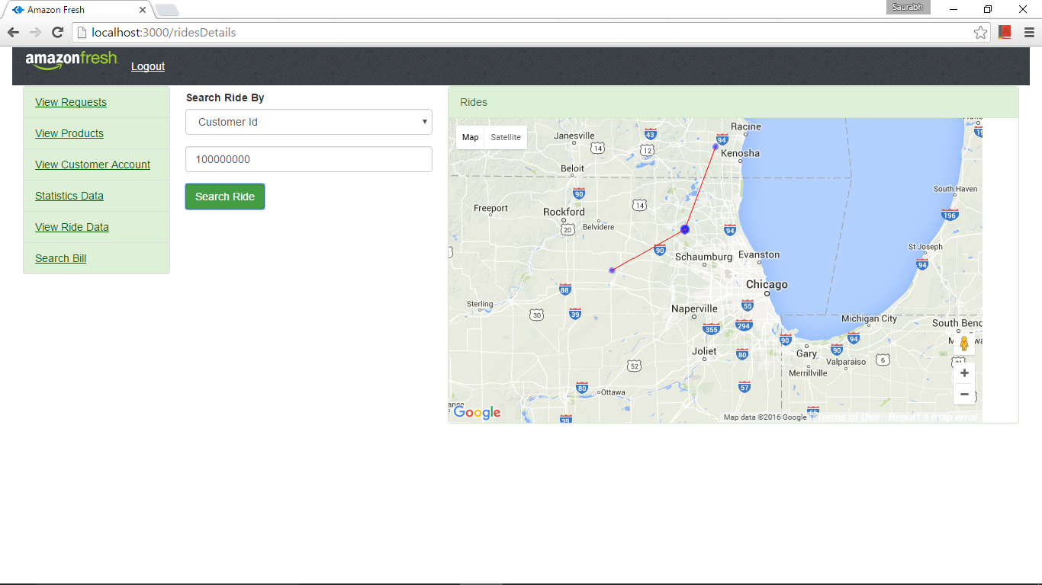

1. Different view from the Google Maps

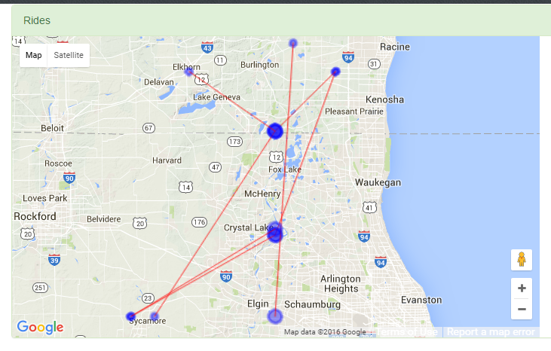

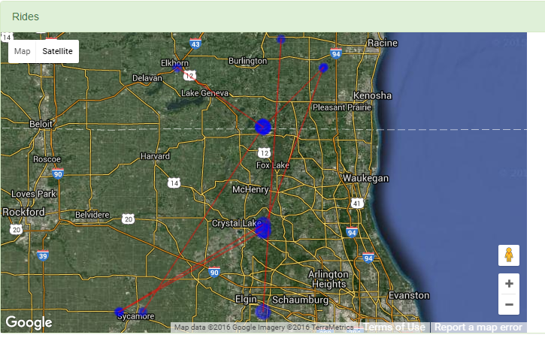

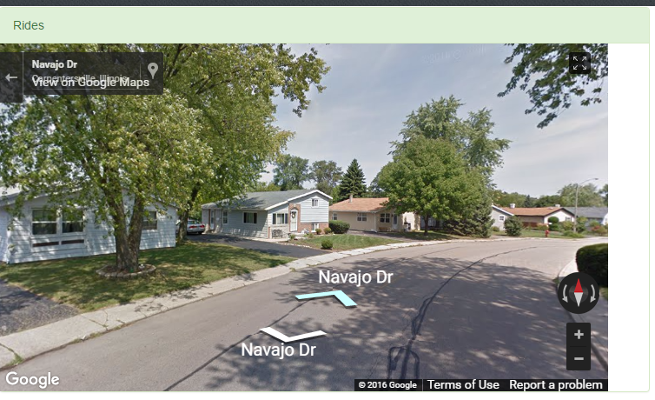

1. Show delivery by area

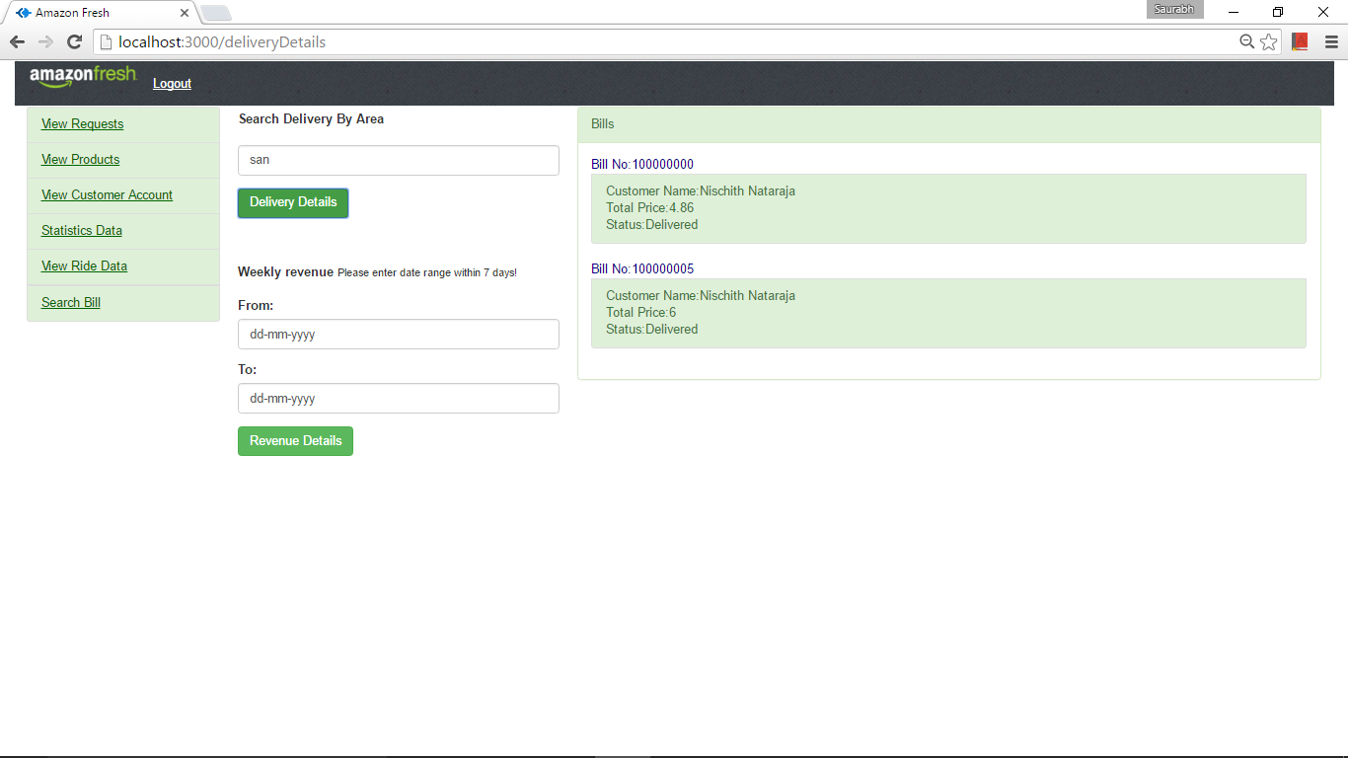

1. The bill can be viewed by clicking the Bill number.

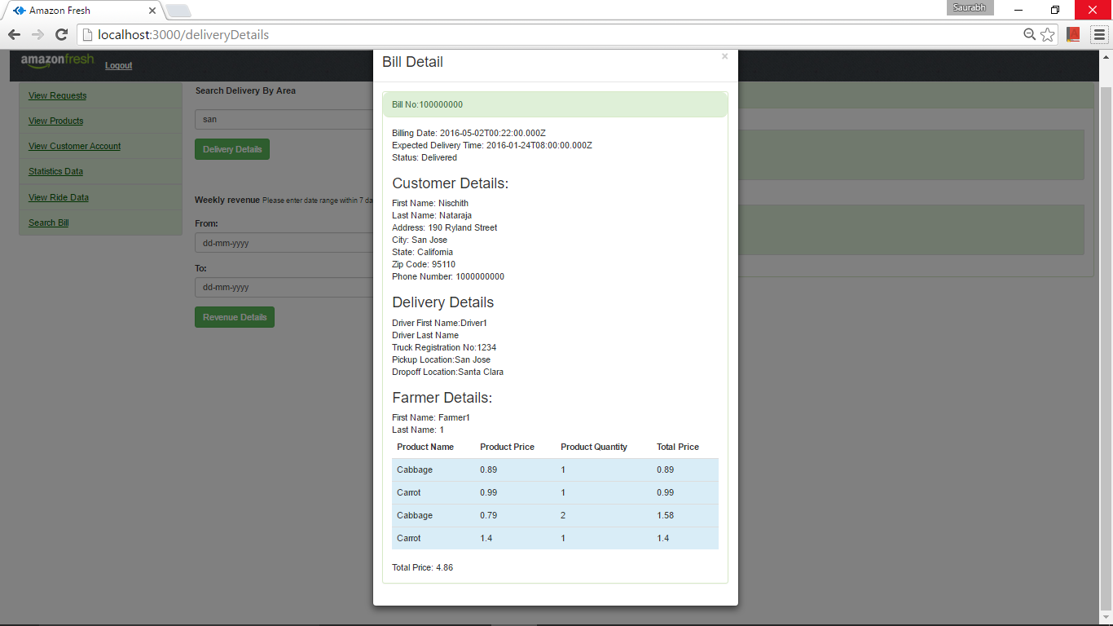

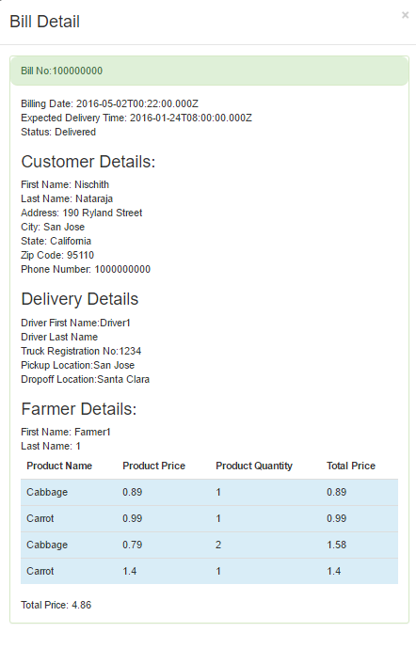

1. Showing the Statistics by Date

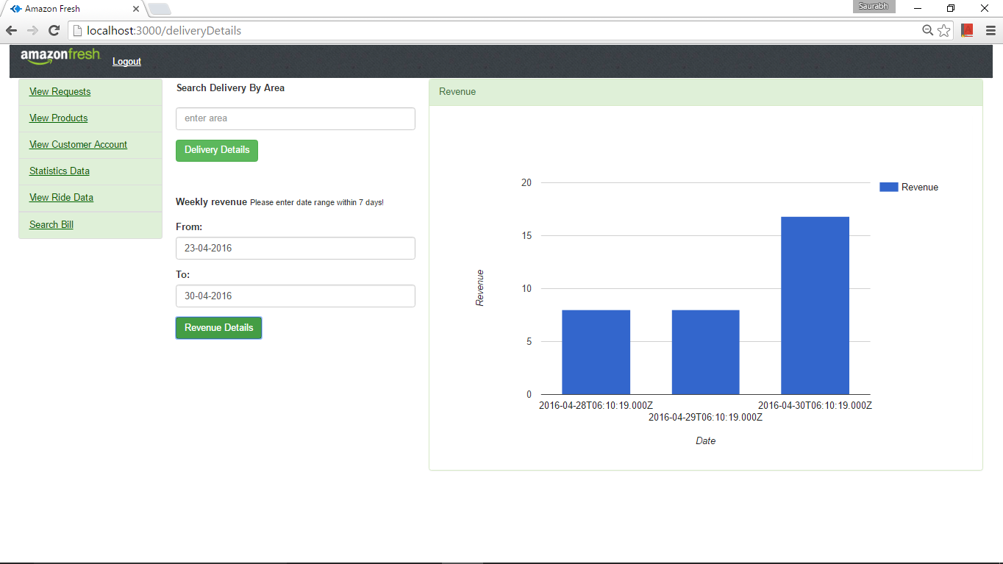

* Farmer

1. Sign Up :

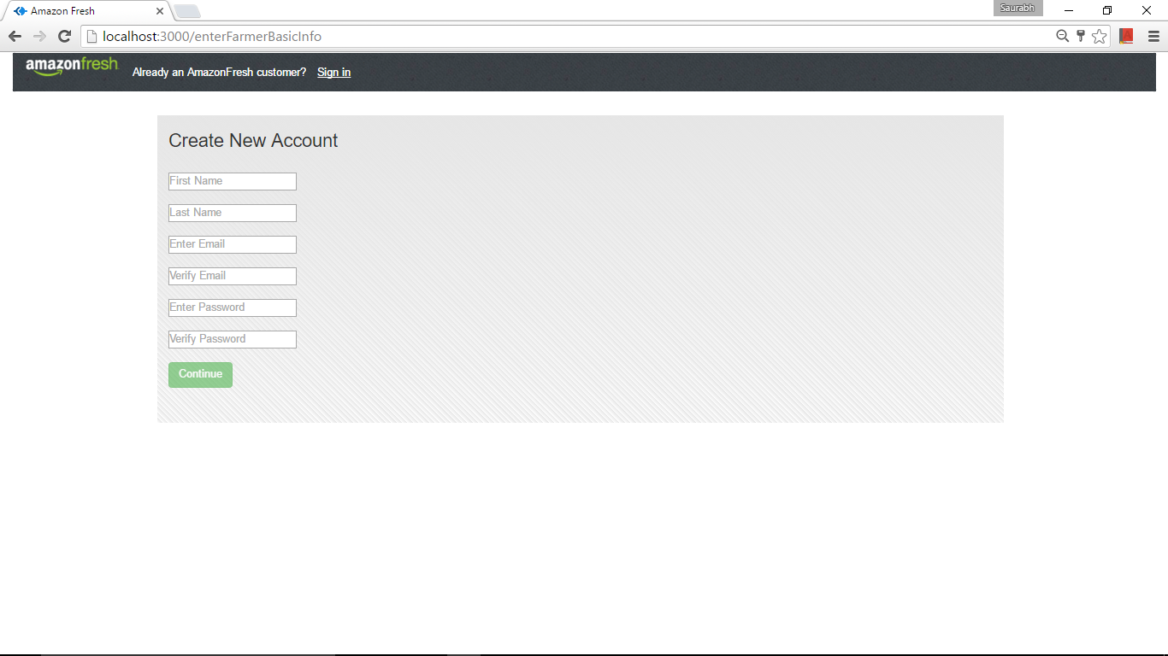

1. Enter the Details :

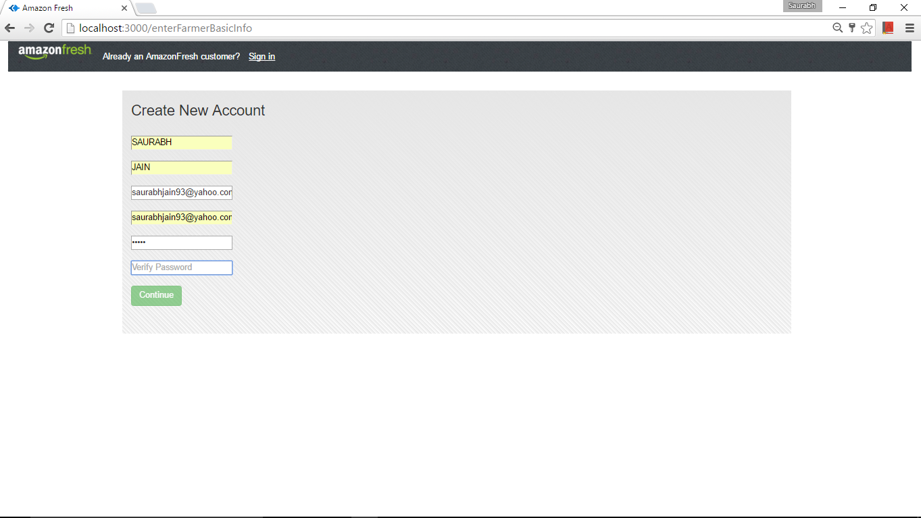

1. Validations are done with proper error messages. For example. Mismatch password As shown below.

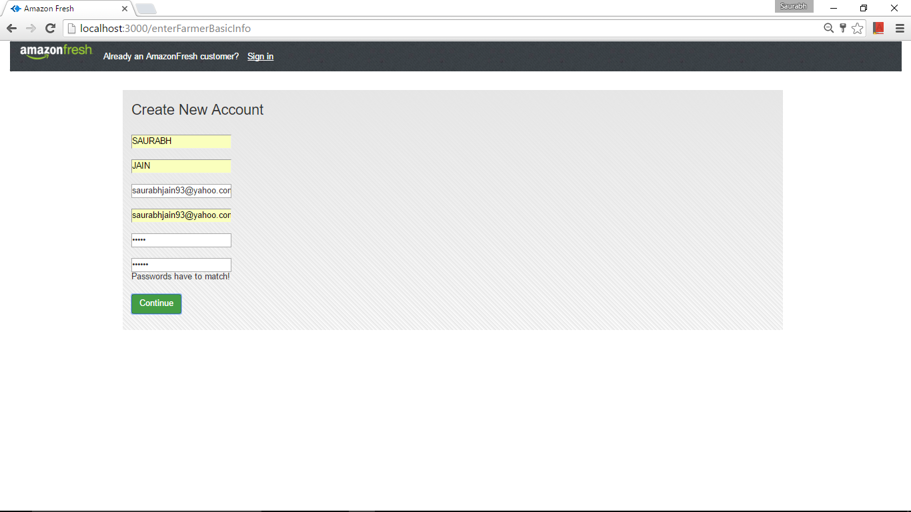

1. Enter Address:

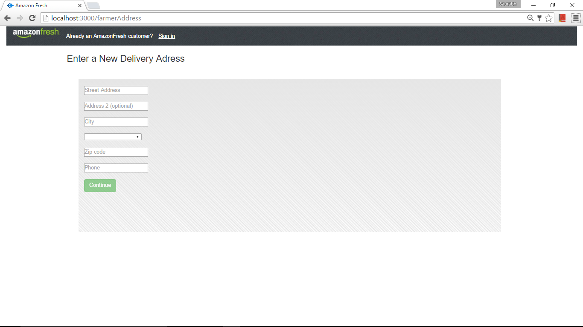

1. Enter Description:

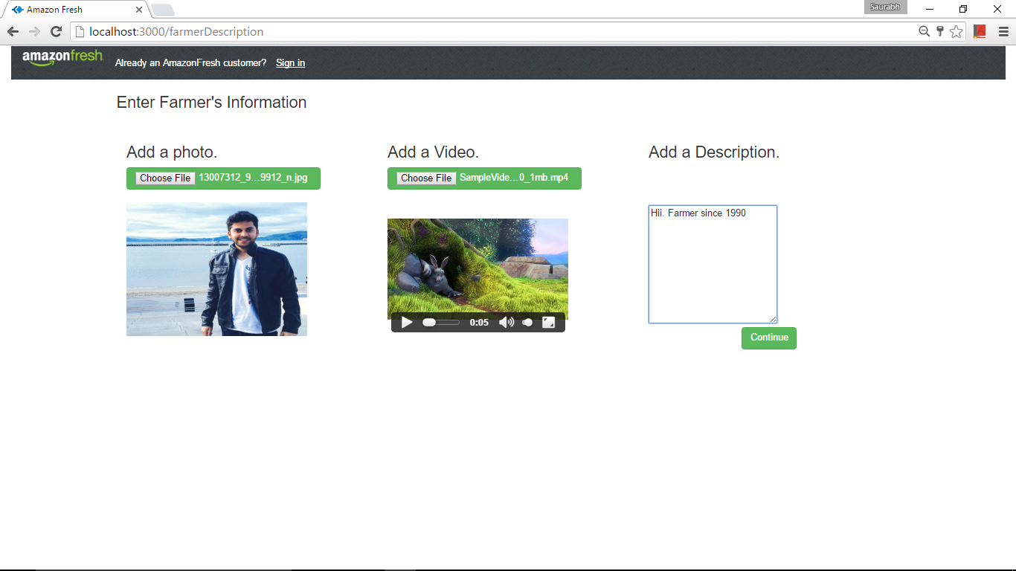

1. After Continue Approval is pending:

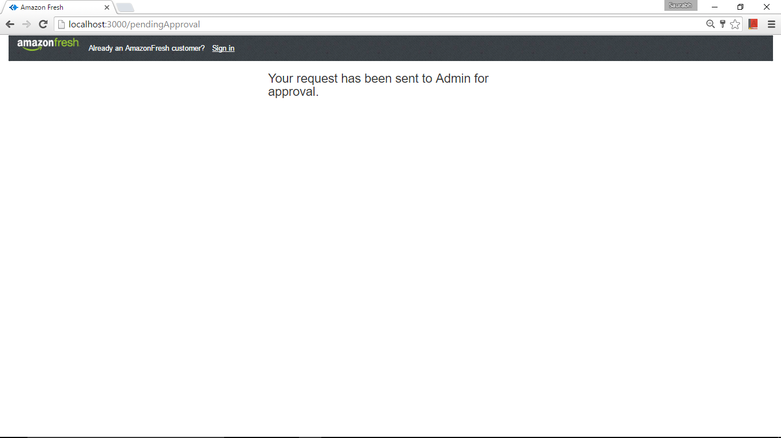

1. Cannot logging approval pending:

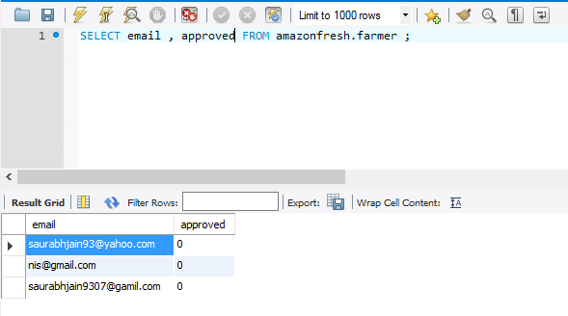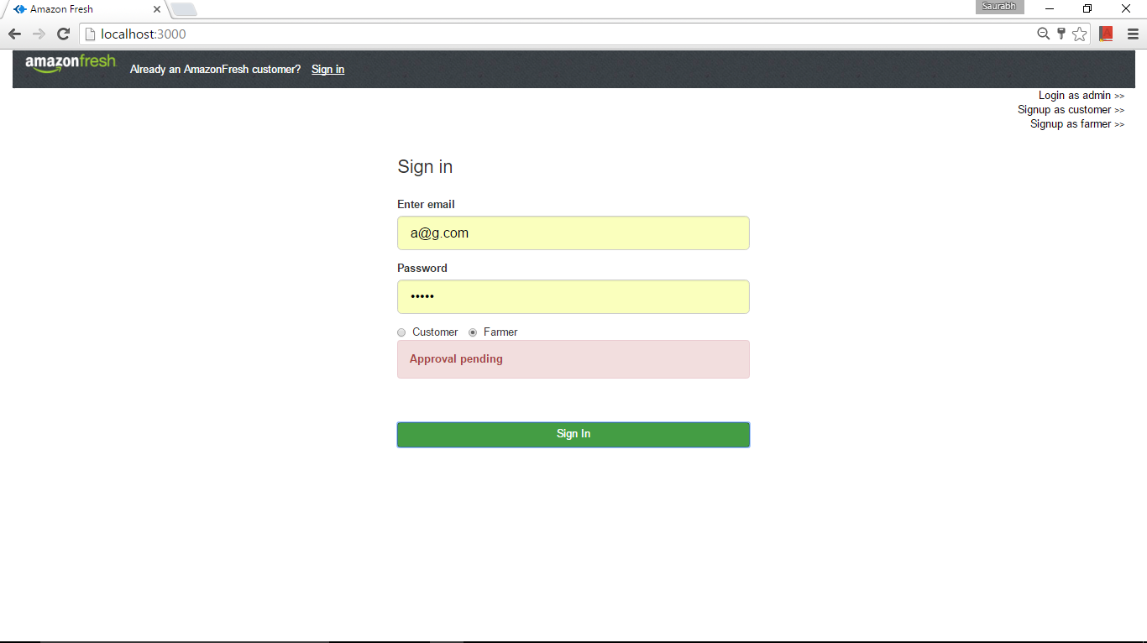

1. Invalid Login

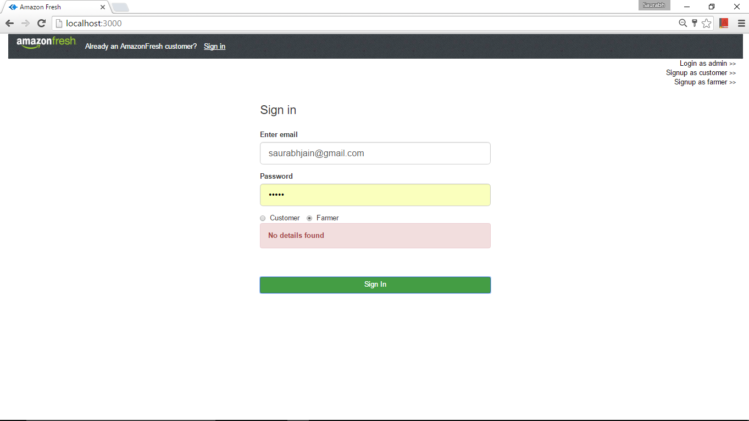

1. Once the admin approves:

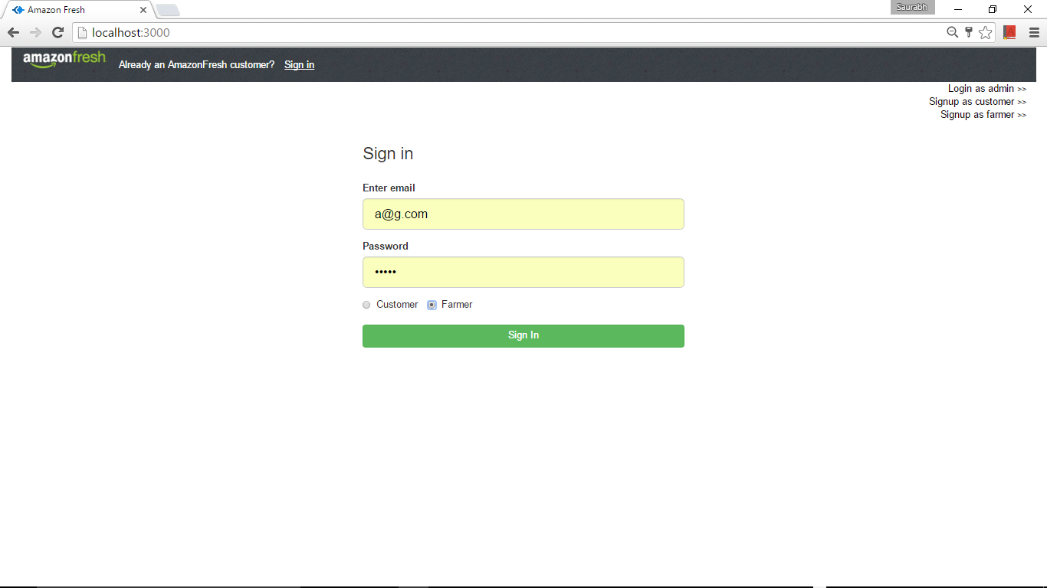

1. Home Page of the farmer: The videos and photos have been stored in the mongo.

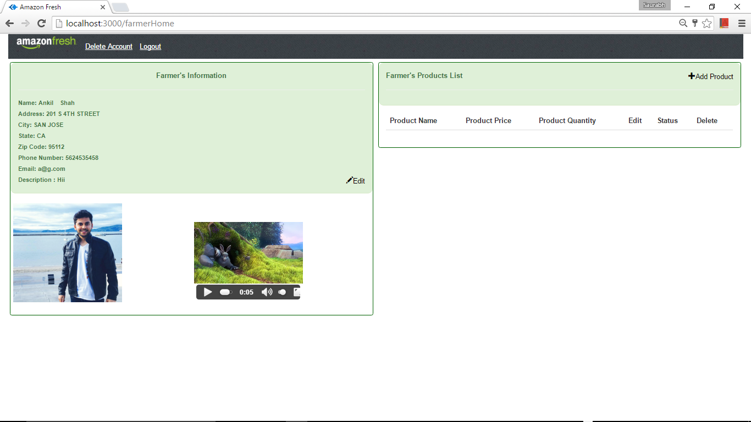

1. Can Edit his profile

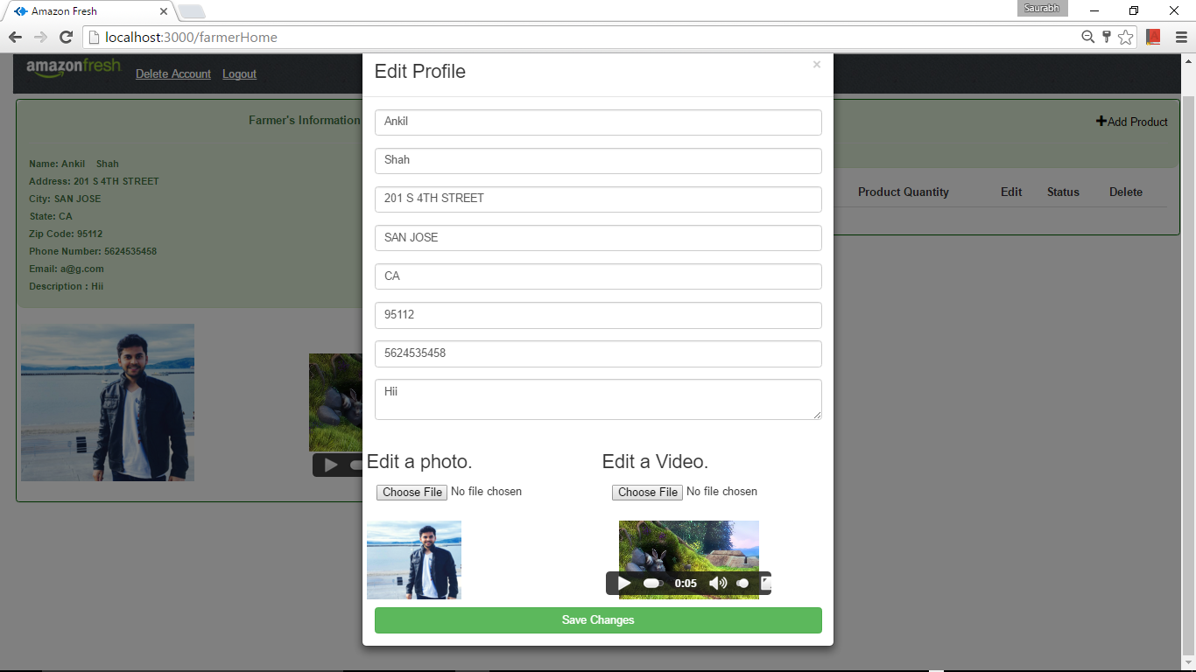

* Product

1. Can Add Products:

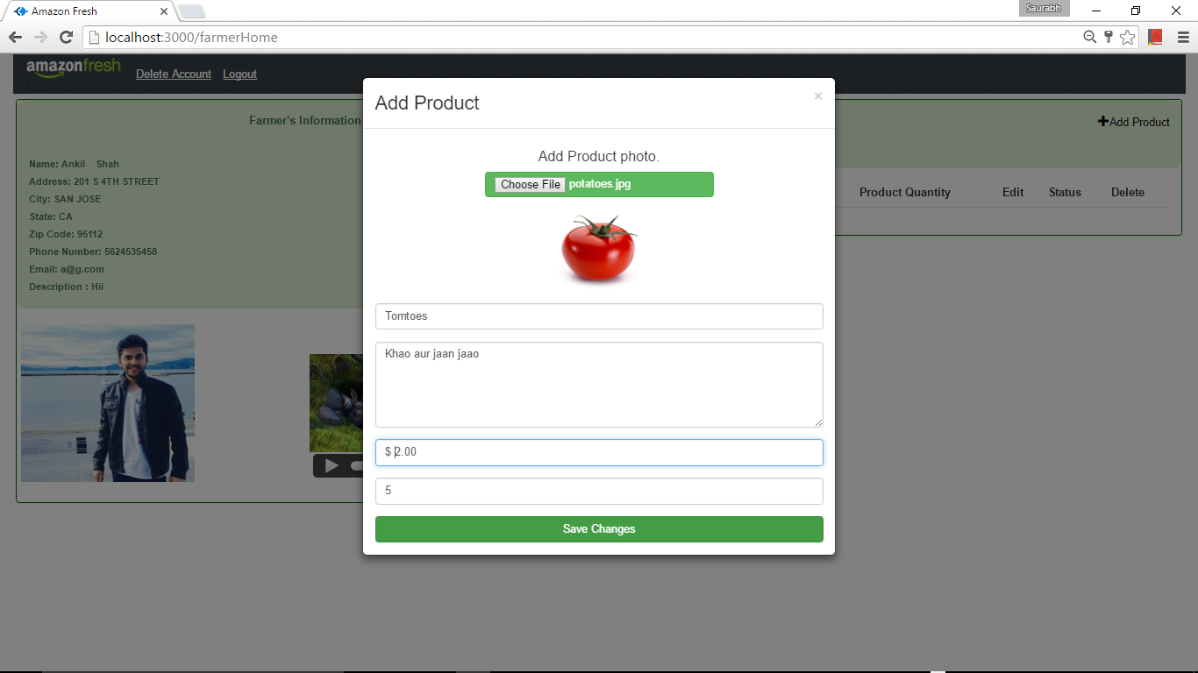

1. I will be reflected in the home page and will be waiting for the admins approval to be able to be displayed in the Customers page.

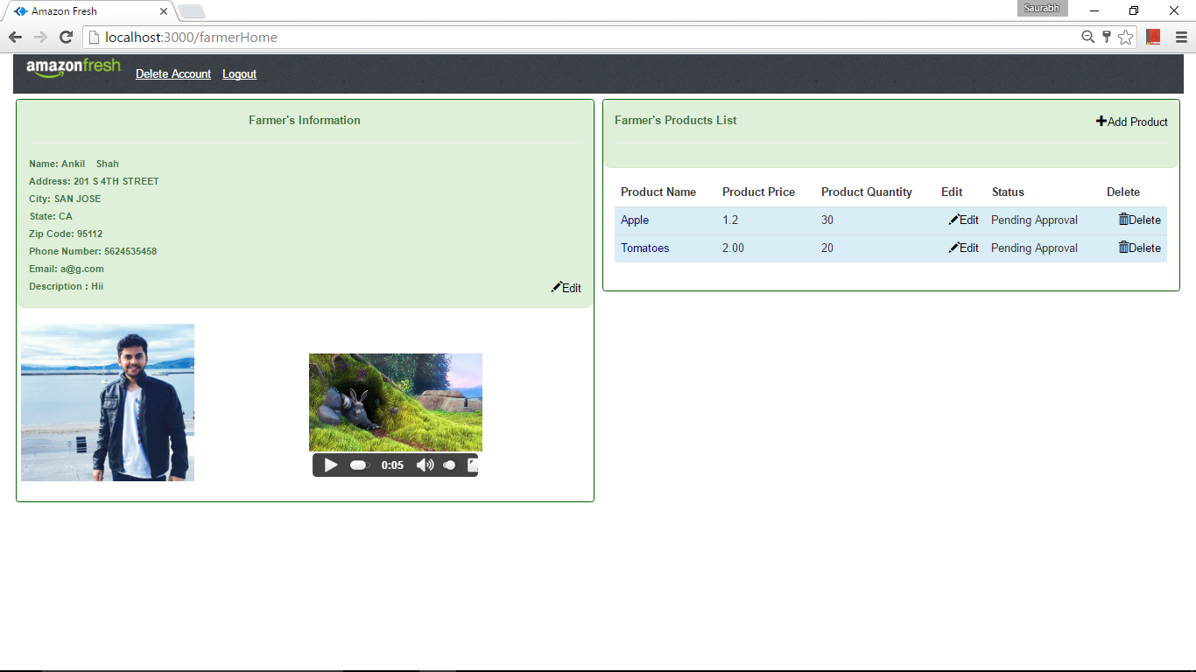

1. Edit the product details:

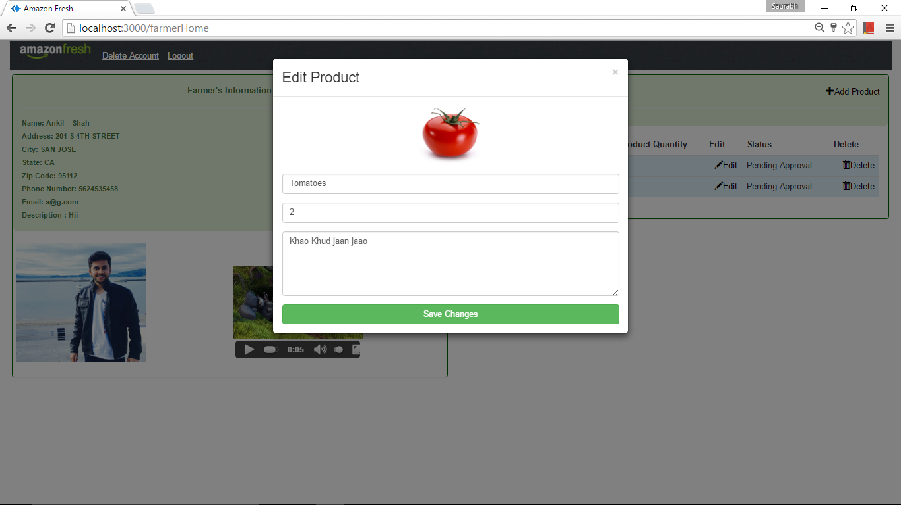

1. Delete a Product: Once the product is deleted it is shown in the history but gets deleted as shown below

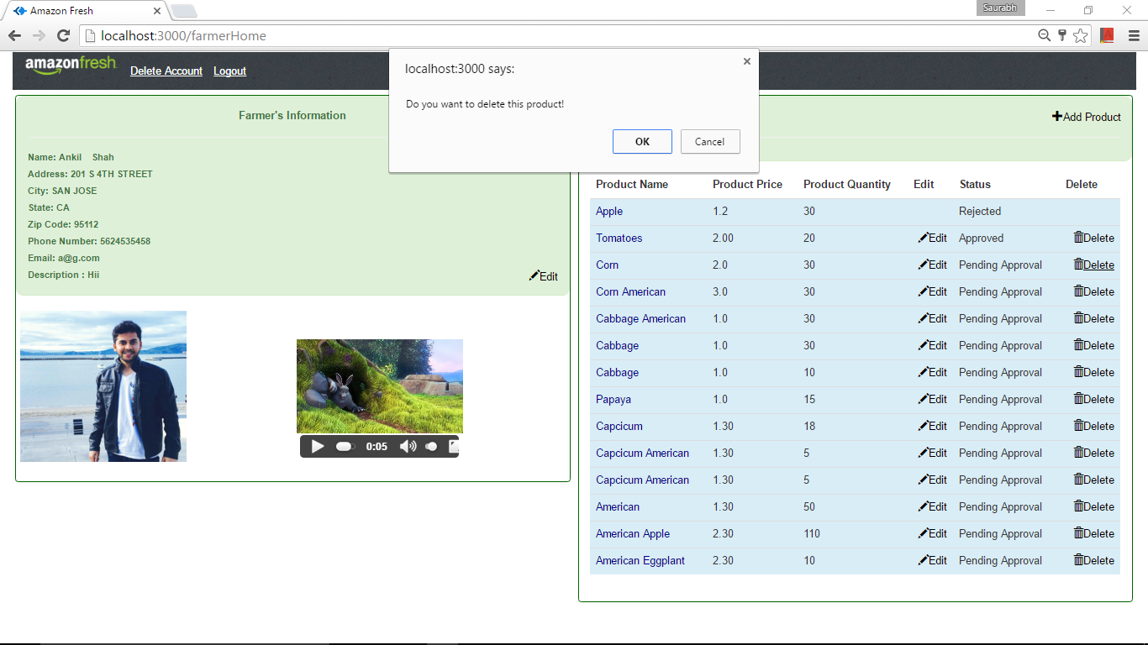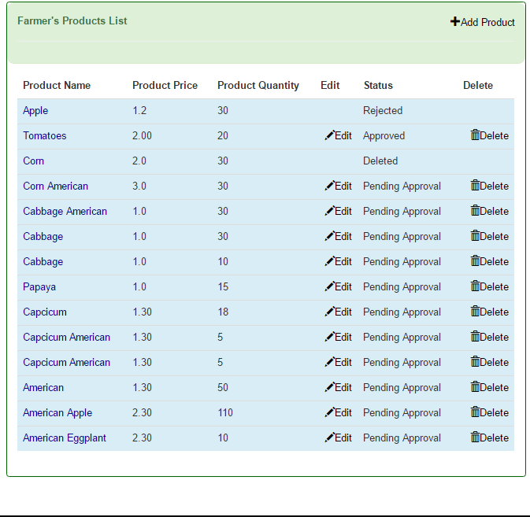

1. Adding multiple products :

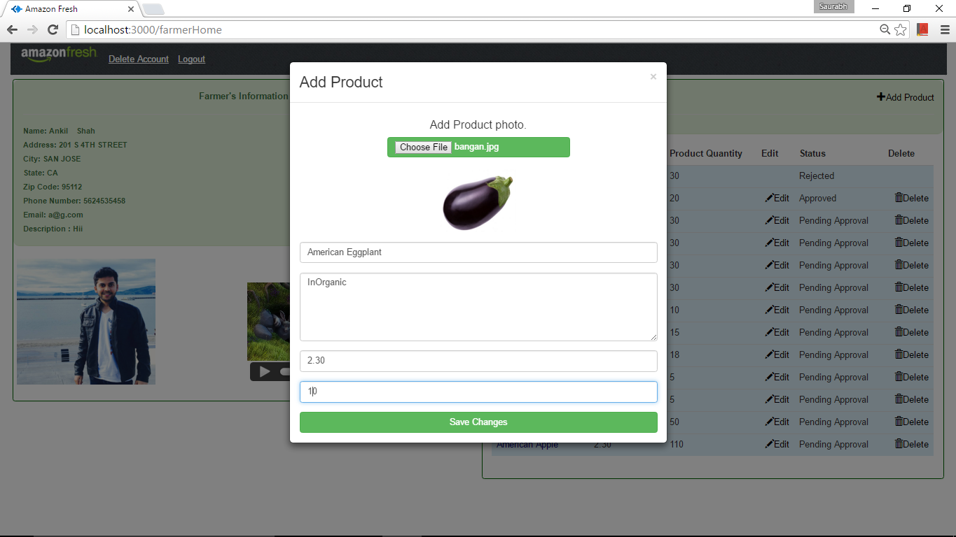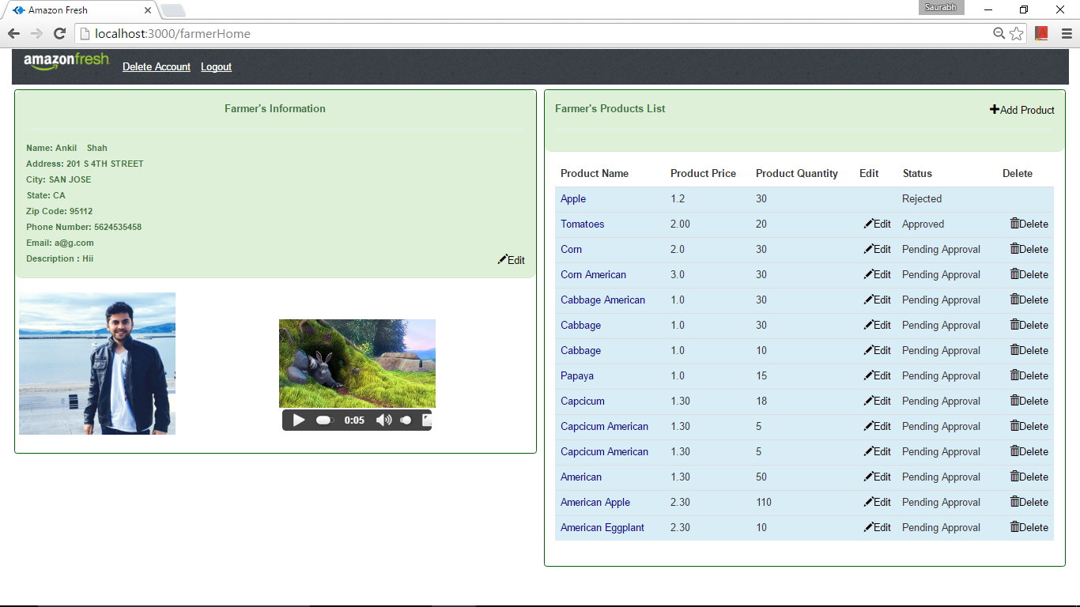

* Customer

1. Sign Up:

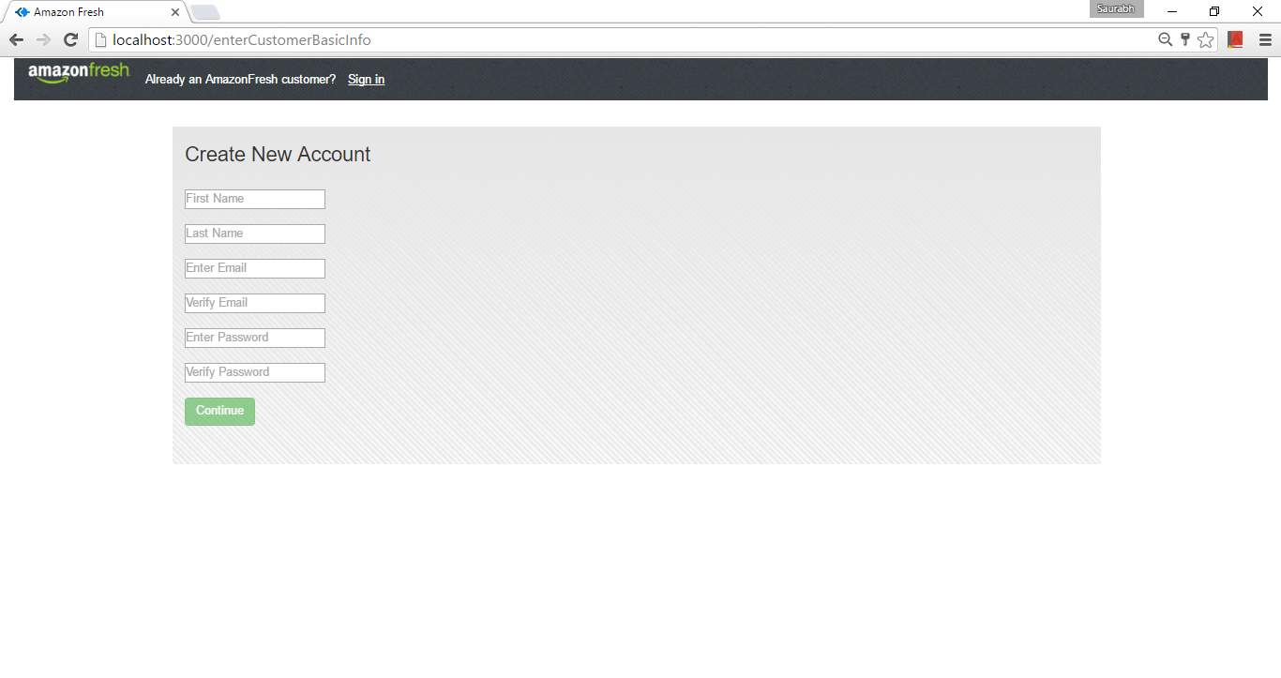

1. Enter Address

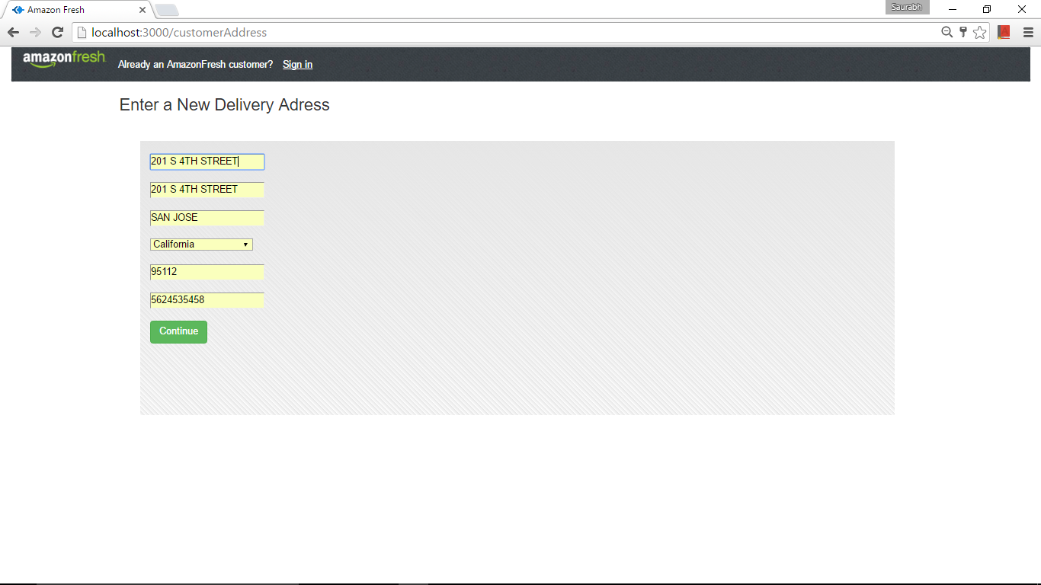

1. Enter Card Details: Validations are done according.

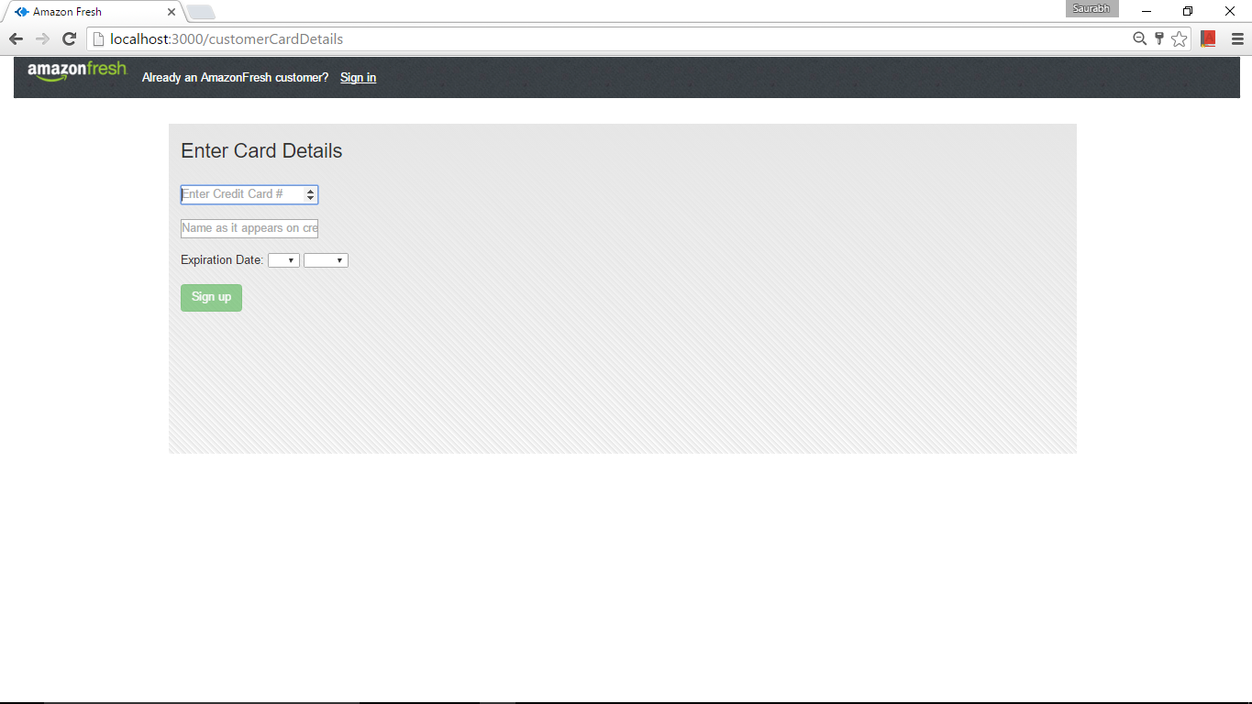

1. Sent request for approval



1. Pending Approval Validation:

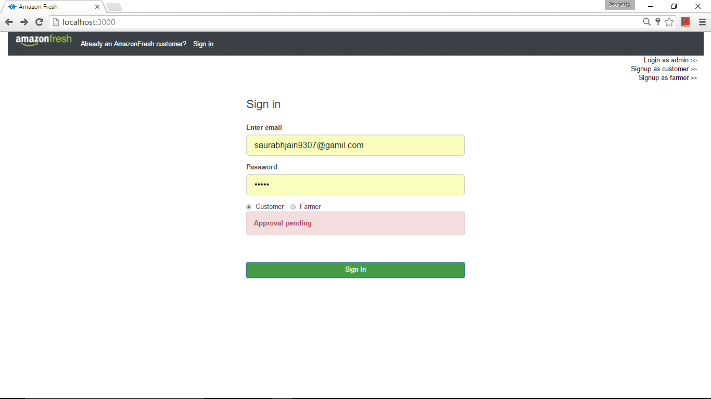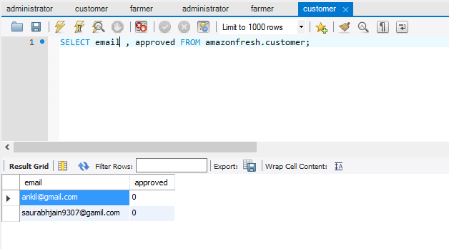

1. Invalid User Validations:

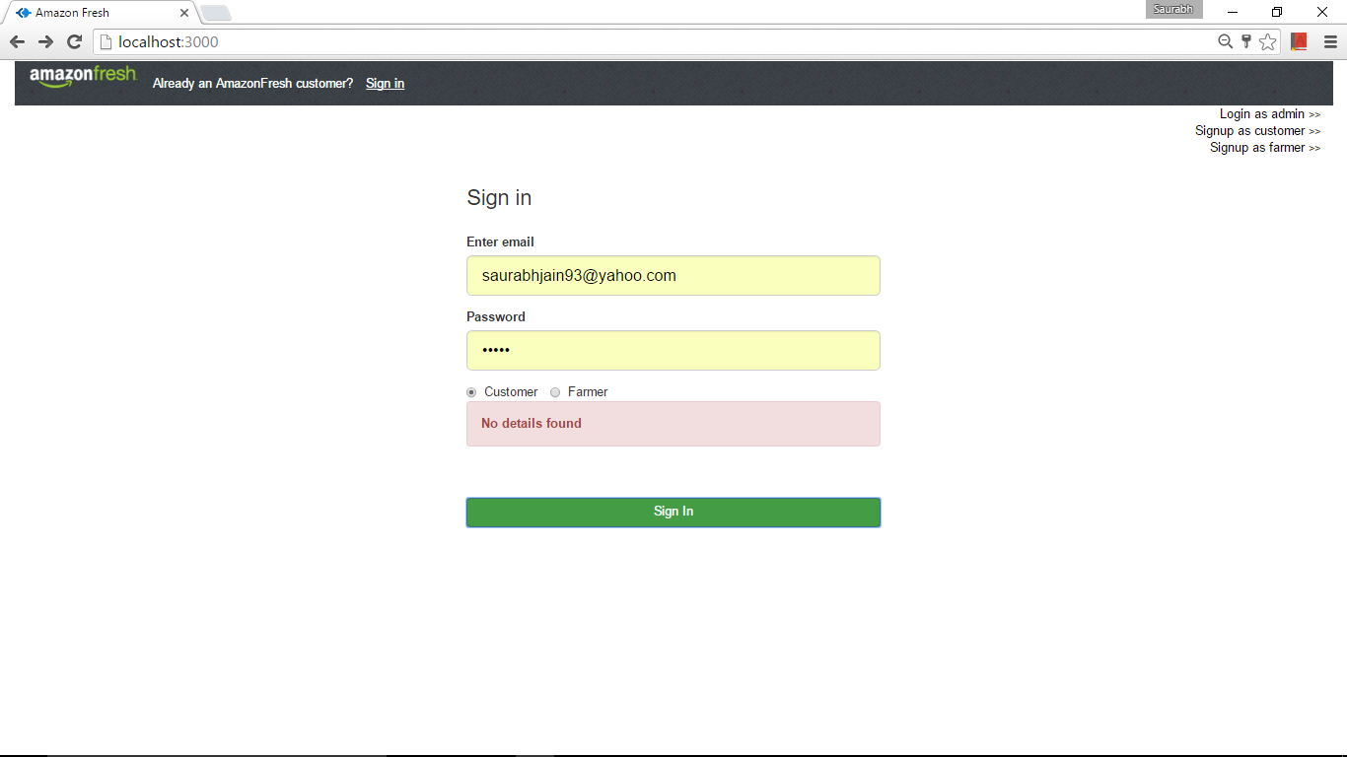

1. Reject request message:



1. Sign In with the existing user to show the homepage. Initially nothing is selected in the cart

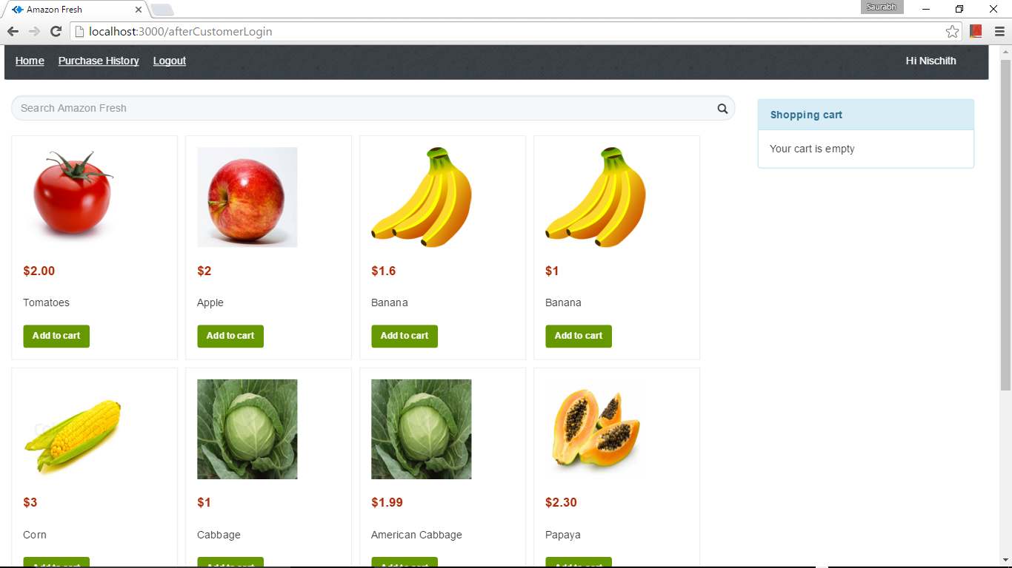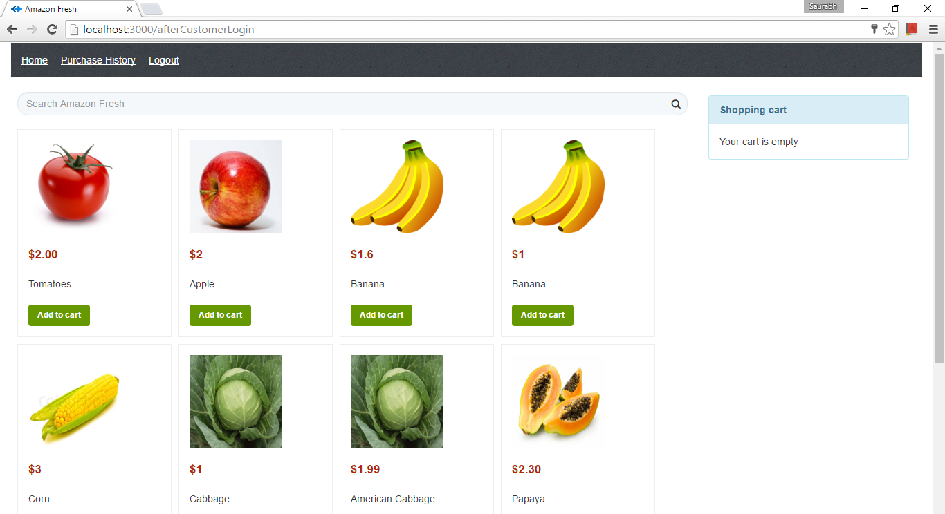

1. Select the items to the cart

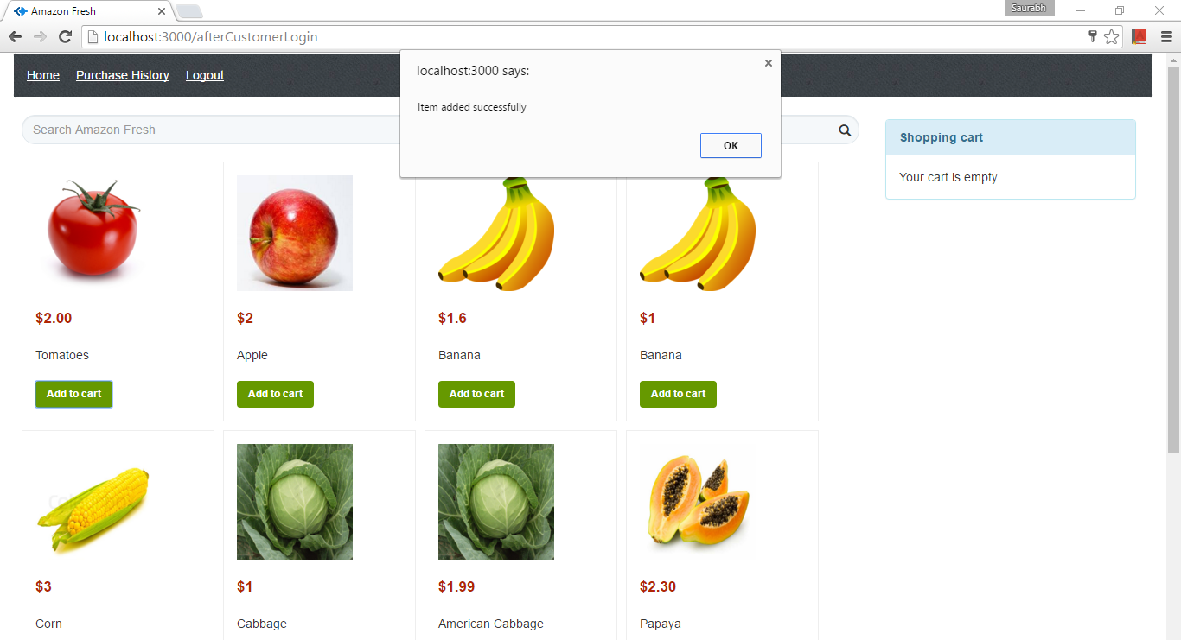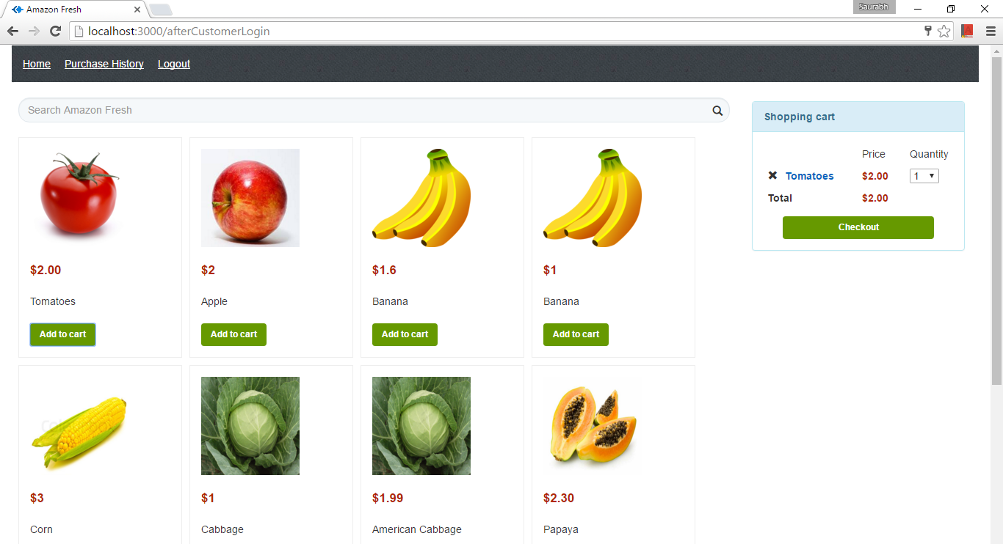

1. Add Multiple items

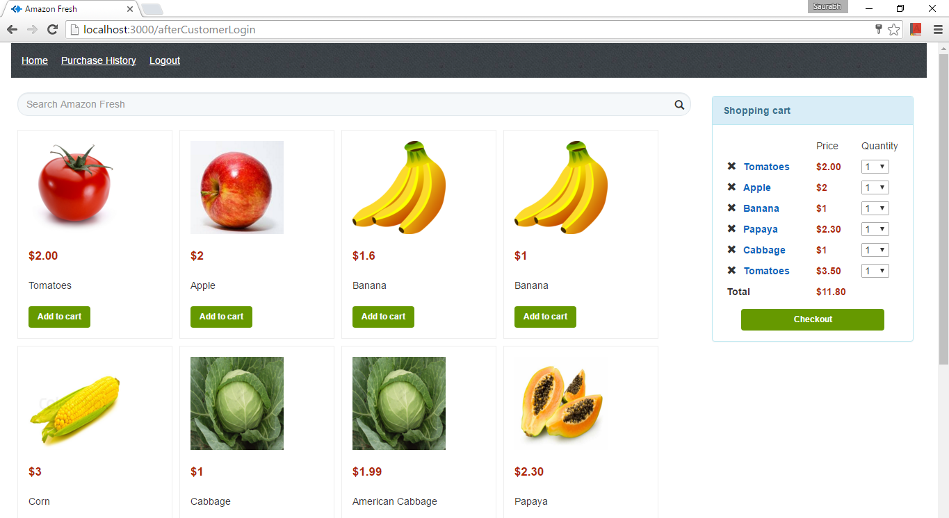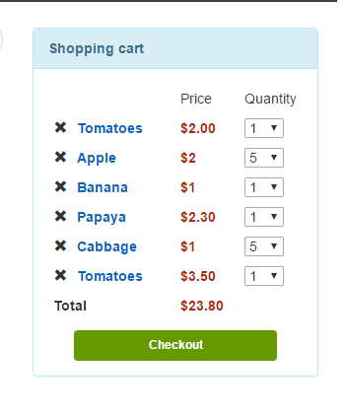

1. Search Products

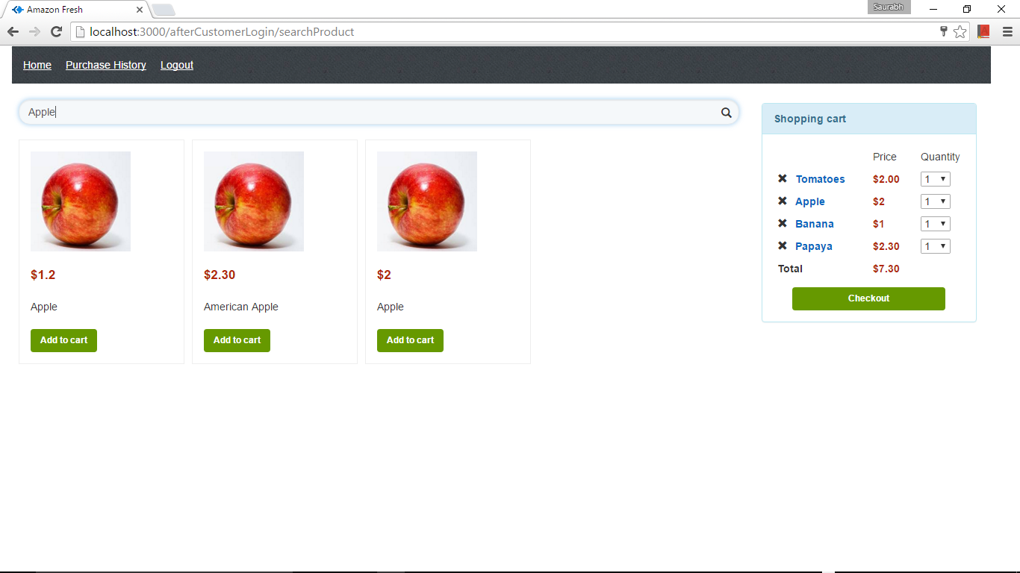

1. View Products

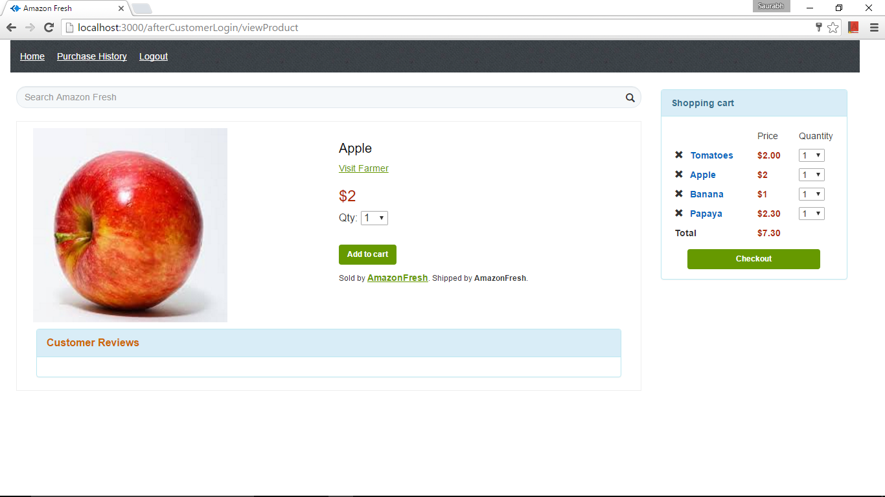

1. Proceed to checkout: Cash On Delivery

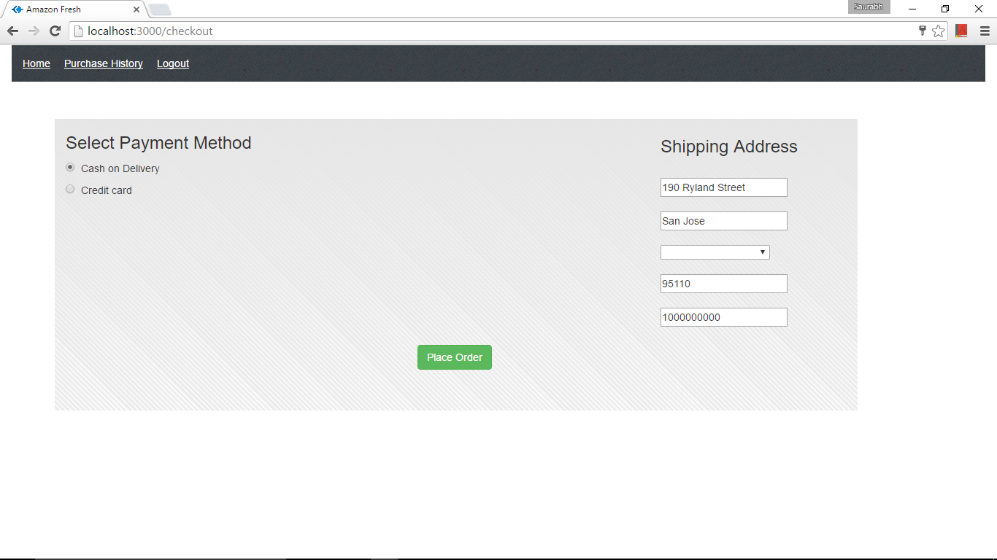

1. Proceed to Checkout : Credit card

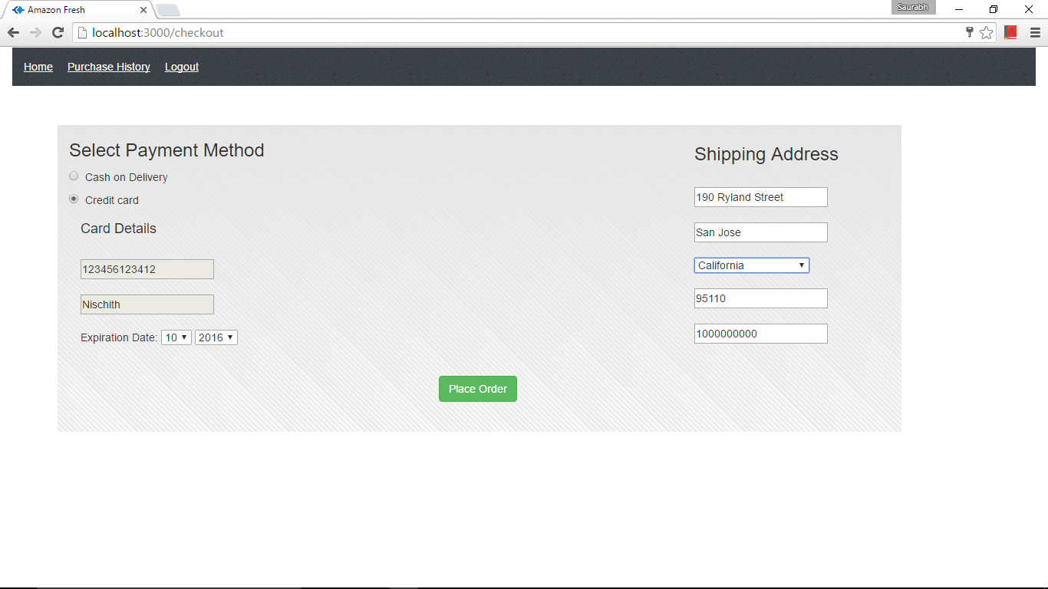

1. Payment Slip

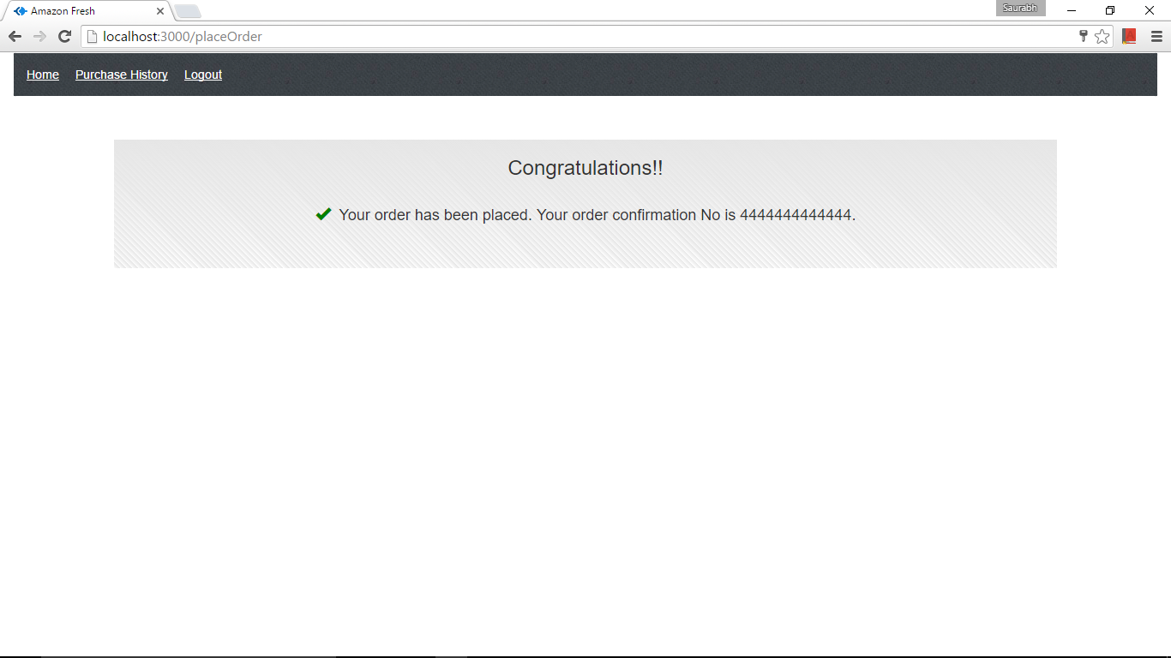

1. Purchase History

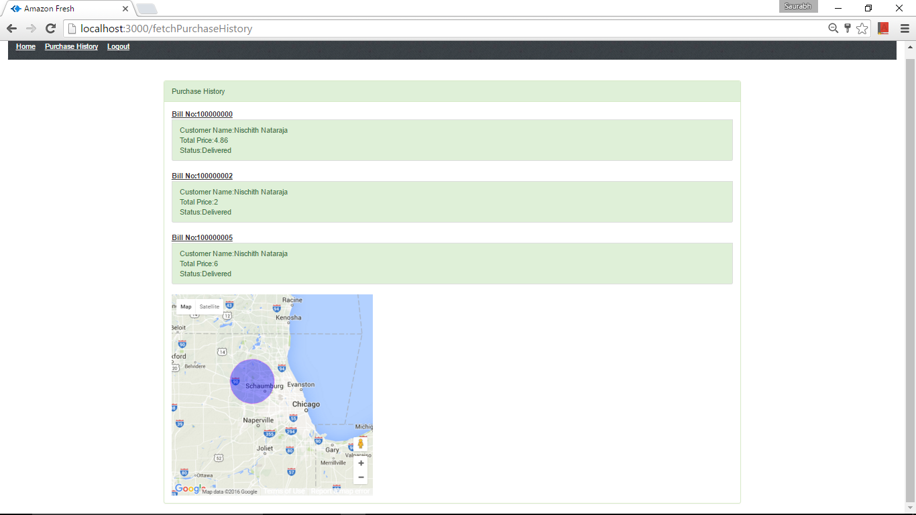

1. Bill

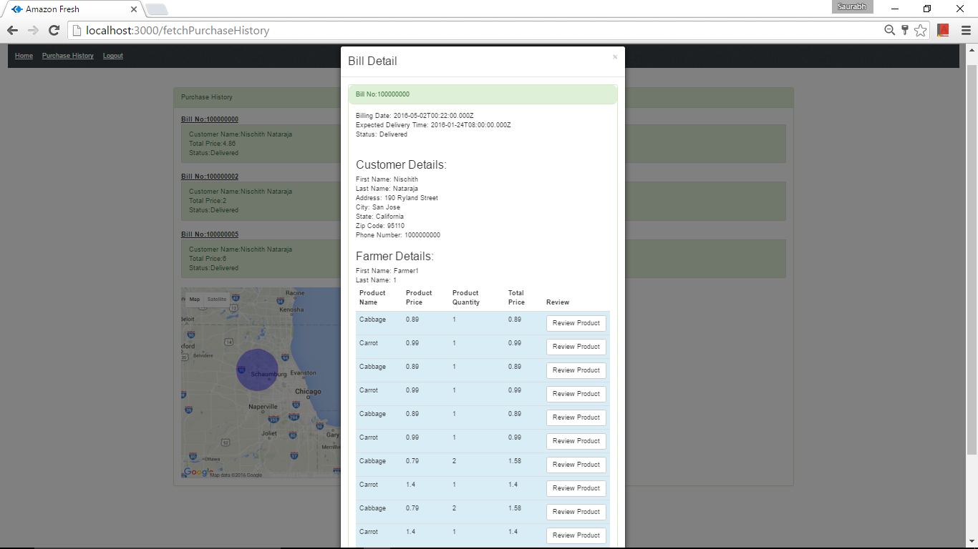

1. Review Products

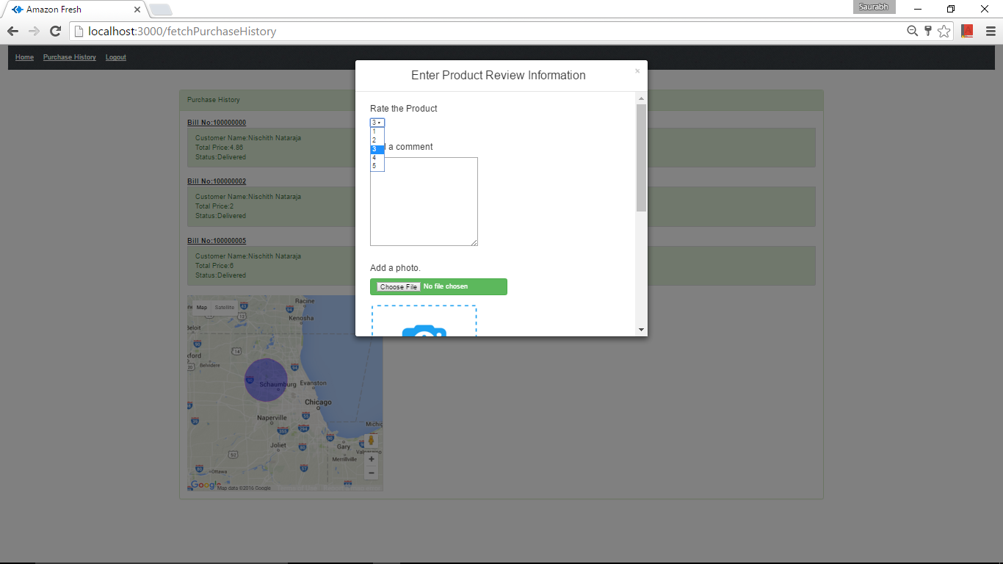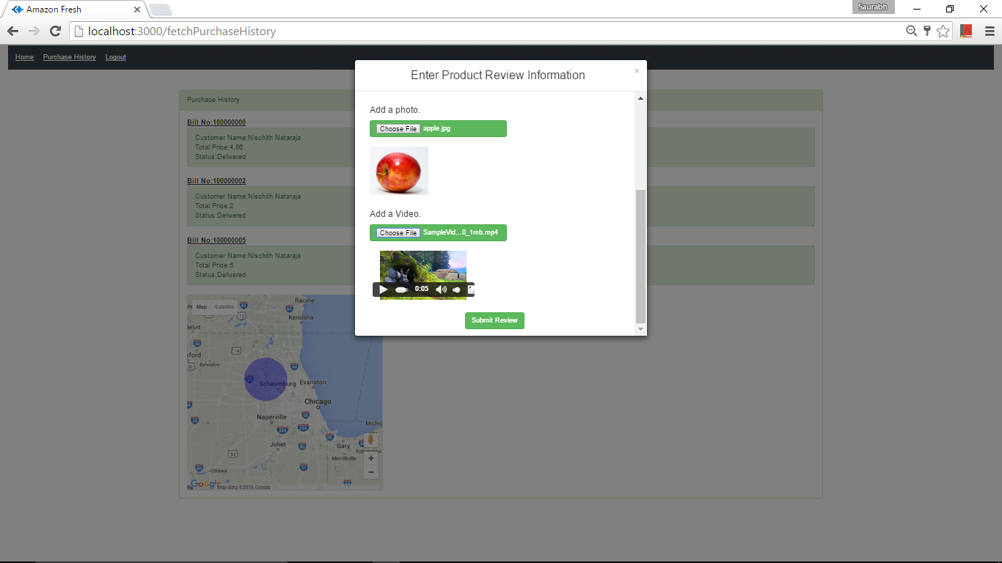

* Billing

1. The Bill details from the customers module.



1. Purchase History



1. The Bill Detail from the admin module based on different attributes.

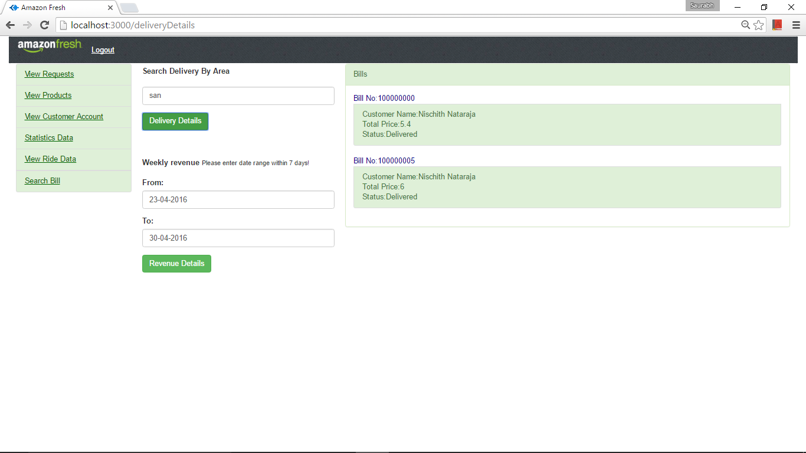

* Trip

1. Search Statistics by Driver ID



1. Search Statistics by Area



1. Search Statistics by Customer ID



1. Different view from the Google Maps







1. Show delivery by area



1. The bill can be viewed by clicking the Bill number.





1. Showing the Statistics by Date



* DB selection

1. MySQL

* ADMINISTRATOR

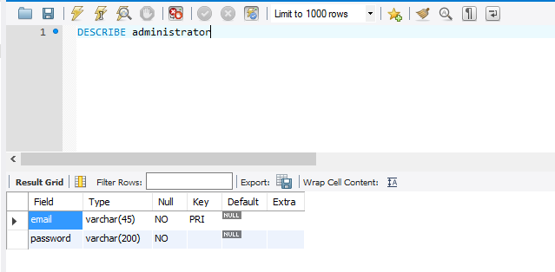

* BILLING

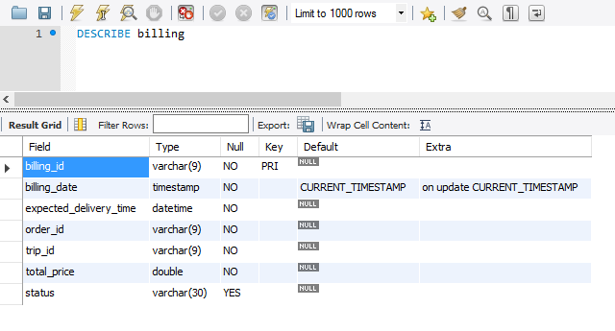

* BIILLING_ITEMS

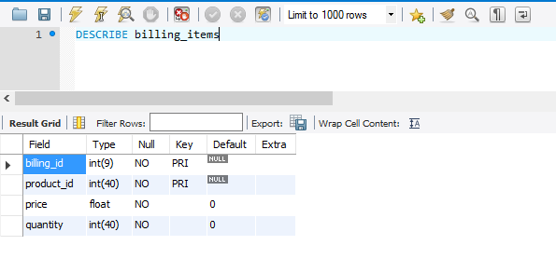

* CUSTOMER

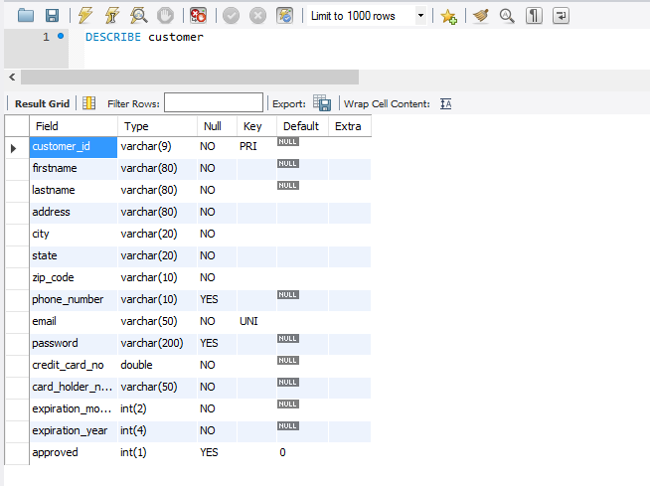

* DRIVER

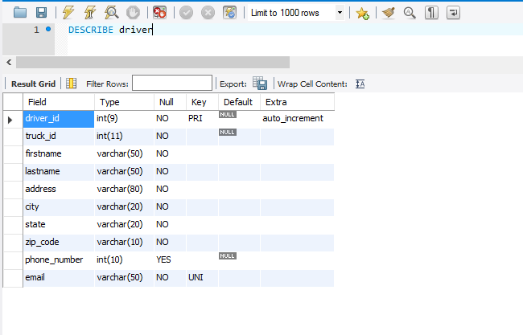

* FARMER

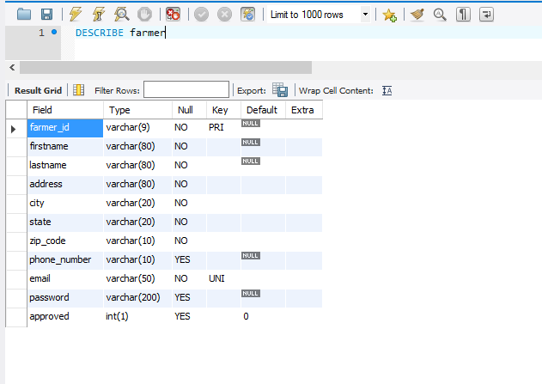

* ORDER

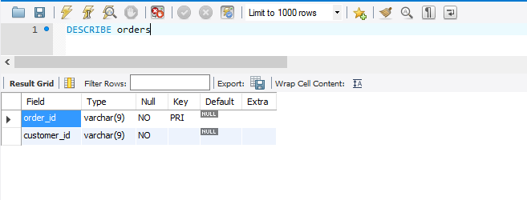

* PRODUCTS

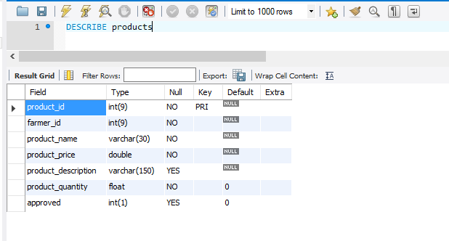

* TRIPS

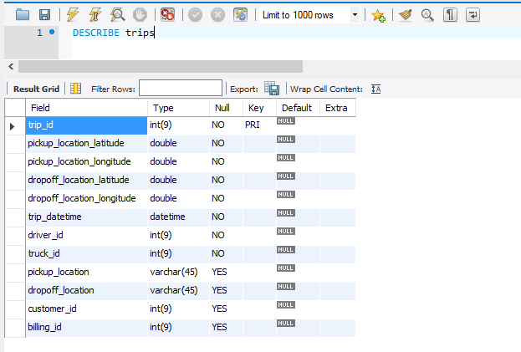

* TRUCKS

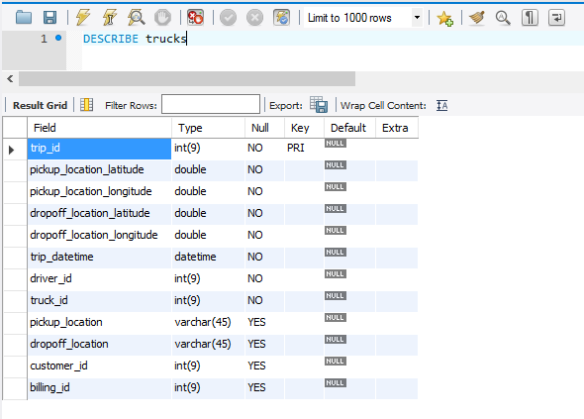

1. MongoDB

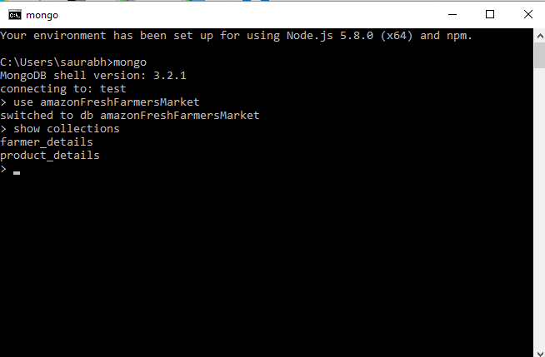

* Session Management

1. Express Sessions which will store data in mongo

exports.afterLogin = function(req,res)

{

console.log("---------------exports.afterLogin");

var email = req.param("email");

var password = req.param("password");

var category = req.param("category");

var msg_payload = {

"email" : email,

"password" : password,

"category" : category

};

mq_client.make_request('afterLogin_queue',msg_payload, function(err,results){

if(err){

throw err;

}

else

{

console.log("???????????????????????????????");

if(results.results.length >0)

{

if(category == "farmer"){

req.session.farmerId = results.results[0].farmer_id;

req.session.firstname = results.results[0].firstname;

req.session.lastname = results.results[0].lastname;

req.session.category = category;

res.send(results);

}

else if(category == "customer"){

req.session.customerId = results.results[0].customer_id;

req.session.firstname = results.results[0].firstname;

req.session.lastname = results.results[0].lastname;

req.session.category = category;

res.send(results);

}

}else{

var results ={

"statusCode" : 403,

"statusMessage" : "No details found"

};

res.send(results);

}

}

});

}

* Connection pooling

1. Mongo Connection Pooling

* Mongo.js

var MongoClient = require('mongodb').MongoClient;

var dbConnection;

var connected = false;

var optionvalues = {

db : {

numberOfRetries : 5

},

server : {

auto_reconnect : true,

poolSize : 400,

socketOptions : {

connectTimeoutMS : 500

}

},

replSet : {},

mongos : {}

};

var dbConnection;

function initiatePool(url, callback) {

MongoClient.connect(url, optionvalues, function(err, db) {

if (err)

throw err;

dbConnection = db;

connected = true;

callback(dbConnection);

});

}

exports.connect = function(url, callback) {

if(!dbConnection){

initiatePool(url, callback)

}

else{

callback(dbConnection);

}

};

exports.collection = function(name) {

if (!connected) {

throw new Error('Must connect to Mongo before calling "collection"');

}

return dbConnection.collection(name);

};

1. MySQL Connection Pooling

* Mysql.js

var mysql = require('mysql');

var listOfConnections = require("collections/list")

var connectionPool;

function getConnection(){

var connection = mysql.createConnection({

host : 'localhost',

user : 'root',

password : 'root',

database : 'amazonfresh',

port : 3306

});

return connection;

}

exports.createConnectionPool = function(noOfConnections){

connectionPool = new listOfConnections();

for(var i=0;i<noOfConnections;i++){

connectionPool.push(getConnection());

}

};

var getConnectionFromConnectionPool = function (){

if(connectionPool.length == 0){

return getConnection();

}else{

return connectionPool.pop();

}

};

releaseConnection = function(connection){

connectionPool.push(connection);

};

exports.fetchData = function(callback,sqlQuery){

var connection=getConnectionFromConnectionPool();

connection.query(sqlQuery, function(err, rows, fields) {

if(err){

console.log("ERROR: " + err.message);

}

callback(err, rows);

});

releaseConnection(connection);

};

* RabbitMQ

1. Login.js – Client

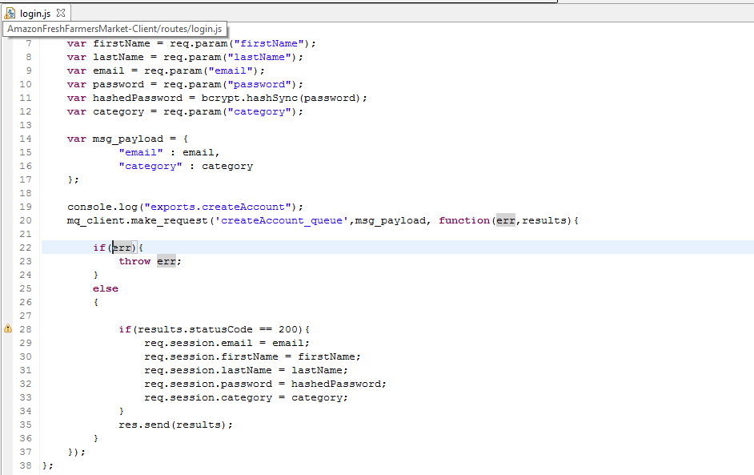

1. Server.js – Back End

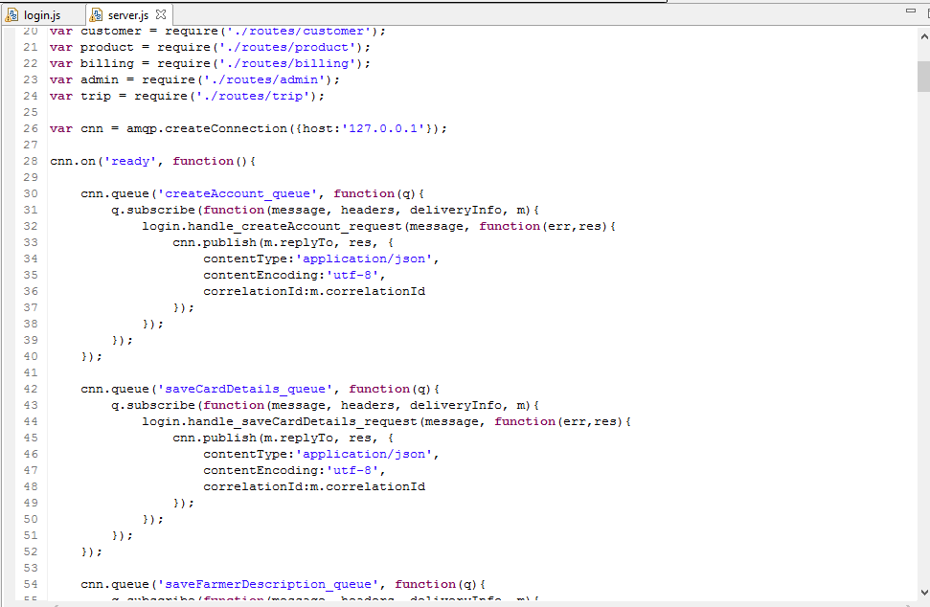

1. Login.js – Back End

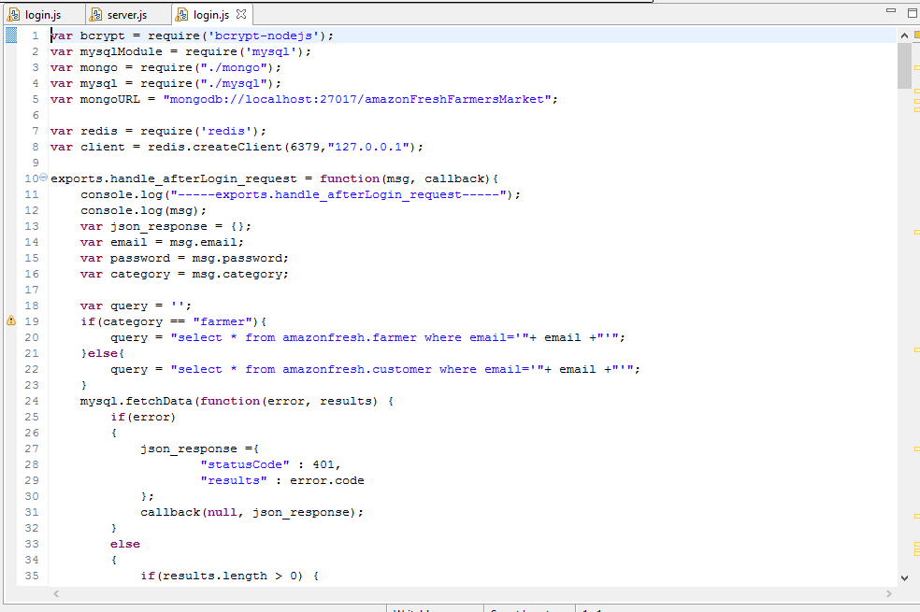

The same

* REDIS

Getting data from redis using search key

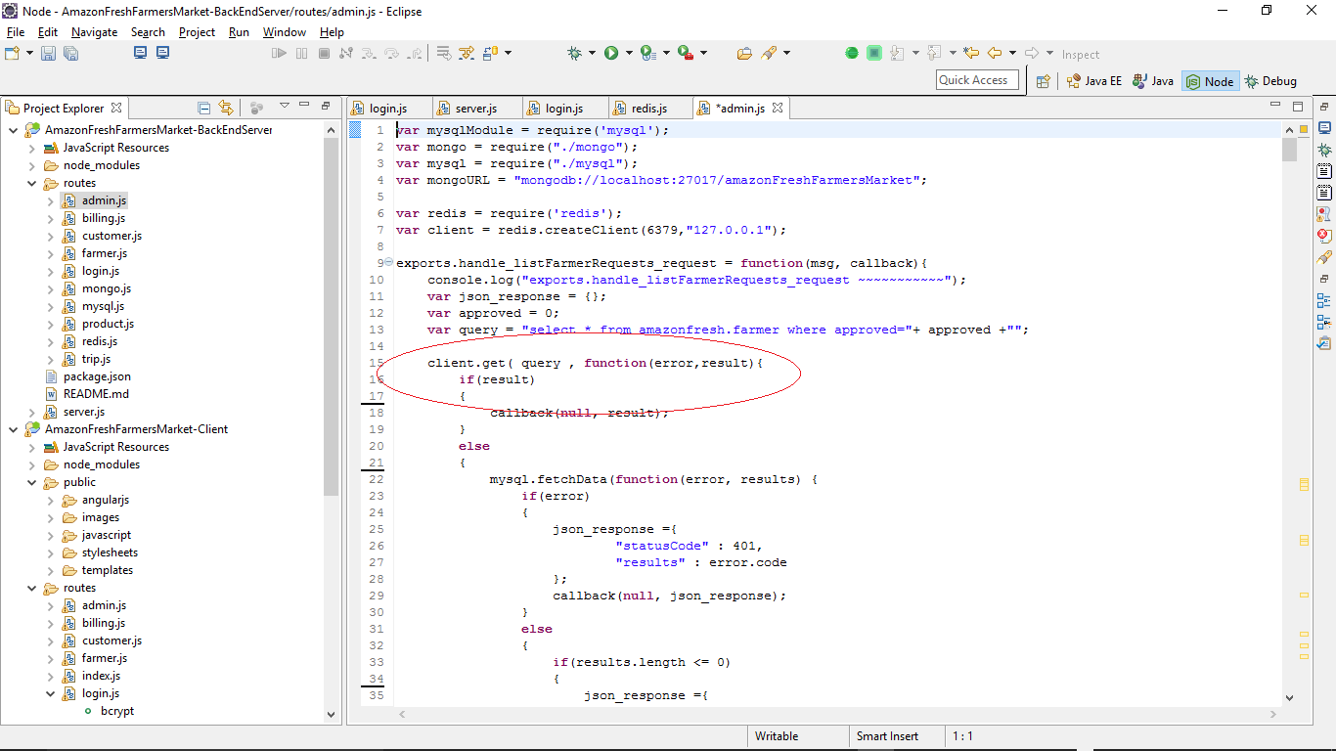

Setting data into redis id the search key is not present

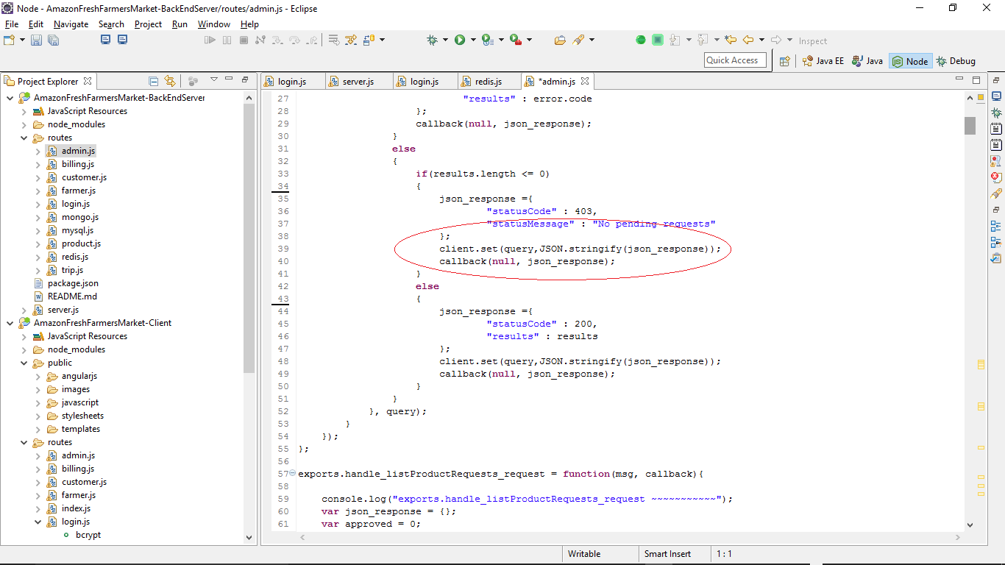

The saved keys can be viewed in redis-client using the command keys *

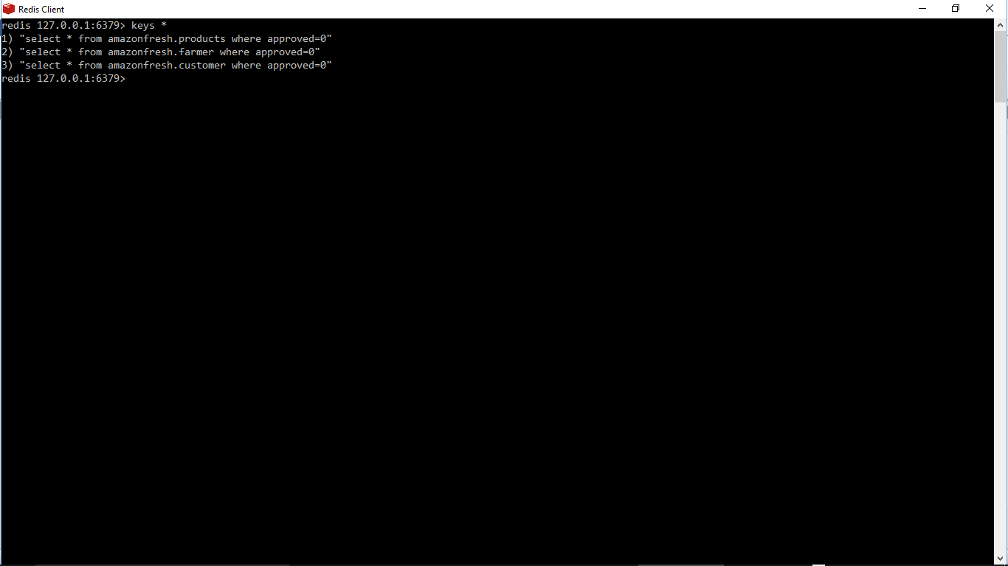

Deleting search key when data id inserted or updated

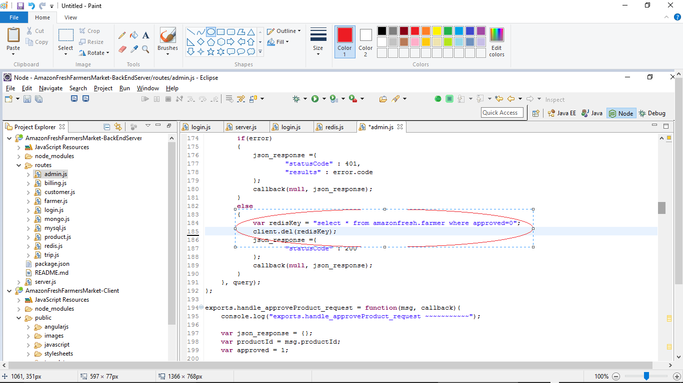

* Passportjs

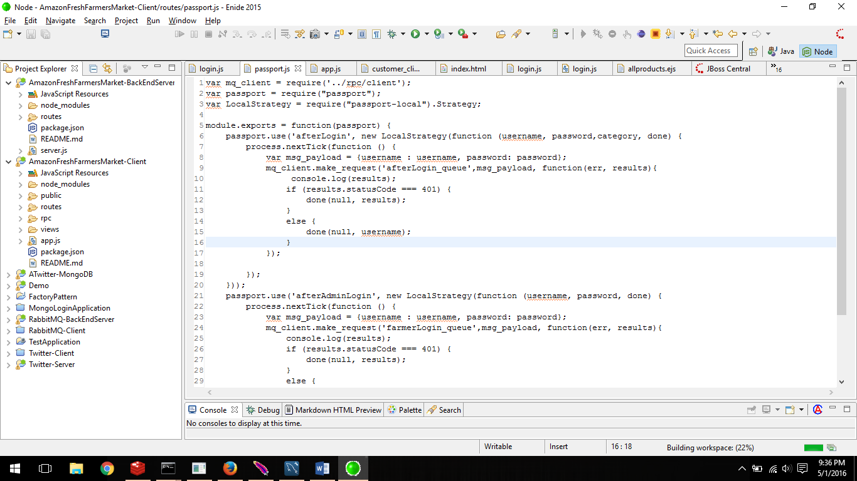

* Dynamic Pricing Algorithm

We have taken two factors into the account while developing the Dynamic Pricing Algorithm.

1) Time of the day

2) Customer purchase history

We have developed application to fluctuate the product price according to rush hours at the particular time in the day and customer will be presented with the different product prices during different intervals of the day. We have also configured product price according to the customer purchase history which means the customer will be provided the discount if number of items he/she purchased will be more than threshold provided.

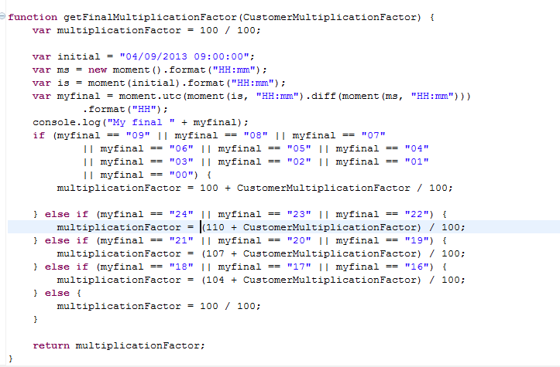

* Scalability

The application has been made scalable with the help of RabbitMQ to handle multiple concurrent users. It is possible because we have used different queues for different request.

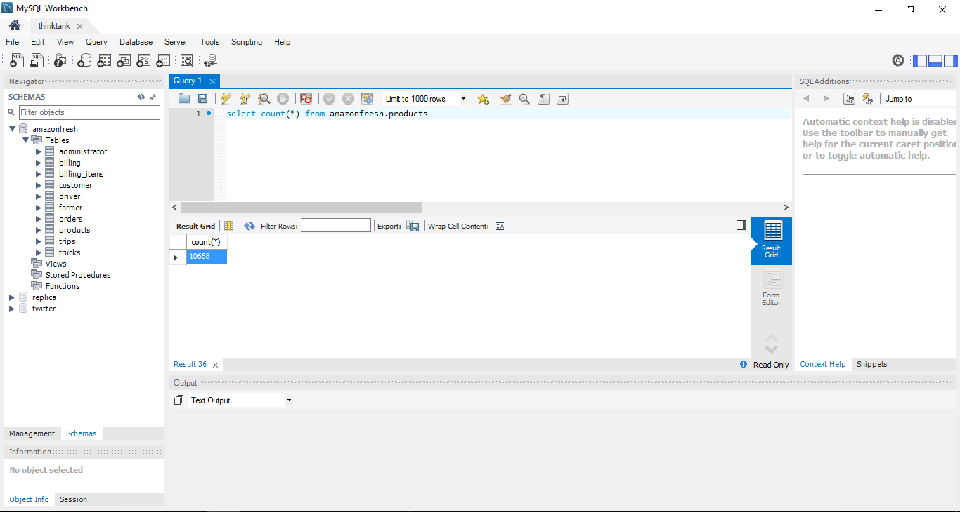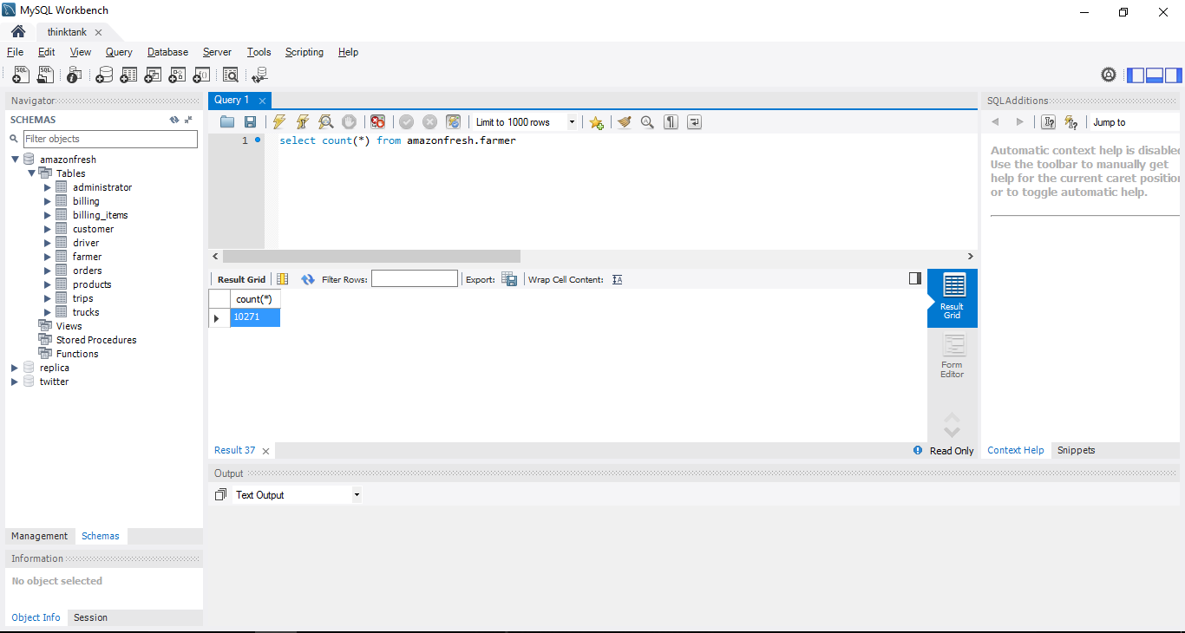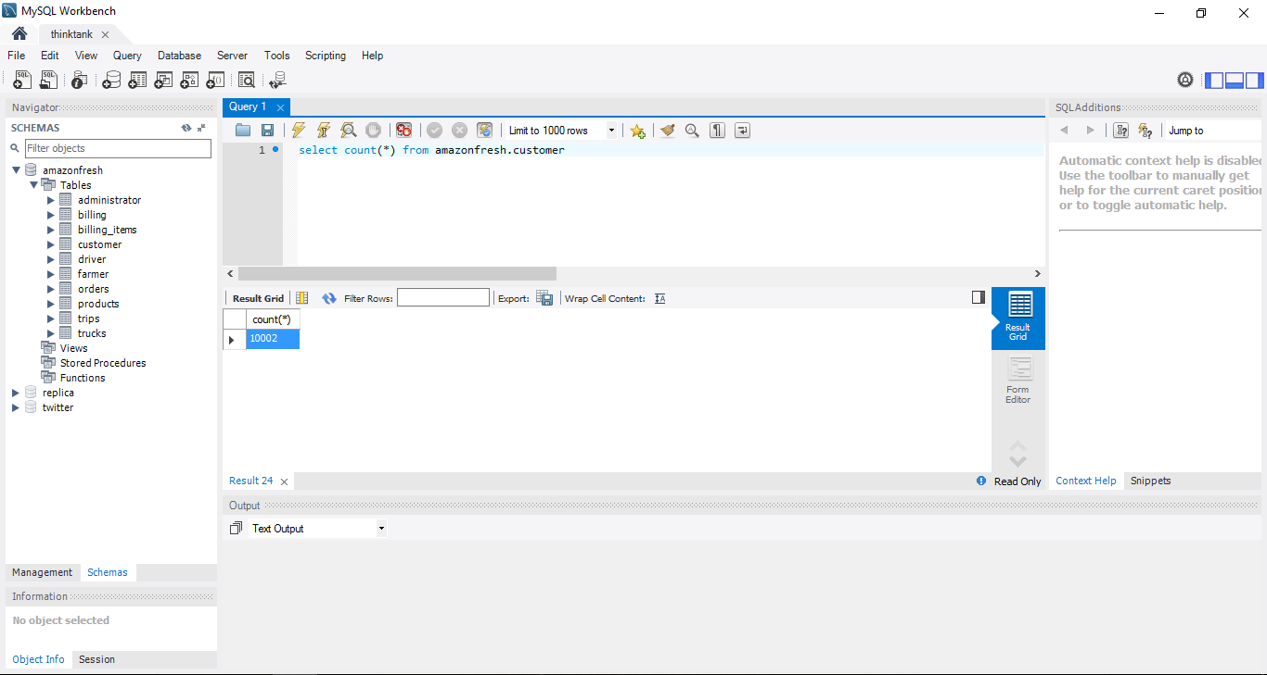

* Testing

1. Mocha Test Cases.

/**

* New node file

*/

var request = require('request')

, express = require('express')

,assert = require("assert")

,http = require("http");

describe('http tests', function(){

it('Test case for Editing Product Details By its Id', function(done) {

request.post(

'http://localhost:3000/amendProductDetails',

{ form: { productId: 12,productName:'Banana',productDescription:'Fruit',productPrice:12 } },

function (error, response, body) {

assert.equal(200, response.statusCode);

done();

}

);

});

it('Test case for list all products', function(done) {

request.get(

'http://localhost:3000/listAllProducts',

function (error, response, body) {

assert.equal(200, response.statusCode);

done();

}

);

});

it('Test for Getting Farmer Requests', function(done) {

request.get(

'http://localhost:3000/listFarmerRequests',

function (error, response, body) {

assert.equal(200, response.statusCode);

done();

}

);

});

it('Test for Getting Product Requests', function(done) {

request.get(

'http://localhost:3000/listProductRequests',

function (error, response, body) {

assert.equal(200, response.statusCode);

done();

}

);

});

it('Test Case for approving farmer', function(done) {

request.post(

'http://localhost:3000/approveFarmer',

{ form: { farmerId: 100000005 } },

function (error, response, body) {

assert.equal(200, response.statusCode);

done();

}

);

});

});

* Out Of Test Cases

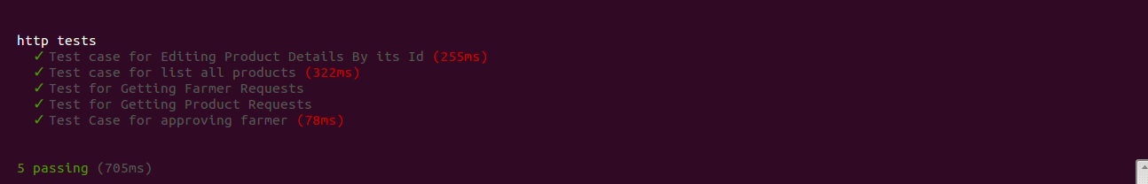

1. Jmeter Testing

**Base Application:**

* **100 concurrent users:**

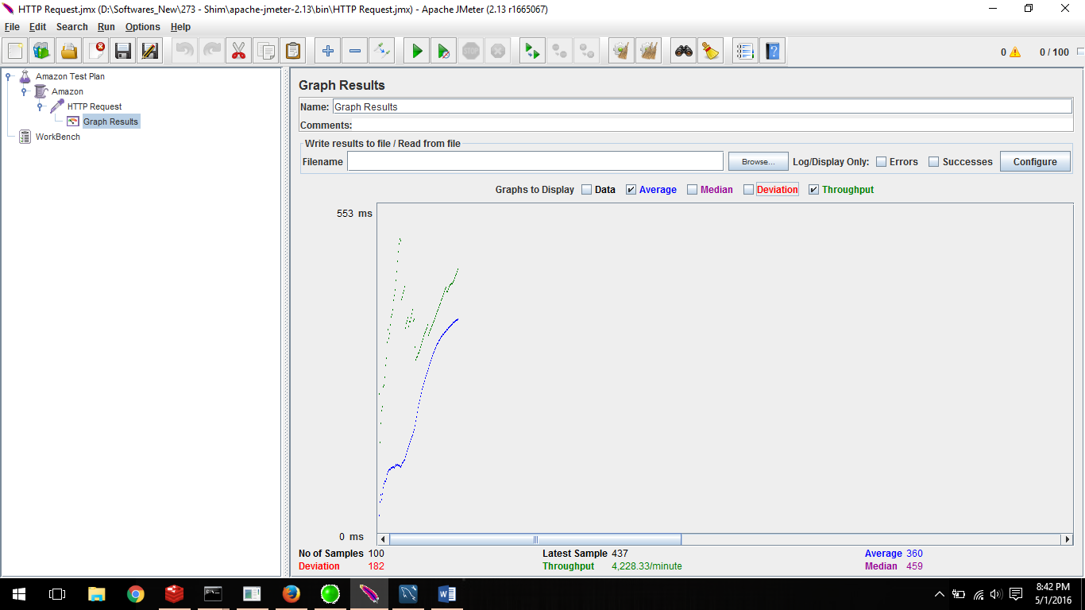

* **200 concurrent users:**

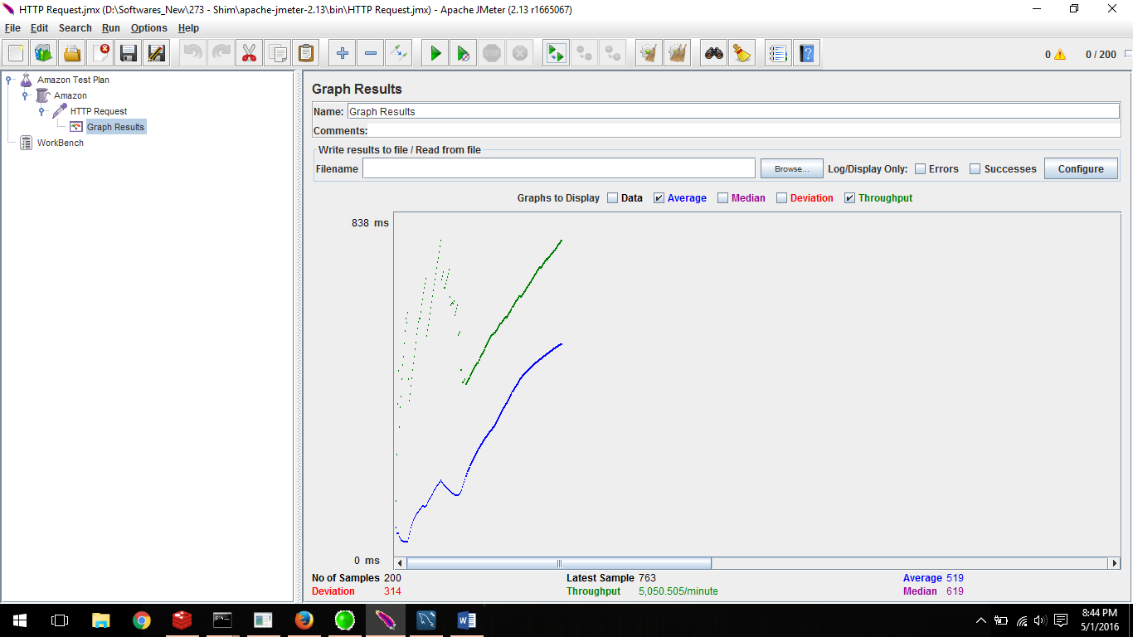

* **300 concurrent users:**

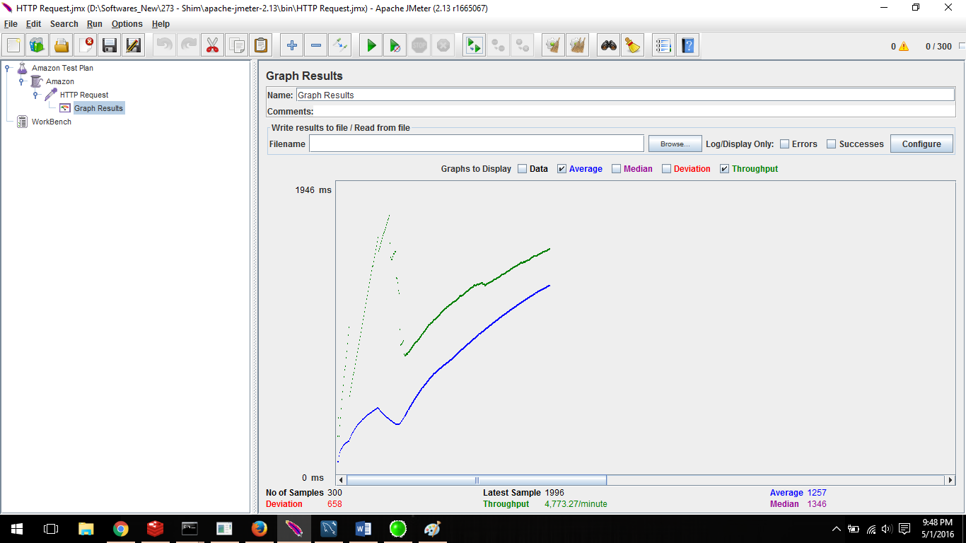

* **400 concurrent users:**

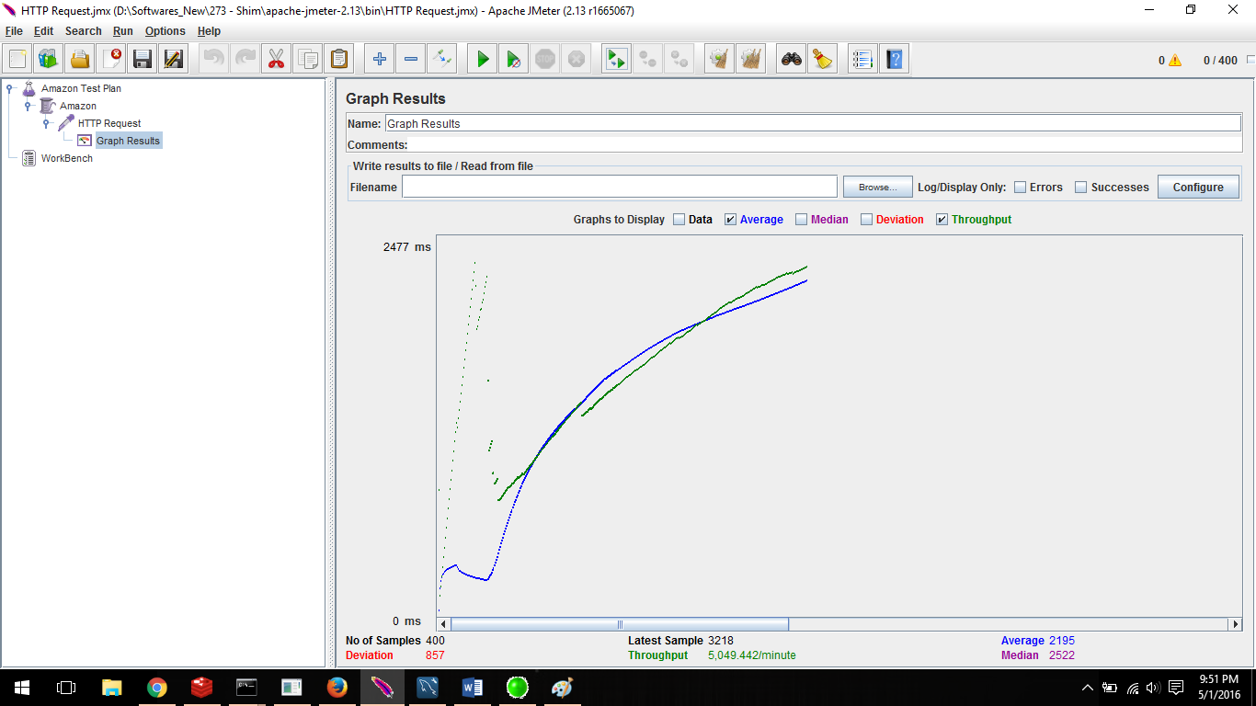

* **500 concurrent users**

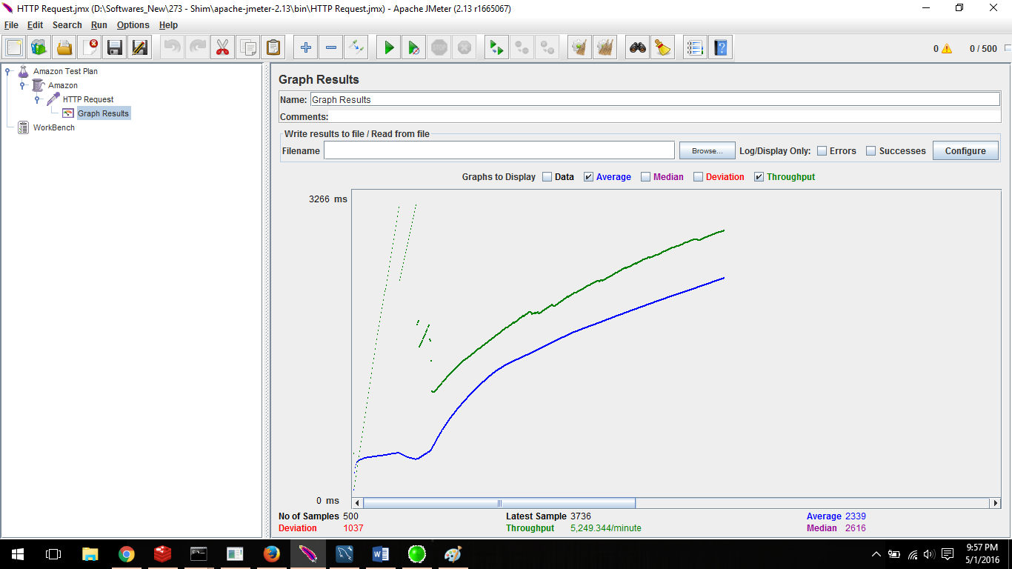

* **Application with Connection Pooling:**
* **100 concurrent users:**

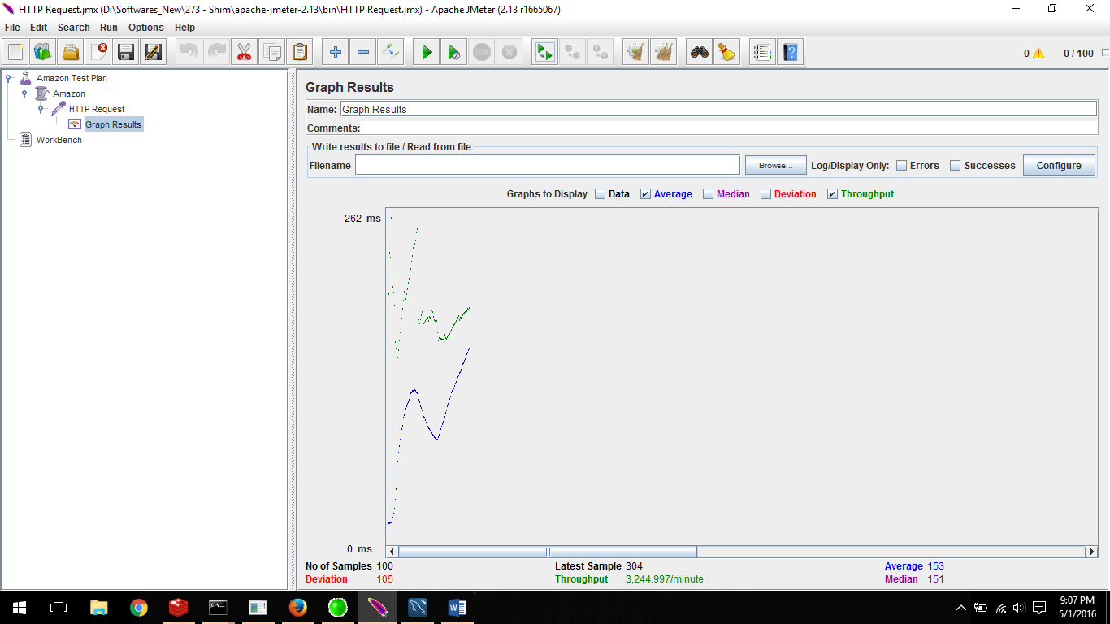

* **200 concurrent users:**

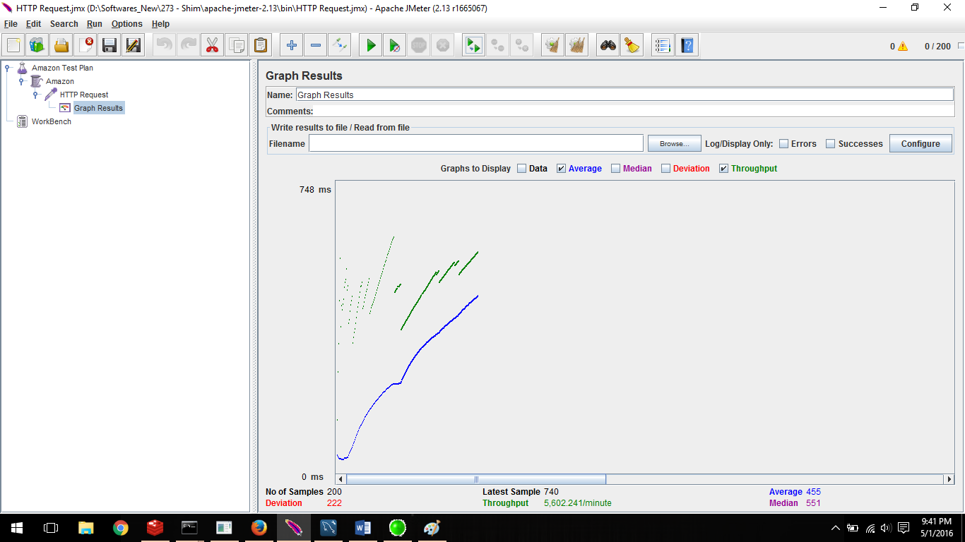

* **300 concurrent users:**

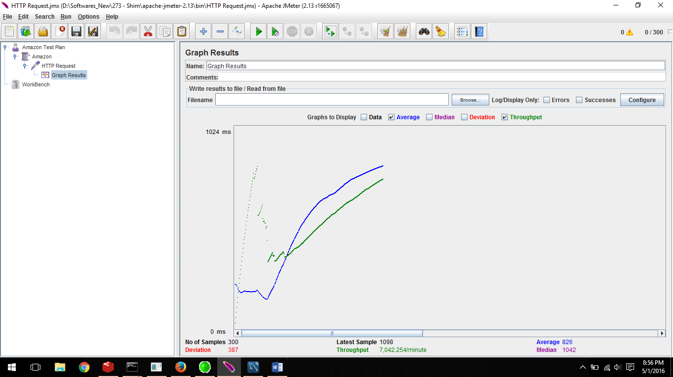

* **400 concurrent users:**

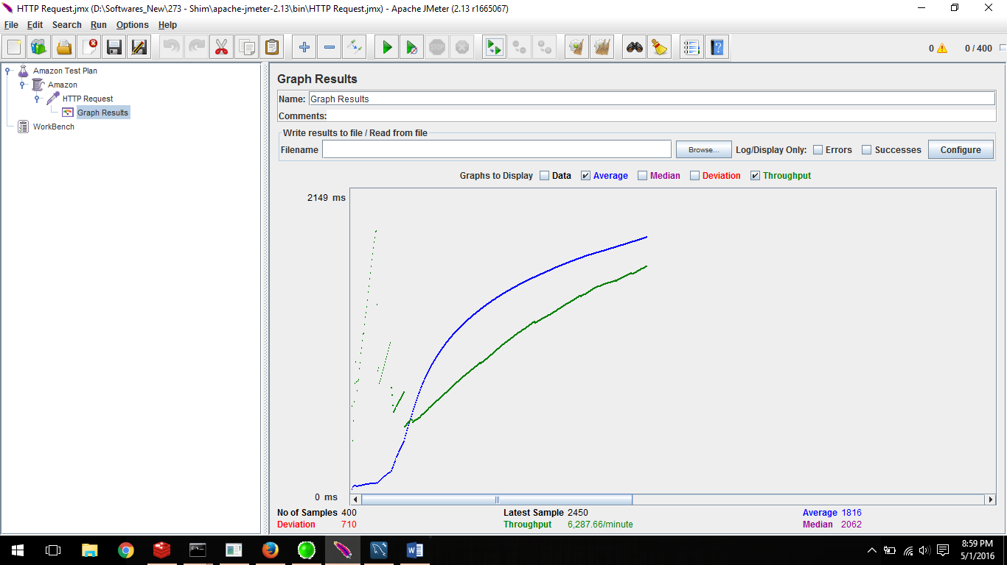

* **500 concurrent users:**

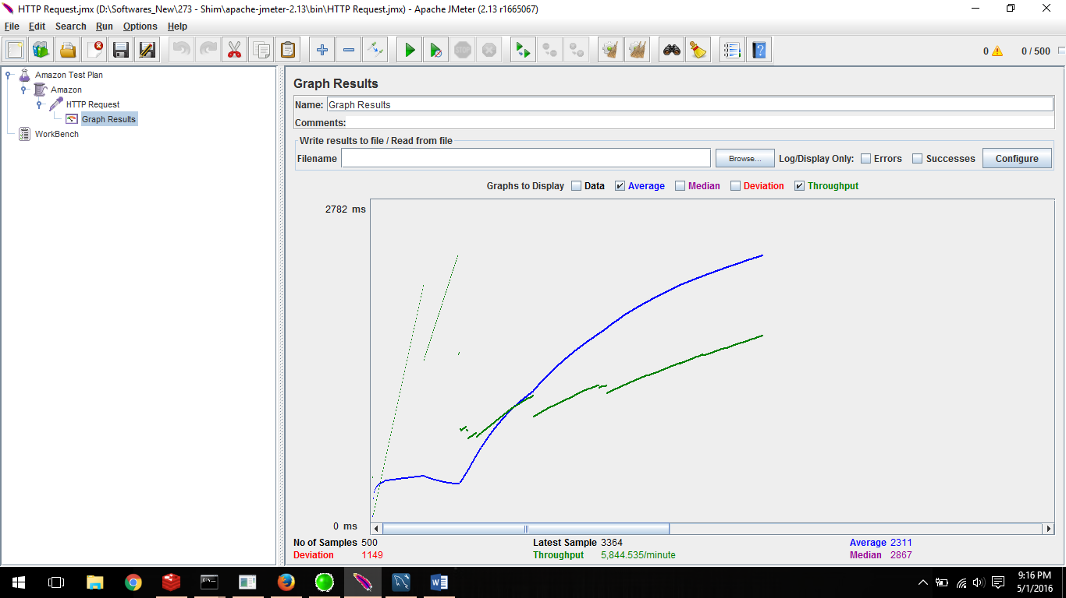

* **Application with RabbitMQ and without connection pooling:**
* **100 concurrent users:**

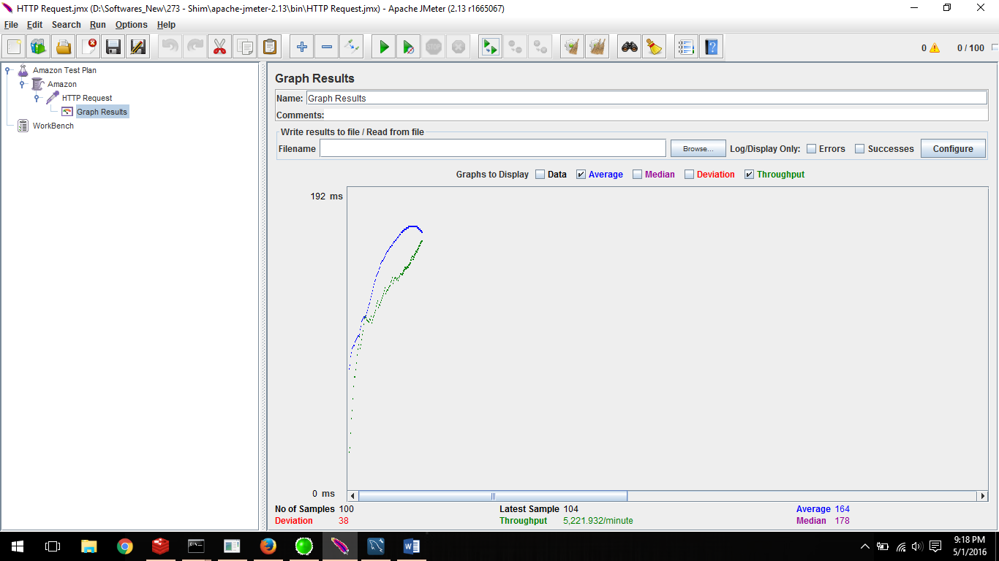

* **200 concurrent users:**

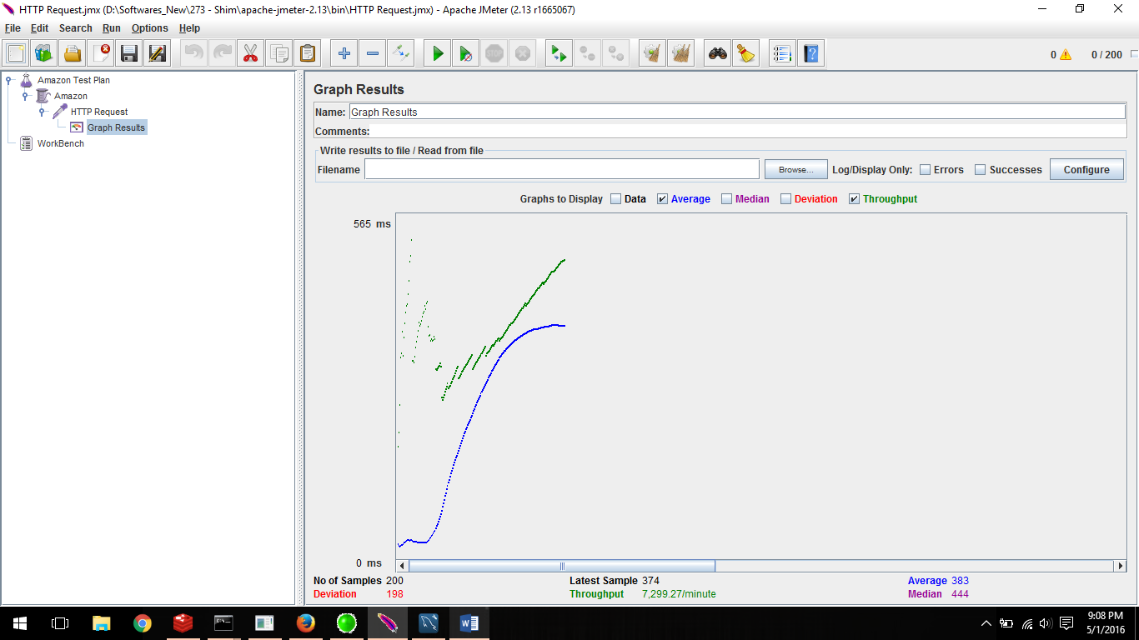

* **300 concurrent users:**

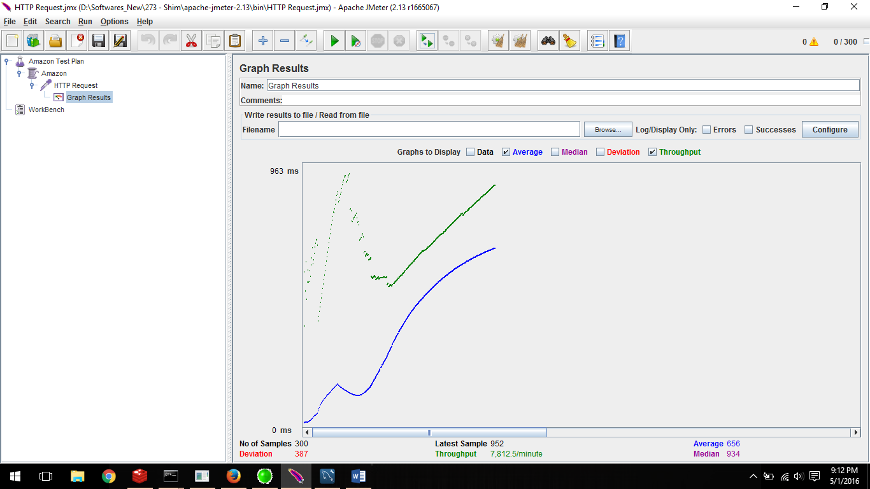

* **400 concurrent users:**

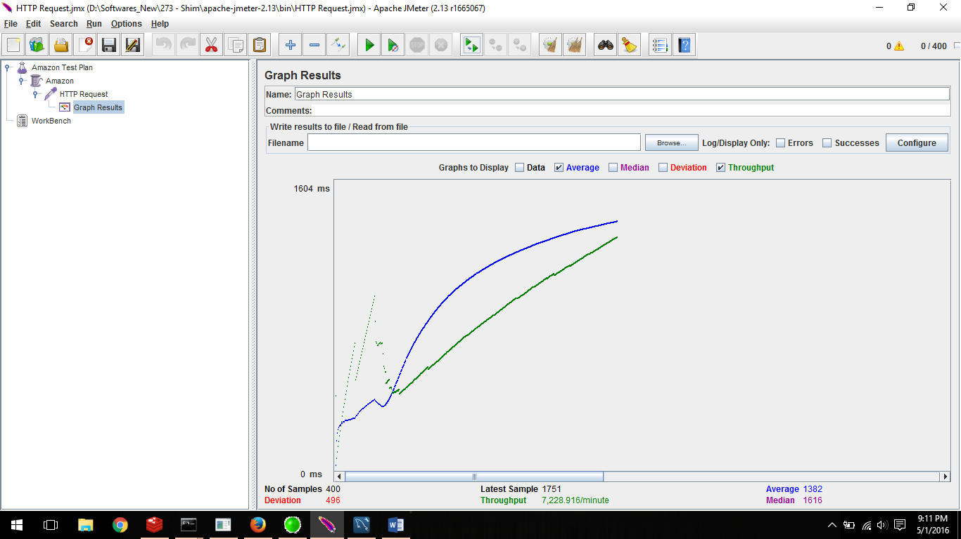

* **500 concurrent users:**

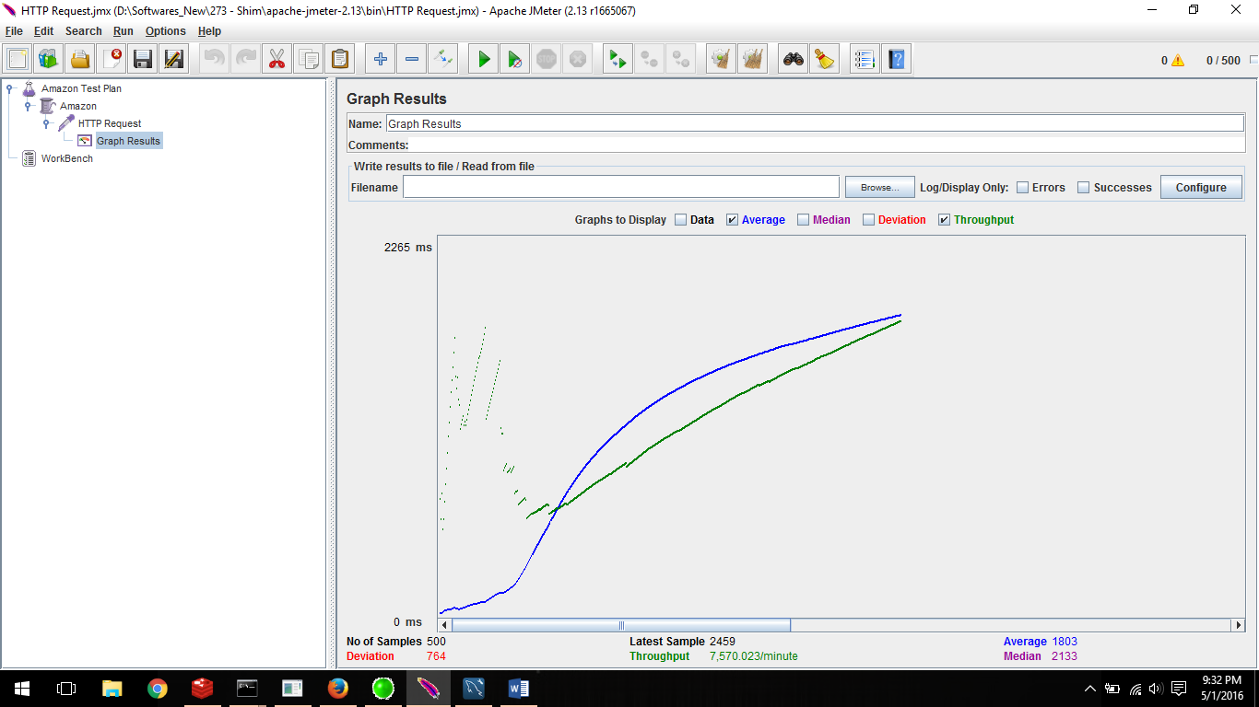

* **Application with RabbitMQ and Connection Pooling:**
* **100 concurrent users:**

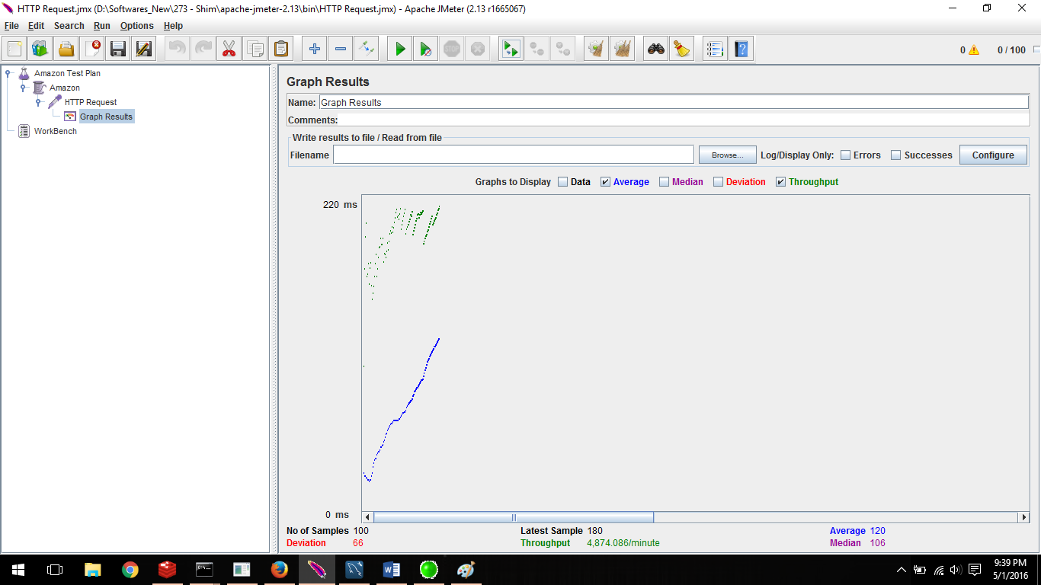

* **200 concurrent users:**

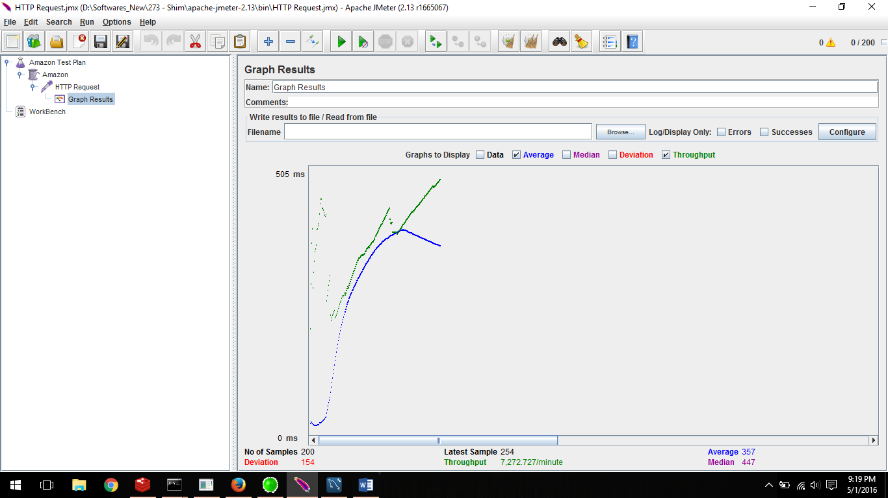

* **300 concurrent users:**

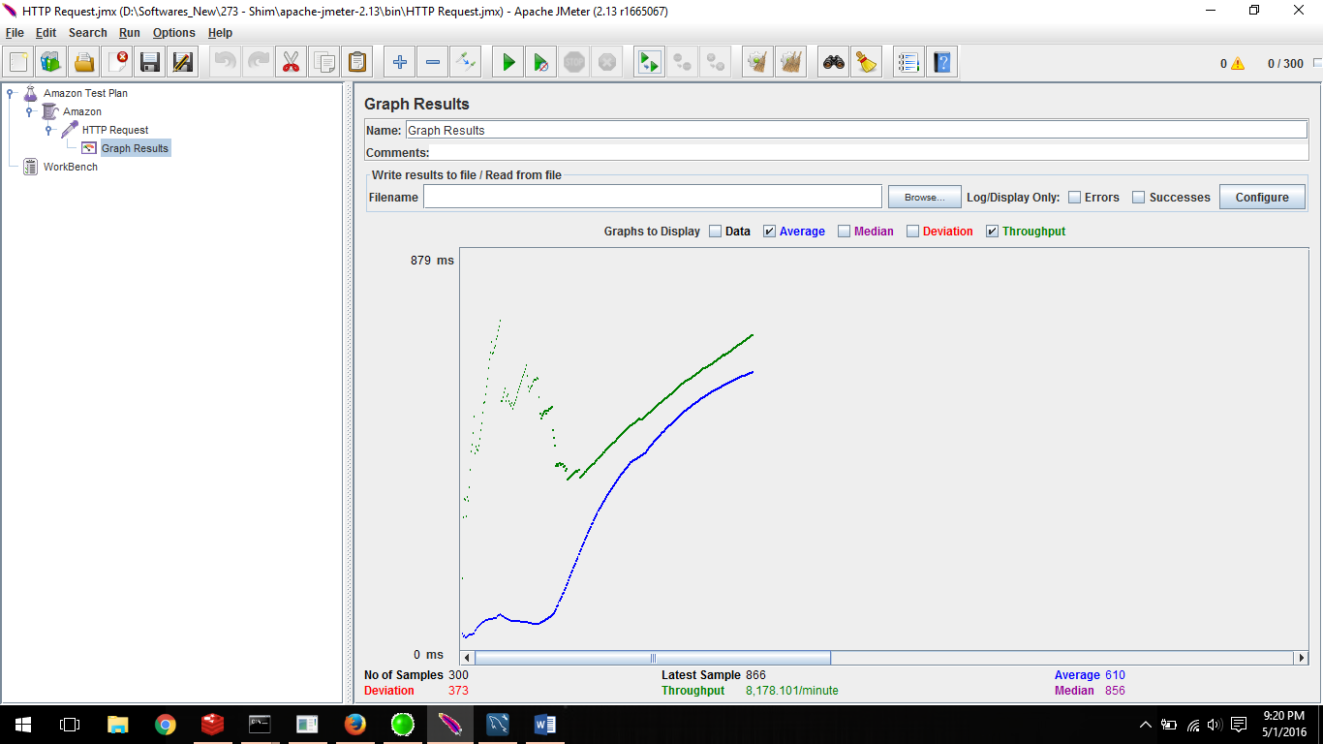

* **400 concurrent users:**

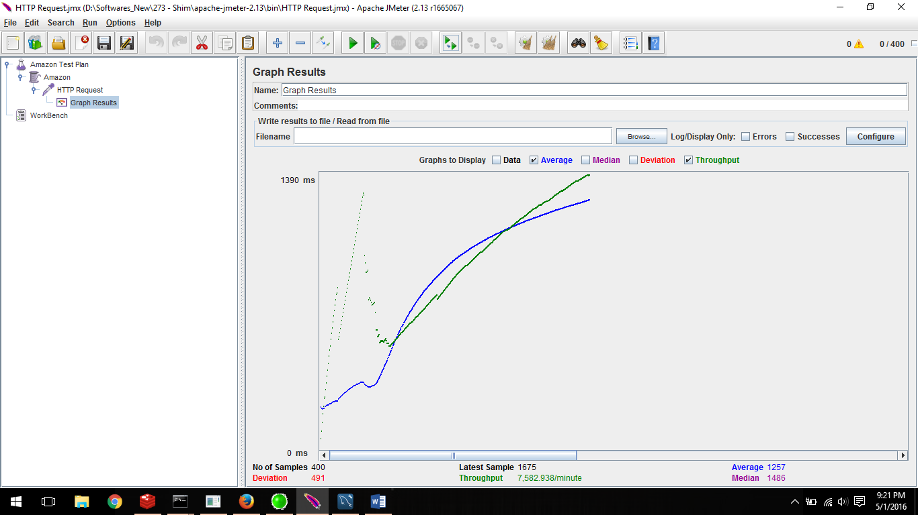

* **500 concurrent users:**

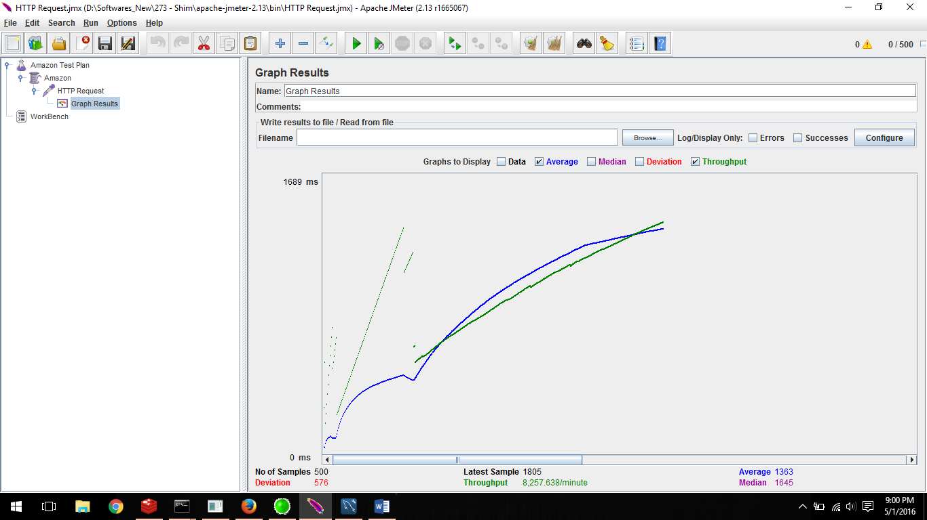

* **Application with REDIS, RabbitMQ and with Connection Pooling:**
* **100 concurrent users:**

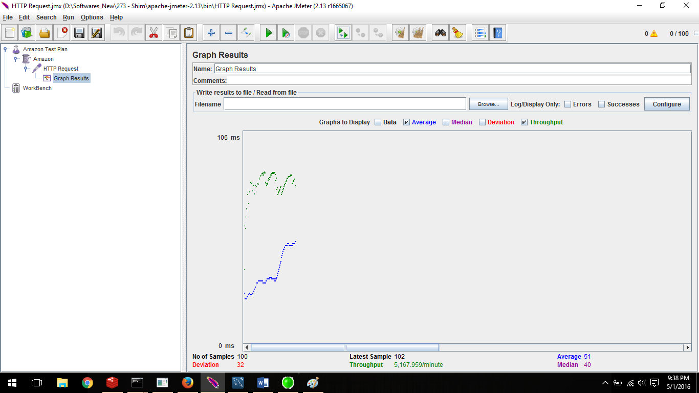

* **200 concurrent users:**

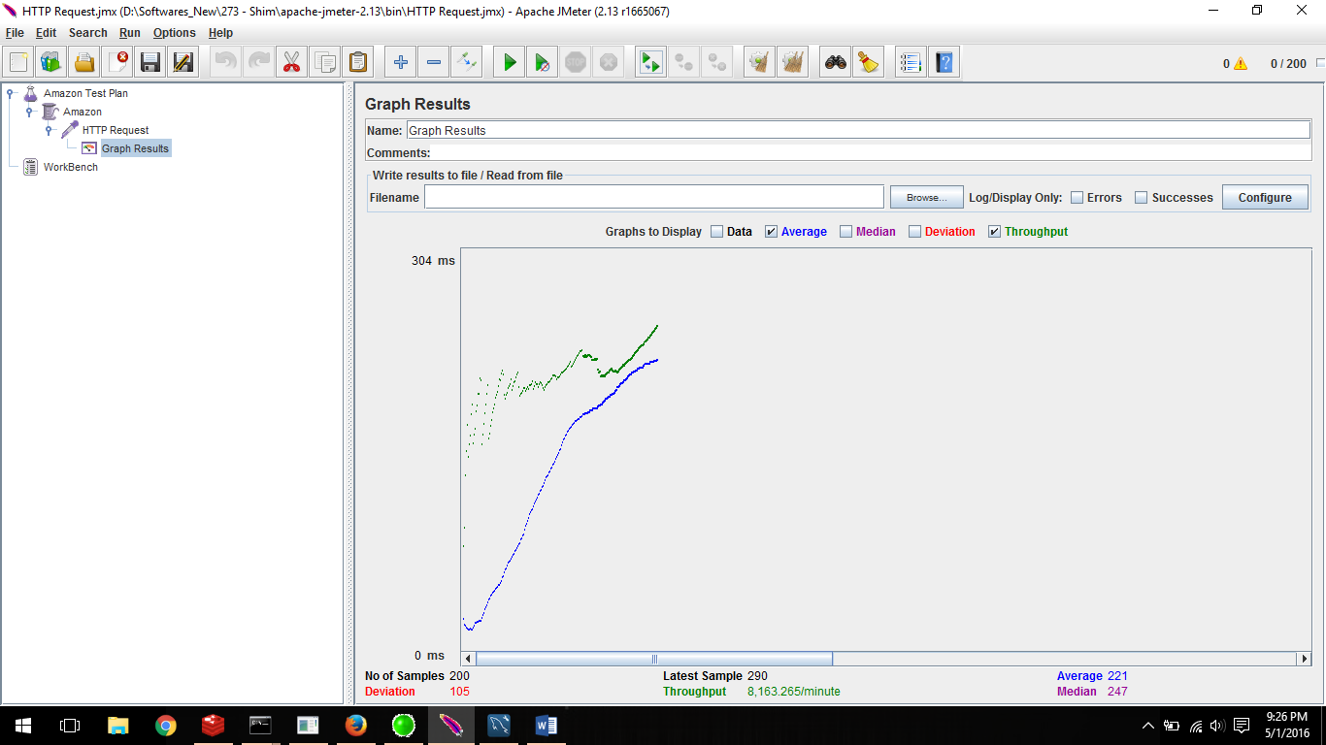

* **300 concurrent users:**

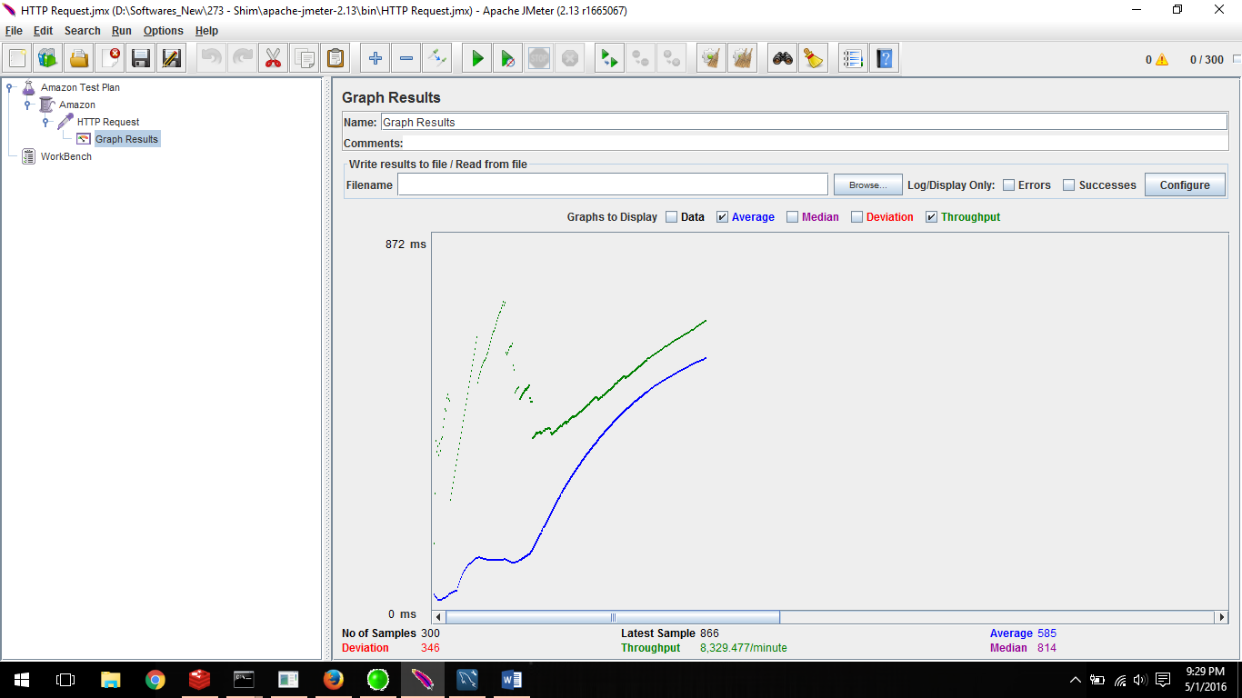

* **400 concurrent users:**

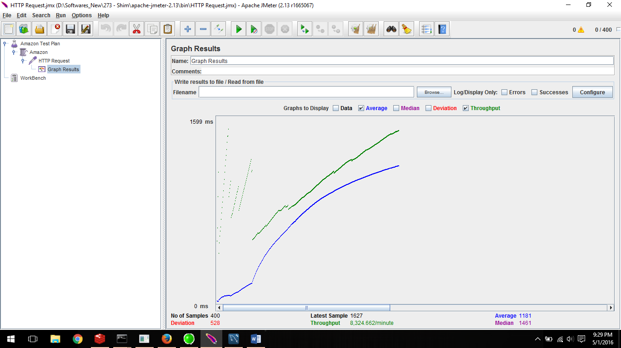

* **500 concurrent users:**

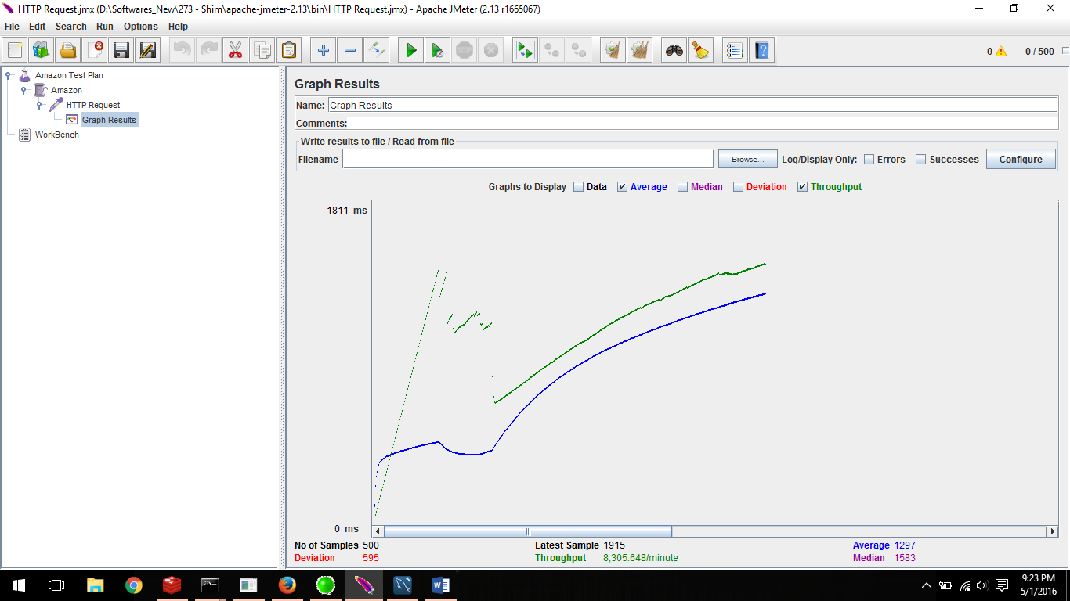

* Performance Comparison

Below graph show the performance comparison for different scenarios. The Jmeter output result is compared and the average time comparison and throughput comparison is displayed below. The comparison is done with the base application.

1. Throughput Comparison

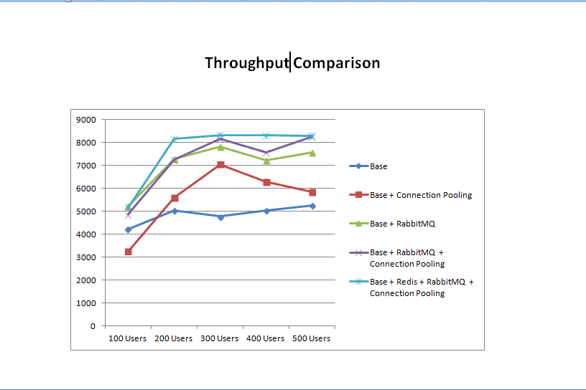

1. Average Time Comparision

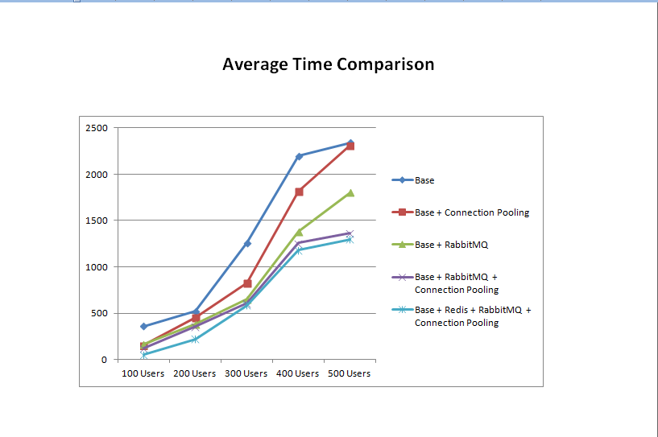

* Observations and Lessons learnt

The System helped us create the efficient robust and a scalable web application.

We created a Restful stateless service. The connection pooling helped us to improve the performance. Jmeter helped us to know about the performance for different scenarios and compare and contrasted for the same. Rest uses the JSON format for message exchange. It marshal and un-marshal faster than XML. We used RabbitMQ for scalability and Redis for cache management. We learnt how to use the MongoDB and MySQL database and saw the advantage and disadvantage of storing data.